**Prescribed by the National Curriculum and Textbook Board as a textbook for classes nine and ten from the academic year 2013**

**English For Today**

##### Classes Nine and Ten

**Writers**

Raihana Shams, Md. Zulfeqar Haider Goutam Roy, Surajit Roy Majumder Md Abdur Razzaque, Naina Shahzadi

**Editor**

MS Hoque

**Revised and Re-edited by**

Syed Manzoorul Islam

**Second Revised Version Writers**

GoutamRoy Urmila Khaled Md. Nasir Uddin

**Editors**

AMM Hamidur Rahman

GoutamRoy

**Reviewers**

Tazin Aziz Chaudhury, Adilur Rahman Mohammed Abdul Karim, Rumena Afroza

**NATIONAL CURRICULUM AND TEXTBOOK BOARD, BANGLADESH**

Published by

**National Curriculum** & **Textbook Board**

69-70, Motijheel Commercial Area, Dhaka

[All rights reserved by the publisher]

**First Publication** October, 2012 **First Revised Edition** September, 2014 **Second Revised Edition** : September, 2017 **Third Revised Edition** : November, 2020

**Reprint** : , 2022

**Design**

National Curriculum & Textbook Board

**For free distribution from academic year 2010 by the Government of the People's Republic of Bangladesh**

Printed by:

#### Preface

The aim of secondary education is to make the learners fit for entry into higher education by flourishing their latent talents and prospects with a view to building the nation with the spirit of the Language Movement and the Liberation War. To make the learners skilled and competent citizens of the country based on the economic, social, cultural and environmental settings is also an important issue of secondary education. The textbooks of secondary level have been written and compiled according to the revised curriculum 2012 in accordance with the aims and objectives of National Education Policy 2010. Contents and presentations of the textbooks have been selected according to the moral and humanistic values of Bengali tradition and culture and the spirit of Liberation War 1971 ensuring equal dignity for all irrespective of caste and creed of different religions and sex.

Honorable Prime Minister of the Government of the People's Republic of Bangladesh Sheikh Hasina expressed her firm determination to make the country free from illiteracy and instructed the concerned authority to give free textbooks to every student of the country. National Curriculum and Textbook Board started to distribute textbooks free of cost since 2010 according to her instruction. In its continuation, this textbook has been reviewed and updated with a view to create a developed and resourceful Bangladesh keeping vision 2041 ahead.

In the era of globalization, English is one of the most powerful tools for pursuing higher studies, using technology, inter-cultural and inter-personal communications, and job markets at home and abroad. The curriculum makes it explicit that language learning will be graded and contents will reflect real life situations as the ultimate purpose of language learning is to communicate. The English for Today textbooks have been developed to help students attain competency in all four language skills, i.e. listening, speaking, reading and writing. The contents and illustrations of this textbook have been developed in order to suit the learners' age and cognitive level.

The textbook has been revised and re-edited by prominent educationists to make it learner friendly in 2017 and 2020. I thank sincerely all for their intellectual labour who were involved in the process of revision, writing, editing, art and design of the textbook.

**Professor Md. Farhadul Islam**

Chairman

National Curriculum and Textbook Board, Bangladesh

#### Contents

|  |  |  |
| --- | --- | --- |
| **Unit** | **Title** | **Pages** |
| Unit One | Father of the Nation | 1-16 |
| Unit Two | Pastimes | 17-31 |
| Unit Three | Events and Festivals | 32-43 |
| Unit Four | Are We Aware? | 44-57 |
| Unit Five | Nature and Environment | 58-72 |
| Unit Six | Our Neighbours | 73-92 |
| Unit Seven | People Who Stand Out | 93-110 |
| Unit Eight | World Heritage | 111-121 |
| Unit Nine | Unconventional Jobs | 122-130 |
| Unit Ten | Dreams | 131-140 |
| Unit Eleven | Renewable Energy | 141-150 |
| Unit Twelve | Roots | 151-163 |
| Unit Thirteen | Media and Modes of E-communication | 164-173 |
| Unit Fourteen | Pleasure and Purpose | 174-192 |
|  | Sample Questions | 193-203 |

**Unit One**

### Father of the Nation

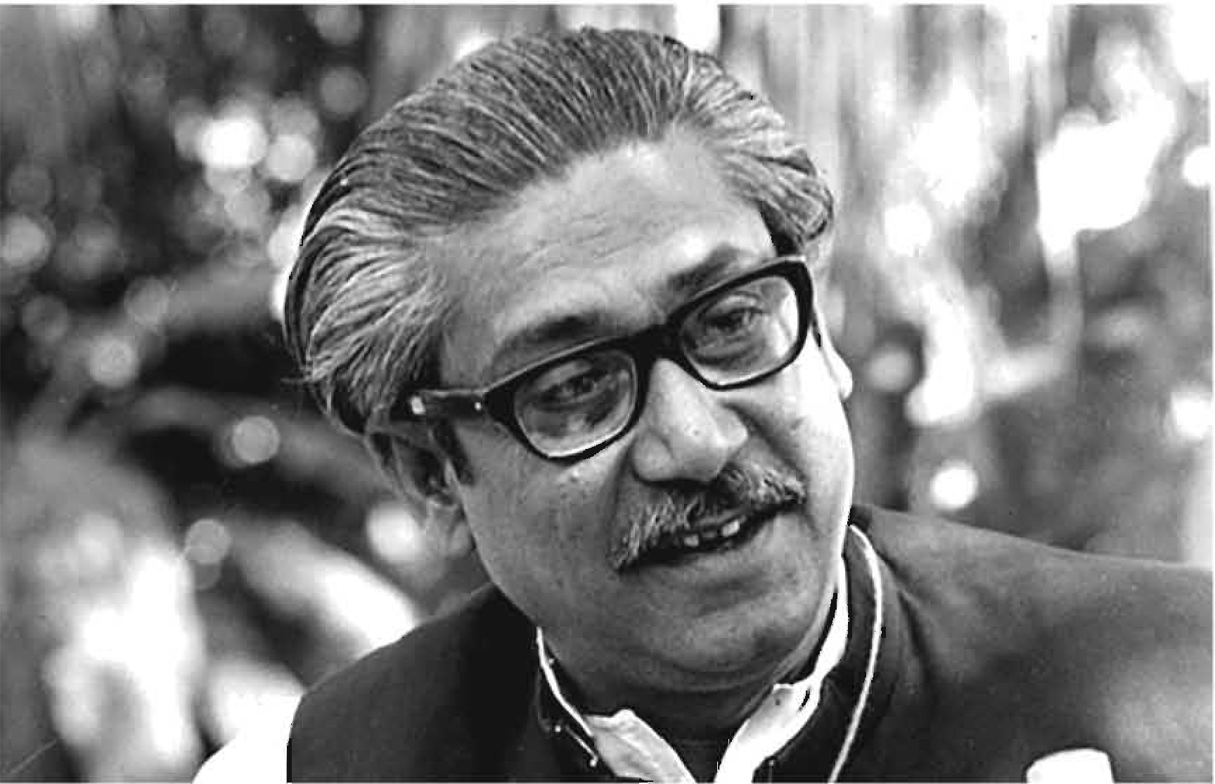

**Learning outcomes**

After we have studied the unit, we will be able to

* read and understand texts
* narrate incidents and events in a logical sequence
* participate in conversations, discussions, and debates
* tell stories

Forma-1, English For Today-9-10

2 

**Let1on 1: Bugabandhu's Family** In **19'71**

**.A.. Lookattli-J."+h11ubetow IUUldl.Kaa lhefoJJowtnil qantlou** In**pair.**

1. Who cm,.yuu seein thepiclure8?
2. Whatdo yolJknowabollt them?
3. **Where_.., lhceopeople** duringlhe Lfbmlion Wrrt

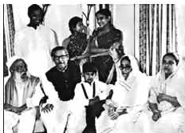**Pictme** 1 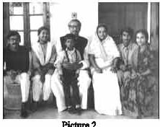

1. **Rad tha tut ucl** ..,_ **tlqe•..UO•thatti:Jllow,**

It wu Ibo night of 251h **MazdJ,** 1971. Thm ***ms* a** full of **quie1-I** at B•npbandlw.'s home **at** Jllwrnnondi ltoe.d No. 32 1hrough0llt the day. B•ngabandb:u Sboith Mujiblll' RabDl8ll .1llld bis family members could appreba:id thlt some1hillg lzlgio was going to happen. Oull.llhoC8 wm: hcatd mtnmd1he city. Bangabm.dhu'a eldm 80!ll Sheikh Kmod wu out of home for formillg against tho Pakiatan Army who had **been** killing people indi!IC:rirnmmly1hatn4:ht Bangab1111dh1d1ecided to IIClldIbogirlsoflho timily toa u.fi:rplace for thenightsodhegavi:theirn:t!pOll&il,ilityto his sonin bnvML Waad Miah. Bangaband!n1'• danglrttt Basin.a, who WU expecting a

Rcmm.a

baby &OC>D.abg wid>.herlis!!:rShcikh andheroousmFaida wcrc sent

to & hatlie at Road no. 15, Dlummondi for lh&t nighl BangJ1bandbu's wife

Begum FazilatllM"fA '1ujll>,stayed with bim,

J'urt beforemidmgb1, Banpbendlm 1lellt thodeclaration of Independence to Mi:. ZahurAhmed Qowdhmyat Chaltogramvia wirelet18.Aflleclarmtpart ofCll.at ni,Bbl,1hc PllkistmAnnysumnmclcd hishomemd lll.m1i:dfiringat'1!M/WD The situation agi:tatlld Banpbendln1 much andbe aabld them to stop. But, soonhe

WU iDrllru'1edtog«midytogowiChthom. Pogu?l 'll,fajibp8"edhi.sDOCll&aty

belmgin,p A&r Bangabmullw. h:ft,she wu at &!011& what to do and wbm-, to :;: go wi1h her childrell. Ho-.-«, beillg a suppoltive wife of 1111& gt\lllt leader all

!'.l

through her life, she soon pulled up her mental strength. But, her anxiety continued till the end of the war.

The next day Begum Mujib had to leave House No. 32 with her children and other members of her home. During the next couple of months, they moved from one shelter to another in search of a safer place. During their stay in those places, some people came forward to helping them while some refused to give them shelter for fear of their own safety. When their provision ran short, Sheikh Kamal, who had already joined the Liberation War, came to them in disguise and delivered some money. Some very close people also supported the family with money and food stuff.

So far the family members were ignorant about Bangabandhu's condition. Suddenly they came to know that he was alive and had been taken to Pakistan. Begum Mujib started to keep contact with Awami League leaders. But soon the family was taken to Dhanmondi, House No. 18 by the Pakistan Army and kept under house arrest. However, people would come to their home with valuable information in disguise of vendors; also some would throw pieces of waste paper with important information written on them.

In the month of May, the same year, Pakistan Army set fire to Bangabandhu 's Tungipara home in front of his parents. A young man from the village protested the evil deed and was shot dead. Both the parents of Bangabandhu fell ill in October and were admitted to the then PG Hospital. Begum Mujib and her family were allowed to visit them two or three times a week for one hour. However, that created the opportunity for them to establish a better communication with the freedom fighters.

Begum Mujib was extremely worried about her children, especially her daughter Sheikh Hasina, because of her health condition. However, she was not allowed by the Pakistani rulers to be with her daughter, when she was admitted to hospital. Mr. Wazed Miah and Bangabandhu's second son Sheikh Jamal accompanied Sheikh Hasina to the hospital. Bangabandhu 's youngest sister, pretending to be a hospital attendant, entered the hospital and looked after her niece. Sheikh Hasina was blessed with a baby boy on 27 July who was later named Sajeeb Wazed Joy. As the Pakistan Army often used to threaten Sheikh Jamal that they would hang him upside down, he, finding an opportunity, fled from the hospital and joined the freedom fighters.

Finally the Victory day arrived! There was joy everywhere! But, Bangabandhu's family was yet to be freed from captivity. The Pakistani occupational forces were still cordoning Bangabandhu's house and firing at people rushing over

there chanting *'Joy Bangla* ', the invigorating slogan of the Bangalees. But they fled the next morning when the Indian Army came to rescue the family. Sheikh Jamal returned home in the afternoon while Sheikh Kamal returned home the next day. Nevertheless, the biggest anxiety of the family persisted­ Bangabandhu was yet to be released from Pakistani prison and they didn't know when that great moment would arrive and how.

*(Source: Sheikh Rehanar sathe ekanto alapocarita: Antaranga Aloy Bangabandhur Poribar by Sanchita)*

1. **List the five ways how the Pakistan Army tortured Bangabandhu's family.**
2. **Divide into pairs and tell the sufferings of Bangabandhu's family during Liberation War in your own words (Do not look at the book).**
3. **Answer the following questions. First discuss in groups of four, then write the answers individually.**
   1. Why was the family anxious on the 25th March night in 1971?
   2. Where did Bangabandhu send the girls on that night?
   3. How would the family communicate with people or freedom fighters while they were under house arrest?
   4. How did the Pakistan Army scare Sheikh Jamal? How did Sheikh Jamal manage to flee from captivity?
   5. How do you explain Bangabandhu's family's contribution to Liberation War?
4. **Discuss** if **the sentences are True/False. Give correct information if any statement is false.**
   1. Begum Mujib went to a safer place at Dhanmandi at the night on 25 March, 1971.
   2. Bangabandhu had declared the independence of Bangladesh before he was arrested by Pakistan Army.
   3. Nobody stood beside the family ofBangabandhu during Liberation War.
   4. Bangabandhu's parents became very sick soon after the Pakistan Army had set fire to their home at Tungipara.
   5. After Liberation War was over, Sheikh Kamal and Sheikh Jamal both returned home on the same day.

f"'l

1. **Identify the sentences using 'however' in the text along with their immediate preceding sentences. Discuss in pairs why 'however' is used between the sentences.**

**Note that 'however' is used to show contrast or contradictions and it is accompanied by a comma.**

1. **Write five more pairs of sentences using 'however'.**
2. **Group work: Discuss the sufferings of people during the Liberation War. Then write a paragraph on that.**

**Lesson 2: The Tale of Homecoming**

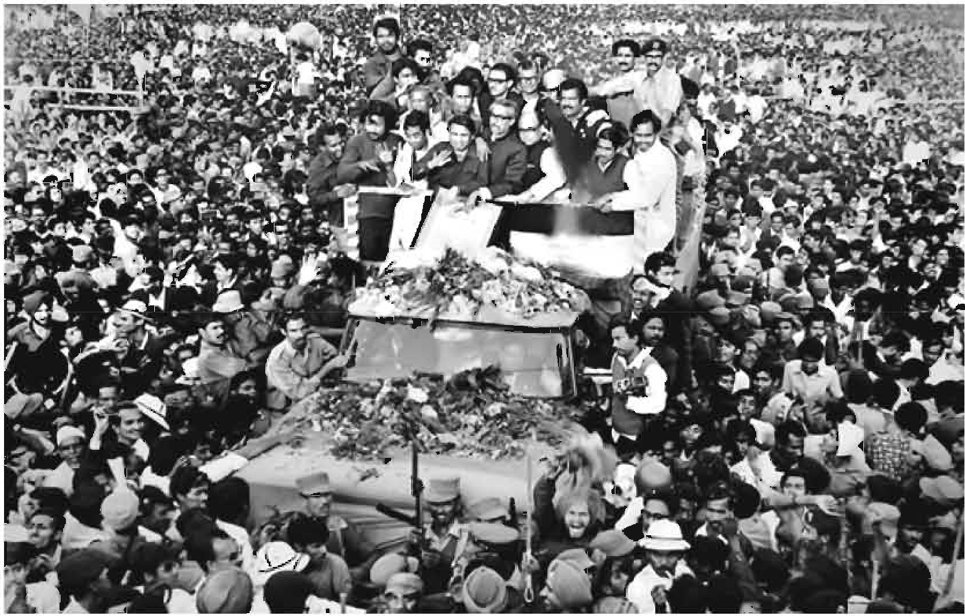

Bangabandhu's Homecoming on 10 January, 1972.

1. **Work in pairs to discuss the following questions.**
   1. What do you see in the picture?
   2. Who do you identify in the picture?
   3. Do you find any connection between the picture and the title of the lesson? How?
2. **Read the story of Bangabandhu's homecoming to answer the questions that follow.**

Bangabandhu Sheikh Mujibur Rahman was arrested by the Pakistani army immediately after his declaration of independence at the first hour of the 26 March 1971. He was taken to Pakistan as a captive and imprisoned there in a small cell for capital punishment until 7th January, 1972. Even a grave was dug in front of his cell but Mujib was fearless. He knew nothing would stop the Bangalees to gain independence. In fact, his name and independence became synonymous. So the whole world was awaiting breathlessly to witness his homecoming. And he had a grand homecoming indeed narrated by eminent columnist and writer, Syed Badrul Ahsan. An abridged version of that narration is presented below.

In the evening of 7 January, 1972; Bangabandhu left Chaklala Airport in Rawalpindi, from where he would fly to London. Nine months earlier he was brought to Pakistan as a prisoner with little hope to return. And now he was free to go home. Pakistan, as soon as the PIA aircraft took off, was finally behind him....

Early in the morning on 8 January 1972, Bangabandhu arrived at Heathrow Airport. News of Bangabandhu's arrival in London spread quickly. Journalists, the general public, British officials and politicians and Bangalee residents in the city made their way to Hotel Claridges. News bulletins on the BBC and other media organizations made note of Bangabandhu's arrival in their headlines. By early afternoon, the Father of the Nation had met the British Prime Minister Edward Heath and the Leader of the opposition Harold Wilson. Then he called Dhaka and for the first time since his arrest by the Pakistan Army in March, spoke to his family. A long conversation then followed with Prime Minister Tajuddin Ahmad. The conversations with his family and with Tajuddin were emotional affairs, but he now had a clear picture of all that had happened in his absence in Bangladesh. It gave him immense pleasure knowing that he had truly liberated his people.

Bangabandhu's opening words at a crowded news conference that evening at Claridges was a touch poetic. He expressed the unbounded joy of freedom "'"l

achieved by his people in an epic liberation struggle. Bangladesh, he told the 8l

crowd, was a reality and would fulfill its obligations as part of the international community. He made it clear that those who were involved in different types of crimes including genocide would be trialled by his government.

**C. Work in pairs. Write on the blank spaces how you would express these words/phrases in your own language and then make sentences with them.**

declaration of independence capital punishment (to) await breathlessly

(to) make their way emotional affairs immense

touch poetic unbounded joy genocide

**""'I**

1. **Talk about the questions.**
   1. What made Bangabandhu so bold while in the prison?
   2. How did time change in Bangabandhu's life within the nine months in a Pakistani prison?
   3. How did London welcome Bangabandhu?
   4. Do you agree with the statement that Bangabandhu was excited as well as relieved from long anxiety in London? Why/Why not?
2. **Read the following texts by the same author that describes Bangabandhu's a few more hours of journey towards home.**

Bangabandhu left London for Dhaka on the 9 January evening in 1972. On the way he would stopover in Delhi. He was welcomed at Delhi's Palam Airport in the morning of 10 January by President V.V. Giri, Prime Minister Indira Gandhi, West Bengal politician and Chief Minister Siddhartha Shankar Ray and the chiefs of the Indian armed forces. Bangabandhu stayed in Delhi for about two hours. During this time, he addressed a public rally and mesmerized everyone. There he wholeheartedly thanked Mrs. Gandhi, the people and the politicians of India for the tremendous help they had provided to Bangladesh and its ten million refugees.

Then it was on to Dhaka, where millions of people had begun to crowd the route that their leader would pass and the Race Course Maidan where the leader would deliver a speech before going home. On the tarmac at Tejgaon Airport, soldiers of the Indian army and the Mukti Bahini were on standby to present Bangladesh's President with a guard of honour. Members of the wartime cabinet waited in the winter sun, as did a horde of newsmen. Sometime after 1:30 pm the Comet aircraft made available to Bangabandhu by the British government landed in Dhaka.

As soon as the doors of the aircraft opened, Bangabandhu appeared. It was clear he had lost weight due to imprisonment for nearly ten months in a Pakistani prison. A big smile appeared on his face as he swept back his hair with his right hand. Prime Minister Tajuddin Ahmad then moved forward and buried his head in his leader's chest. Both men broke down. Their tears soon led to moist eyes in nearly everyone else present around them. Once the formalities at the airport were completed, the Father of the Nation climbed on a board of an open truck, with the Mujibnagar government figures and the student leaders crowding around him. He headed for the Race Course.

The two-mile stretch of road would take the procession almost three hours to cover. At the Race Course, Bangabandhu wept remembering the sacrifices of the Bangalees had made in the war against Pakistan. He told how the military junta had tried to intimidate him during his trial. He said, "I told them I am a Bangalee and a Muslim, who only dies once. I would walk the gallows with head held high." The Father of the Nation remarked, the Bangalees had become the golden children of the Golden Bengal. Quoting the poet Rabindranath Tagore, who once had complained that the people of Bengal had remained mere *Bangalees* but were yet to become true human beings. Mujib told the jubilant crowd that the poet had been proved wrong. "Come back, 0 poet", he intoned dramatically, "and see how your Bangalees are today transformed into worthy men."

Moments later, as dusk and a winter haze settled over Dhaka, Bangabandhu Sheikh Mujibur Rahman made his way back to his family. They had been waiting for him at the house in Dhanmondi Road 32 where he had left his family before the Pakistan Army arrested him on the eve of the Liberation War.

1. **Match the words/phrases in Column with the meanings in Column B. One is done for you. After matching, make sentences using them relating to your life.**

|  |  |
| --- | --- |
| **Column A** | **ColumnB** |
| on the way\. | a group of army personnel who rules a country |
| stopover \. | to fill eyes with tears |
| mesmerized '\ | uttered |
| wholeheartedly | in course of a journey |
| tarmac | area from which planes take off at an airport |
| horde of newsmen | a group of journalists or newspaper reporters |
| to moist eyes | mist or fog that covers winter evening |
| military junta | hypnotized |
| intoned | from the heart |
| winter haze | rest for some time |

1. **Section B and Section E describe different times and situations of Bangabandhu's homecoming. Below, there are sentences that match with certain parts of the texts in these two sections. Match these sentences with the parts of the texts.**

Dream comes true Home, sweet home Days behind the bars Good bye Pakistan

The hero before the world press Tribute to genuine friends We've been worthy

End of a long waiting Tears of joy

1. Work in groups. Make a timeline of the incidents mentioned in the

**texts on Bangabandhu's homecoming.**

1. **Work in groups. Suppose you are some journalists interviewing Bangabandhu at that time. Make a list of questions that you could have asked him?**
2. **Do you agree with Bangabandhu that the Bangalees have become worthy now? Justify your argument in 200 words.**

Forma-2, English For Today-9-10

1. **Bangabandhu had three sons, two daughters, his wife, brother, housemaid, caretakers, and soldiers waiting for him. Imagine what happened after Bangabandhu had entered his home. Then complete the following story.**

Dhaka was full of crowd. Inside a house, there were family members, relatives and many others. The wall clock was ticking at every second. Two daughters were getting impatient to see their father. They peeped through the windows a thousand times. Baby Russel was asking his mother, "Ammo, when will Abba arrive?". Then slowly stopped the convoy before the main entrance of the historic house at Dhanmondi 32..........

###### Lesson 3: Bangabandhu at the UN

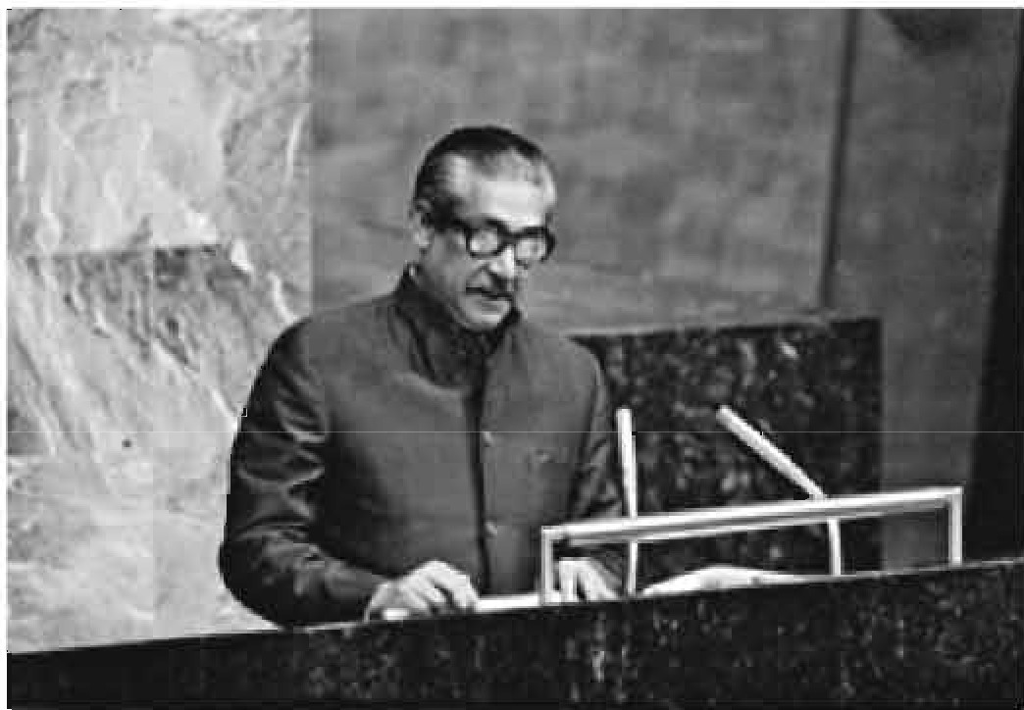 1 ED *TIO* S

1. **Work in pairs and discuss the following questions.**
   1. What do you know about the UN?
   2. What do you know about Bangabandhu's speech at the UN?
2. **Read the text and answer the questions that follow.**

Bangabandhu's speech at the United Nation's General Assembly is a matter of great pride for us. He delivered the speech on 25th September 1974, just after a week Bangladesh became a member of the UN. To be a member of the UN was not an easy go as some influential countries were opposing the membership for Bangladesh. So it was another war that Bangabandhu had to wage.

But finally, Bangabandhu won. He won not only the UN membership, but also everyone who listened to his ever first speech at the UN. It was a *veni vidi vici* experience for him - he came, he saw and he conquered everyone. Bangabandhu was the first person in the history of the UN to deliver a speech in Bangla, the language of the seventy-five million Bangalees, the language of the language martyrs. The poet of oration, the icon of charismatic leadership touched another milestone and so did the Bangalees through him. It was a speech that revealed Bangladesh's stand on national and international issues before the global community.

Identifying the UN as the parliament for the humankind, Bangabandhu recognized the moment of delivering his speech historical. He mentioned that the very moment justified the century-long struggle and sacrifice of the Bangalees for self-rule, independence, dignity and co-existence along with other nations. He assured that Bangladesh would follow the ideology of mutual respect, national sovereignty, regional integrity, and non-interference into internal issues of other countries. Bangabandhu explained Bangladesh's absolute pledge to the UN charters and reminded how the people of his country made the highest sacrifice to achieve the same. The Father of the Nation added that Bangladesh would look forward to such a world where peace and justice would take their rightful place. It was essential to justify the sacrifice of the countless martyrs.

In his speech, Bangabandhu expressed his utmost gratitude to the UN and the international community for standing beside Bangladesh with their aids and support in the reconstruction of the war-ravaged country, relocation of 10 million war-refugees who took shelter in India during the Liberation War. The leader of the country reminded the world how Bangladesh stood on the ruins and debris of a war where people were just struggling for survival. However, the repeated natural calamities were making their life harder and people even didn't have a minimum intake of food for a day.

Going beyond Bangladesh, he expressed solidarity for all the oppressed people around the world and denounced racism, discrimination, imperialism, and the use of force to stop people's justified movements for their rights. Referring to the struggle of the people in Africa, Asia, Latin America, Namibia, Palestine and Zimbabwe, he expressed his worry about people's plight to achieve their own

"'"l rights. The leader of the oppressed noted- when millions of people were destitute with unending miseries, only a handful of people were enjoying the

highest luxuries. He emphasized quick measures for global financial management based on justice. Bangabandhu warned that an absence of such a system would lead the world to experience an unprecedented misery of the history.

The leader of the third world countries expressed his deep concerns over a global recession and inflation, unemployment, unequal distribution of wealth and opportunities, and the gap between the rich and the poor countries. He described how those had hit the development plans in many poor countries of the planet. To Bangabandhu, it was a global responsibility to fight these problems and take concerted efforts to put an end to these.

Before he concluded his speech, Bangabandhu declared that Bangladesh would follow the paths of togetherness, brotherhood, and mutual respect and cooperation. He expected the UN would take substantial roles in solving the prevailing human crises in the subcontinent as well as in other countries.

*Bangladesh has been following the paths of Bangabandhu, the dreamer and the peoples leader, even after his death nearly five decades ago.*

1. **Here are some words/phrases from the text the meaning of which are given below with alternatives. Choose the best answer as per the context.**
   1. So it was another war that Bangabandhu had to wage. Here the meaning of the underlined word is -

a. cause b. lose c. carry on d. pay

* 1. It was a *veni vidi vici* experience for him. The meaning of the underlined phrase is -
     1. He came, he spoke, he won b. He spoke, he ran, he saw

c. He ran, he came, he won d. He came, he saw, he conquered

* 1. Bangabandhu clarified Bangladesh's absolute pledge to the missions of the UN charters. The meaning of the underlined word is -

a. determination b. explanation c. narration d. situation

* 1. It was essential to justify the sacrifice of the countless martyrs. The meaning of the underlined phrase is -
     1. number of people who sacrificed their lives.
     2. number of people who sacrificed their lives but not counted.
     3. number of people who sacrificed their lives and has been counted.
     4. number of people who sacrificed their lives and it's impossible to count them. f"'l
  2. Bangabandhu expressed his utmost gratitude to the UN ... for standing beside ... the war-ravaged country. The meaning of the underlined phrase

**IS-**

* + 1. distrated by the war

c. distracted by the war

* + 1. disturbed by the war

d. damaged by the war

* 1. He expressed his worry about people's plight to earn their own rights. The meaning of the underlined word is -

a. suffering b. flying c. crymg d. fighting

1. **Here are some sentences that sum up the text in Section B. Match the title with each of the paragraphs except the last two. The first two paragraphs will have the same title.**
   1. Bangabandhu 's policy to friends and neighbours
   2. Call for unity
   3. The background information
   4. Voice against tyranny
   5. Thanks giving
2. **Read the text in Section B again. Then work with a partner and ask and answer the following questions.**
   1. How did Bangabandhu pay tribute to the language martyrs?
   2. Why did Bangabandhu seek for togetherness and global partnership?
   3. What foreign policy did Bangabandhu formulate in his speech?
   4. Do you think Bangabandhu could speak about the national, regional and international problems? Justify your argument.
   5. Why did the text term Bangabandhu as *a leader of the oppressed and leader of the third world?*
3. **Underline the information that you consider important to summarise the text in 200 words.**
4. **Search the net to listen to the speech and then write an email to one of your friends giving him or her the information that you have gathered about Bangabandhu's speech at the UN.**
5. **Work in pairs/groups. Make a list of some questions that you would have asked if you had a chance to meet Bangabandhu after his speech at the UN.**

14 J!l!&lllb Far Today

**Lesion 4: Banpbanclhu's Relationship with otherCountries**

1. **Lookat diepldun:c bdow and dlml11thefollowtng queltlou**Ill**pair.**
   1. a, Who do you **see** inthopictures?
      1. How arelheyrc:latedto Bang1b1odhu?
      2. Whatcloyou think arelherelal:iomhip**among**them?

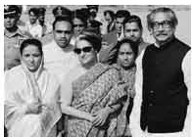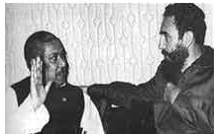

1. **Re&dtletest.**

"I havel10t aeen1he Himalayu. But, I hs.ve &ee11 Sbeilch Mujib. Iii per:90ll8.lity 1111d in C011111ge 1hi& man is **1he** Himlll«)'U, I have:1hU8 had1he experient;e of wi:tnemllgtbo Himalayas,"- saidFidelCulro, thethenPrimoMini ,.11fCuba

in *1m,* when h• fint met B•ngaband'lr<l Such was 1he impression Barlsabendbu left on lhe minds of worldleaders. Heowned the positi1111mlhe beetofpi:opk aeIODlhe woddby hisselflc:t111neae, andgreallle..

Any 00\IJllry bu to determine i11; mode of rJr.l!ng with other collDlrie& of lhe world. **Tho**oonstitution .. Ban,glad•m of 1972 cloai:ly re1loc:tB!he philosophy, 'Friendlhip tor all, ro•Jic»to none.•Bangabandhu lod-newgovo,nmcmt decided to 111Bintain friendly 'co-exisb:nce'withoCher coumriea basedon Chisprinciple.

Tho cbarismatie lesdorsbip of D•ngabandlm inqMd India. to emnding

its lllll'P0rt di.il'i1l8 the I.ibentiM W• even in his aheence. It p an aclivc: role to the world leaden about Bllff of the pc;:,pw of Bangladesh and thoir right to be me. Moreover. !his c:olllrtry IU{)PC)rtod !he fteedom figlmm with ita anny fi&hting **1be** Pakistani occupetion fon:es in **a**

frontal B41Dpb1ndhuwu to forlhi8. YelitW11l'R1111pbandhu who could ea the Indian "Prime Minister Indira Gandhi on their :lint meeting **when sho** would withdraw **her** army from BtnlgladMh Mrs. Gandbi soon

replied,"*A1J.'j*timewhen youwish". Noticeably, th• grestleader'Rangabandbu

had a strong personality to ask for any clarification from any other leader of the world! Consequently, very soon, before Bangabandhu's next birthday, the withdrawal was completed.

Bangabandhu had an open mind to maintain good relationship with all countries irrespective of their capitalist, democratic or socialist ideologies. He left no stones unturned to make entry into different global organisations. During the period between 1972 and 1975, Bangladesh signed more than seventy treaties, agreements, memoranda and contracts with different countries of the world. Managing entry into OIC (Organisation of Islamic Cooperation) and attending its conference at Lahore filled up a major gap in diplomacy of Bangladesh. It opened opportunities to explore all the possibilities of trade and other potentials with the Islamic world.

Bangabandhu charmed common people all over the world. His speech in different summits revealed that Bangladesh did not only think about its own self, it was also concerned about injustices prevailing in the rest of the world. Bangabandhu sent a medical team to Egypt and Syria for the treatment of the war victims of Arab-Israel war. He always used to say, "Today the world is divided into two parts - the oppressors and the oppressed. And I am with the oppressed." This kind of strong voice and wisdom made his position firm as a global leader.

He was such a leader for whom the British Prime Minister Edward Heath broke all the protocols to welcome him at Claridge's Hotel on 8 January, 1972 while Bangabandhu was returning from Pakistani prison. His elegance was reflected in the voice of a renowned journalist, "The courage and charm that flowed from him made him a unique superman of these times."

Bangabandhu's philosophy of secular democracy honoured him with a firm position in the world. The period from 1972 to 1974 was actually a bright and busy era for Bangabandhu Government, when he visited many countries of Asia, Africa, Europe and Latin America. He made those visits to gain support from those countries and to promote friendly relationships with them. Consequently, wherever he went, he cast a very positive influence on the leaders of those countries. Among the world leaders who admired him were India's Prime Minister Mrs. Indira Gandhi, Palestinian leader Yasser Arafat and Cuba's President Fidel Castro. His leadership, wisdom and personal relationship with world leaders made him a successful politician of international repute.

16 English For Today

1. **Work in groups. Ask and answer the following questions based on the text you have read at Section B. Then write the answers individually.**
2. What did Fidel Castro compare Bangabandhu with? Why?
3. What do you understand by 'Friendship to all, malice to none'?
4. How did India help us during our Liberation War?
5. Why did Bangabandhu try to join different alliances?
6. What was the purpose ofBangabandhu's visit to different countries?
7. **Here are some words from the reading text. Find the opposite words and write on the blank spaces. You can take help of a dictionary. Then make meaningful sentence with each of these words.**

charismatic evident harmony wisdom capitalist E **Look at the third paragraph of the passage and identify the**

**connecting/linking words. Observe how they have connected one sentence to another. Write the purposes of their use in the next chart. The first one is done for you.**

|  |  |
| --- | --- |
| **Connecting or linking word** | **Place of use** |
| For instance | to give example of what was said before |
|  |  |
|  |  |
|  |  |
|  |  |
|  |  |

1. **A successful man or woman has to maintain good relationship with others, for example, family members, friends, neighbours, etc. In groups discuss on ways of improving relationship with your neighbours.**
2. **Now work individually and write a paragraph on 'How to Maintain Good Relationship with Our Neighbours'. Use linking words as** needed.

##### UnitTwo

**Pastimes**





**Leamillgowtc:ome,**

Aj}erwehave studiedtheunit.we will be able to

* + ll8l'me incidenla **and**cventa in a logical aequence
  + participate in conversation, dixcossions and debates
  + readmaps, cbads, graphs, etx:.

Foima-3, Bnelio!J11Qt"Today-9-10

18 

Lesson 1: Have **You anyFavourite Pastime?**

1. **Look at the pictures. What arethe persons doing here?When dothey**

**do theee kinda of adivld.es?**

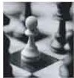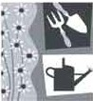



1. **Read the conversation andanswer thequeltfom.**

Tiya : Anusha, what's thematter? You're wearing sports trousers,T-6hirts, sports shoes and carcying a bag! Where an, youcoming from?

And you look tired!

Anusha : Not exactly, Tiya. I'm great because I'm ju.st coming back from

the gym.

Tiya : Do you go to the gym regularly?

Anusha : Yes. I do.I go twi0e a week. It's one of my favourite pastimes.

Tiya : Really! Going to the gym is your favourite pastime! You make

me laugh!

AnU8ha

Tiya Anusha. Tiya Anusha

: Why not?I like sportB becau1!e I liketo be fit. I'm not a lazy person like you!

: What do you do there?

: Idoyoga.

: Don't you have anyother pastimes?

: Hmm... yes, I have. I likeplaying chess, painting, and reading books when I'm fteo. I also likephotography but I'm yet toleam it. What do you do in your pastime?

Tiya : I like watching TV, listening to music, reading books and magazines, and playing games on the computer. I do like gardening. But we don't have sufficient space. So I do pot planting. By the way, I don't know much about yoga. Would you please tell me about it?

Anusha : Sure! I'll give you an article on it.It will help you know about yoga.

**Questions**

Okay?

* 1. Why does Anusha like going to the gym?
  2. What are her pastimes?
  3. Make a list ofTiya's pastimes.
  4. How will Tiya learn about yoga?

1. **Read the following texts. Then check** ( ) **the statements below: Yoga: Tap Into the Many Health Benefits**

**Understanding yoga**

Yoga is a kind of posture and breathing exercise. It brings together physical and mental disciplines to achieve peace of body and mind, helping you relax and manage stress and anxiety. Traditional yoga puts emphasis on behavior, diet and meditation. But if you're just looking for better stress management- and not an entire lifestyle change-yoga can still help. Yoga trainers gradually choose easier to complex activities for practitioners. However, all practitioners do not necessarily need the same kinds of practice.

**The health benefits of yoga**

The potential health benefits of yoga are numerous and may include:

* **Stress reduction**

With its quiet, precise movements, yoga draws your focus away from your busy and chaotic day towards calm as you move your body through poses that require balance and concentration.

* **Increased fitness**

As you learn and refine new poses, you may enjoy improved balance, flexibility, range of motion and strength. And this means you're less likely to injure yourself in other physical endeavours or in your daily activities.

* **Management of chronic health conditions**

Yoga might help in a variety of health conditions, such as cancer, depression, pain, anxiety and insomnia, fatigue and mood shifts. Yoga can also help reduce heart rate and blood pressure.

* **Weight loss**

If you're overweight or have eating disorder, yoga may help you make the healthy lifestyle changes necessary to gain control of your eating and reduce weight.

While you shouldn't expect yoga to cure you or offer you 100 percent relief, it can help some health conditions when combined with standard medical treatment. And if you already enjoy good health, yoga can be an enjoyable supplement to your regular fitness routine.

1. **Work in pairs. Discuss these questions. Give your own opinions.**
   1. How does exercise work on our memory?
   2. What other benefits can you think of from exercise?
   3. What is the most important benefit of exercise to you and why?
2. **Complete the sentences.**
3. Yoga is a practice of ........................................
4. Traditional Yoga works through ............................................. .
5. Yoga is very effective in managing.............................. .
6. Through the poses of balance and concentration Yoga ....................

e results in increased fitness.

1. Yoga can reduce or work for ..................................................
2. Yoga can control .......................................
3. Yoga cannot cure 100 percent, but .................................
4. **Check** ( ) **the statements about yoga below.**

a Yoga improves fitness. D

c It may differ according to D

practitioners' levels.

e It works both on body and mind. D

g If you know yoga, you have better D

control over your real life hazards.

b Yoga has little to do with eating □

habits.

d It helps people shake off all types D

of physical and mental disorders.

f It helps practitioners undergo □

similar level of difficulty.

h It also helps you live longer. □

1. **Read the text.**

Hi, I'm Shyam. I'm from Magura. Although it's the district headquarters, it's a small town. I'm in grade 9 now in Chander Haat Bidyaloya. I love games and sports very much. My father was an athlete in his student life. He inspires me to follow in his footsteps and take part in games and sports or do some exercise besides my studies. So I get up early in the morning and take a walk with my father almost every day. We walk for about an hour. At school, during break I play *kabadi, gollachhut,* badminton, table tennis, and carom. Sometimes I prac­ tise the high jump and the long jump outside the school campus. Playing football is a passion for me. I like watching television too.

I watch sports programmes on different TV channels during my free time. I'm a fan of National Geographic, Discovery, and Animal Planet for their documentaries as they are quite interesting as well as educative. Recently my father has presented me with a camera as he was very happy with the result of my Junior School Certificate exam. When I hold the camera, I feel so excited! I wish I could be an amateur photographer in future - not to take only personal photographs at different parties but to shoot our beautiful Bangladesh. I'm sure that soon photography will be my most favourite pastime.

1. **Work in pairs. Read the statements of the following grid. First match the parts in Column B with Column C to make complete sentences. Then make questions for the statements in Column A.**

|  |  |  |
| --- | --- | --- |
| **Column A** | **Column B** | **Column C** |
| What ------------------------- | 1. Despite the fact that | a.besides his studies. |
|  | Magura 1s a district |  |
|  | headquarters, |  |
| When------------------------- | 2. His father was a | b.it is a small town. |
|  | sportsman |  |
| How-------------------------- | 3. He encourages Shyam to | c. in his student life. |
|  | participate in games and sports |  |
| When------------------------- |  |  |
| 1. Shyam enJoys playing d. during break at   different games and sports school.   1. He walks e. on different TV channels. | |
| Who -------------------------- |
| How long -------------------- 6. They walk  Why --------------------------- 7. He prefers programmes  on nature and life  What-------------------------- 8. He watches sports  programmes | | f.with his father.  g.for their educative values.  h. for about an hour. |

1. **Write about your own pastime following the model in G.**

1'111timca 23

Leason 2: **Reading** ReallyBelp!lf

1. **Read** the **coa'fetati'.c.111111d** tdJ **wlultAalllha b p1q 1vread.**

Anusha : *Ti:ya,* hopeyOlienjoyed the mcleon yop.

T'J}'ll

Amudia

Annlha

: **Yee,** it's groat By tho *wtty,* A.m1&ba, bow did yoo mjoy

London Olympics **118 a** spomlover?

: People rightlysay that it i& tin. g.eato.rt &bow en earth. rm still thrilled to mnember what .Mfobaol Phelps and Usain Bolt have shown. Arn•zin&I

: Right you are. They are incmh'blo. However, I've got an inlm:ostins article on the Internet on Mk:hael l'bclp& llUd UaainBolt.Yon might I it end lake part in the ddiate onwllo it better betwee:n these two gtelll8. Pi- readit.

: Ahh... Michael Phelps and Usain Boll!Thank yon Tiya!I wtmld

love to-.iiit

1. **Read** theta:t publilbrd *in* a.. ew.paper ID201%,**ud mnm-**1he

q11estiont **tlllt** follow.

Ml Phelpjl, u,11nBolt aregnat, bat wJio••betterf

With th.. w1:llimil closing on tho 2012 Lendon Olympics, it's impossible not

to look beck andreflect on!he greatect pc,ri'C)ffl)An<',"8by Olympic athletes..

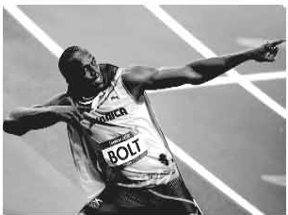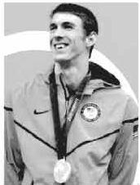

(Pl,,,m:K'.il1,yLeo,USA 'lUOAYSpmm]

The Olympics have many memorable moments and athletes we'll remember by name alone. The list is quite big. Michael Phelps and Usain Bolt are the latest addition to this list of the bests. They made London Olympics stand apart. If there is any question like this: "What is the standout performance of London 2012?", perhaps the answer is "The London Games gave us Michael Phelps vs. Usain Bolt." The first one is an already decorated Olympian, who put the finishing touches on his great athletic careers. And another came up with a new definition of fast. Two of the most popular Olympic sports, sprinting and swimming, saw their two biggest stars captivating audiences. They'd also domi­ nated the 2008 Beijing Games, but Phelps and Bolt cemented their legacies in London. Phelps, the American swimmer, passed gymnast Larissa Latynia for the most Olympic medals ever. Bolt was the third man to repeat as a 100-meter gold medalist and the first as a 200-meter gold medalist, and he broke his own Olym­ pic record by running the 100 meter in 9.63 seconds. Once Phelps and Bolt were back in their pool and track, the story lines changed.

Phelps is the most-decorated Olympian ever, with 22 overall medals: 18 gold, 2 silver, 2 bronze. Bolt is the most accomplished Olympic sprinter, with the unprecedented double, making clear that he's the fastest man in the world.

But there's a debate: Who had the better Olympics? It'd be tough to top Phelps' eight gold medals in Beijing, but what if we're only talking London?

London was Phelps' grand finale. He won four golds and two silvers in seven events, and he says he'll never race again.

London was Bolt's chance to prove he's still the greatest. Bolt won six gold medals in six Olympic finals. He is the first man ever in the history of the modem Games to sweep the 100 and 200 in back-to-back Olympics. Not to mention the addition of back-to-back relay golds.

And Bolt became a legend, in his own words. Phelps already was. Bolt is just 25 years old, so there is no telling how long he can be on top of the sprinting world. What if he decides to "retire" from sprinting to focus on the 400 meters, just to break another world record or two? It would be amazing and entirely possible for him to accomplish.

Who had the better 2012 Games? You tell us, let the debate begin.

[Adapted from USA Today, Sports,London 2012] "'"I

**Questions**

* 1. What makes London Olympic 2012 exceptionally sensational?
  2. How are Phelps and Bolt brilliantly similar and different?
  3. Between these two Olympians who has bagged the highest honour within the same time frame?
  4. What is special in Bolt so far?
  5. How does Bolt evaluate himself ?

1. **Make two flow charts on Michael Phelps and Usain Bolt. The first two are done for you.**

Michael Phelps

UsainBolt

the most successful sprinter

the greatest swimmer ever

1. **Read the following text and complete the blank spaces with the appropriate words from the box below.**

answer sprinter Olympians speed Olympics swimmer

debate legends retired prove histories biggest

These are the stories of two most successful Olympians of history. While one is famous as the fastest .........., the other is celebrated as the fastest

...... of the world. However, both are unparalleled for their ........... in their own field. They made history in the Beijing .......... They have made newer

........... in the London Olympics too. They are the living now.

Though Phelps has .......... from his race, Bolt has prospects to himself

in the next Olympic as well. After the .......... show on earth is over in London, this . .. . .. .. .. will go on- who is better. Only time will this question.

Forma-4, English For Today-9-10

1. **Work** in **pairs. Decide who is better between these two champions.**

**Give reasons** in **favour of your decisions.**

###### Lesson 3: Change in Pastime

1. **Read the text.**

**Childhood outdoor pastimes** 'in **decline'**

Traditional childhood pastimes of climbing trees and playing conkers are in decline, according to a survey by the RSPB (Royal Society for the Protection of Birds). It's a charitable organisation registered in England and Wales.

The survey shows that people under 34 recall far fewer such childhood outdoor experiences than people over *55,*according to a survey by RSPB.

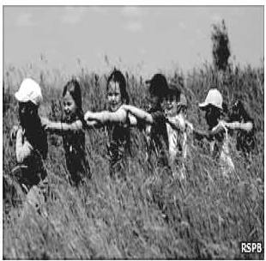People were asked which of the twelve childhood outdoor experiences they could remember. The answer included making dens, daisy chains, climbing trees, playing conkers and feeding birds. Four out of five boys climbed trees and the same number of girls made daisy chains. But the survey showed the numbers declining among the newer generations.

Some 15% more of those aged over *55* had these

outdoor experiences in their childhood, compared with those between 15-34 years old. Some 92% of the public agreed that experiences of nature were still important to children, and 82% agreed that schools should play a role in providing them to all children.

The survey has highlighted the positive impact of contact with nature on a child's education, health,

wellbeing and social skills. At the same time, there has been a decline in these

opportunities, with negative consequences for children, families and society-a condition now known as nature deficit disorder.

Mike Clarke, chief executive of the RSPB, will meet parliament members to urge the government to join other organisations in providing children with first­ hand experiences of the natural environment...."We believe this guidance should include the many positive impacts to children of having contact with nature and learning outside the classroom."

[Adapted from BBC news 6 September 2010]

1. **Read the following words and write their meanings as you understand them from the context.** If **you don't understand, check the words from a dictionary.**

conkers ............................................................................

dens ................................................................................

decline ............................................................................

highlight ..........................................................................

impact ........................................................................... .

consequence .....................................................................

disorder ...........................................................................

urge ................................................................................

1. **Read the following statement taken from the text in A and say what the subject of comparison is. Find out the other comparison in the text above.**

People under 34 recall fewer such childhood outdoor experiences than people over 55, according to the survey by Ipsos Mori for RSPB.

1. **Do you agree that if children have more contacts with nature, they may have a positive impact on them? Make a list of the benefits or harms they may have if taken to nature frequently.**
2. **Speak to the senior citizens in your home or community. Ask them about their pastime activities and take notes on them. Then write a paragraph in the style of the text given in Section A to show the differences. Also mention why these differences have taken place.**

###### Lesson 4: Change in Pastimes in Bangladesh

1. **Tiya and Anusha decided to make a survey on students' pastimes in their class. After the survey they presented their findings in a chart. Look at the chart and read how they explain their findings.**

|  |  |  |
| --- | --- | --- |
| Items | For classes 9-10 | For classes 5-6 |
| Playing games and sports | 22.3% | 9.2% |
| Watching television | 17.2% | 31.2% |
| Chatting with friends | 13.7% | 6.7% |
| Reading books or magazmes | 12.9% | 11.7% |
| Gardening | 10.7% | 6.1% |
| Attending social programs such as music, recitations or debates | 9.1% | 7.8% |
| Playing games on computers | 8.2% | 20.9% |
| Others | 5.9% | 6.4% |

Tiya: Hello everyone! My name is Tiya. My friend, Anusha and I are going to do a presentation on Pastime Habits of Classes 9 and 10 students in our school. There are 120 students, 60 in class 9 and 60 in class 10. The classes have gender equity. Each class has 30 male and 30 female students. The survey shows that

22.3 percent of students in classes 9-10 like games and sports as their most favourite pastime, which is the 4th option given by classes 5-6 students. Watching television is the second choice (17.2%) by the first group in contrast to 31.2% of the second group. It is noteworthy that watching television is the first choice of the second group. A considerable number (13.7%) of 9-10 students like to chat with their friends and thus it becomes the third popular choice in the chart while this becomes one of the less important choices by the younger kids. Only 6.7% of the kids take it as their first priority. It's interesting that both the groups like reading books. 12.9% of students of classes 9-10 take it as their favourite pastime. The number is **11.** 7% for Classes 5-6 students. Besides, gardening is voted (10.7% of students) to be the 5th preference by the grown up

8l

group though it is not that much liked by the younger group. Only 6.1% of the young kids are involved in it. This is interesting that though the higher number of students in classes 9-10 prefer attending social programs ( 9.1% ) than students of classes 5-6 (7.8%), yet as a choice it is preferred by the latter group. It is the 5th choice for them while to the older group it is the 6th• Young kids have greater fascination for playing games on the computers (20.9% like it as their first choice). The chart shows that as the kids grow up, they lose their passion for computer games. According to the chart the ratio declines to 8.2% from 20.9% when the kids are students of classes 9-10. Finally, it can be said that the influence of television has impact on both the groups but the more students grow up, the more they opt for fields/ gym.

**Questions**

* 1. What are the gender policy of the surveyors?
  2. What are the survey findings regarding watching television?
  3. Which age group is more interested in socializing with others?
  4. According to the chart, how do the kids change their pastimes when they are grown up? What changes does the chart for 9-10 reflect?

1. **Work in groups. Make a chart on the pastimes of the students in your class and present it to your class.**

###### Lesson 5: Pastimes Vary

1. **Read the conversation. What is it about? Do you agree or disagree?**

Tiya

Anusha Tiya Anusha

Anusha, I really wonder how pastimes vary from generation to generation.

Oh yes. I can tell you how.

: Although I don't know exactly, I think time is a big factor.

: You are right. Time changes many things. It changes our tastes and abilities. Technology has roles too. Look, there was a time when playing in the fields was very popular because we had many open fields around. Going to a neighbours' houses and hanging out in groups were popular pastimes as well. You won't see these activities now. The process of urbanization, the aggression of satellite television and people's dependence on technology have changed our lifestyle. Now boys and girls of urban and semi-urban areas are more dependent on the computer for social networking, video games, or computer assisted programmes.

Tiya

Anusha

Right. But how do you know all these things, Anusha?

: Oh....I read an interesting article on people's changing pastimes. It analyses the issue through a graph. Here it is. Read, and I'm sure you will enjoy it.

1. **Read the article. Underline the words/expressions used** in **the article to show the changes in the data. The first one is done for you in the text.**

Young people's changing attitude to pastimes

* + Watching TV Games and sports -online/computer **assisted** programmes

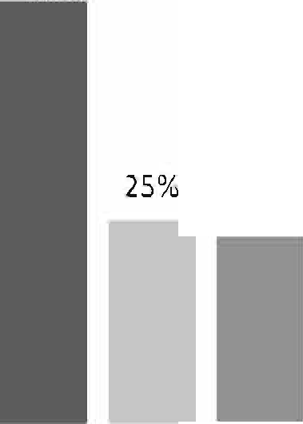

23%

41%

50%

9%

48%

38%

14%

52%



1990 2000 2010

There is change in people's preferences for pastimes. A recent survey shows that during the last twenty years, teenagers have gone through significant changes in choosing their pastimes. The survey results are presented through a graph which shows that there is a steady rise in young people's tendency to watch TY. In 1990, 41% of teenagers liked watching TV which increased to 48% in the next ten years and it further increased to 52% in the next decade. Unfortunately, the picture is grim in terms of young people's attraction to field games and sports. While 50% of youngsters opted for games and sports in the 1990s, the figure was 12% less after a decade at 38%. Unfortunately the falling tendency persisted through the next ten years and by 2010 it came down to 25%. Though the young people have dissociated themselves noticeably from games and sports, there is a sharp and steady rise in their association with online or computer assisted programmes. In 1990 when the users of online or computer for pastimes were only 9%, in 2000 the number nearly doubled and reached 14%, and with a rapid increase in the next ten years it shot up to 23%.

**('I**

The survey also explains the reasons for this change. It says that television has become a part of everyday life even to the underprivilegedsection of society. This has reBUlted in larger number of young people opting for watching TV as one of the most favourite pastimes. The increasing urbanization has ed the number ofopen fields. Therefore, there isa fall in selecting games

and sports as favourite pastim .though it'snot a good news for the oounuy.

And the reason for selecting the computer assisted or online programmes is that computer technology is getting cheaper, easier and more popular everyday. Indeed,ouryoung generations arestepping intothee-world.

1. **Now work fngroups and analyse** the following graph.

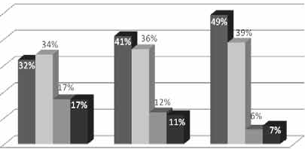Elderly people's changing attitude *to* pastimes in a community

* WatchingTV Play,ngGJrds
* O wmgroom

chats

* Others

1990 2000 2010

Unit Three

**Events and Festivals**

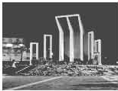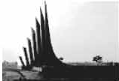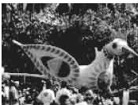



* havo studiedthis'llllit,we will boable to
  + talkabouteve:ut&and fmivlls
  + ask and1111JW«questions and give opiniona in a logical sequence
  + inferme.llffliS iromthe00111ext.

**Lesson 1: Mother's Day**

1. 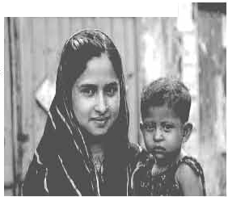**Look at the picture and discuss the** questionsir·-:;.;::==-r,r
   1. What do you think the woman is to the child?
   2. Why is she holding the child on her flank?
   3. Can a mother be compared to anybody? *"She canbe compared with no other; This lovely lady is none but my mother/'*
2. **Listen to the audio and answer the questions that follow.**
   1. **Listening text 2**
3. **Choose the correct answer.**
   1. According to ancient Greek myths Rhea is the

a mother of gods. b goddess of love.

c goddess of wealth. d goddess of health.

* 1. The name of Jesus Christts mother was

|  |  |  |  |
| --- | --- | --- | --- |
| a | Rhea. | b | Mary. |
| c | Anna . | d | Anna Junior. |

* 1. Julia Ward Howe was

a Dutch. b English.

c Australian. d American.

* 1. Mother's Day was flI'St announced as a formal holiday in the USA in

a 1872. b 1905.

c 1910. d 1914.

* 1. In 1914 the American president was

a Roosevelt. b Ford.

c Nixon. d Wilson.

* 1. Which country doesn't celebrate Mother's Day on the 2nd Sunday of May?

a Denmark

1. Italy

Forma-5, English For Today-9-10

b The UK.

d Turkey

1. **Listen to the text again and answer these quesdons.**
   1. What country first observed Mother's Day as a national holiday?
   2. When is Mother,s Day now celebrated by most of the countries in

the world?

* 1. How is Mother's Day usually observed?
  2. Why should we observe Mother's Day?

1. **Write a paragraph by answering each of the following quesdons.**
   1. Do you help your mother with her housework? How?
   2. Do you celebrate Mother's Day? If yes, when and how?



• •

**Lesson 2** : **May Day**

1. **Look at the picture and ta1k about** it.
   1. What do you see in the picture? •
   2. Can you relate any historical event to this picture? What happened on this day?
2. **Read the text and answer the questions that follow.**

May Day or International Workers' Day is observed on May 1 all over the world today to commemorate the historical struggle and sacrifices of the working people to establish an eight-hour workday. It is a public holiday in almost all the countries of the world.

Since the Industrial Revolution(l) in the 18th and 19th centuries in Europe and the US, the workers in mills and factories had been working a long shift, fourteen or even more hours a day.

On May 1st in 1886, inspired by the trade unions<2>, half of the workers at the McCormick Harvesting Machine Company in Chicago went on strike demanding an eight-hour workday. Two days later, a workers' rally was held near the McCormick Harvester Machine Company and about 6000 workers joined it The rally was addressed by the labour leaders.They urged the workers

to stand together, to go on with their struggle and not to give in to their bosses. At one point of the rally, some strike breakers startedleaving the meeting place. The strikers went down the street to bring them back. Suddenly about 200 policemen attacked them with clubs and revolvers. One striker was killed instantly, five or six others were seriously wounded and many others were injured.

The events of May 1, 1886 are a reminder that workers will continue to be exploited until they stand up and speak out to gain better working conditions, better pay and better lives.

**Notes**

1. Industrial Revolution: the period, especially in the 18th and 19th centuries Europe, when machines were invented and first factories were established.
2. Trade Union: an organisation that represents workers of mills and factories.

**Questions**

* 1. What does May Day refer to?
  2. How long did the workers have to work in a day before the May 1 strike?
  3. Why did the workers in Chicago go on a strike?
  4. What do you learn from the events of May 1, 1886?

1. **Fill in the blanks with the verbs given in the box. Put them into their correct forms.**

add

amve

begin

do

hear

live

send

support

tread

work

Tania is a poor garment worker. She in a big garment factory in Gazipur. She in a slum with a few fellow workers. She works eight hours a day on a monthly salary of Tk. 3000/-. She does overtime to some more

money to her income. If she can save something, she it to her father to the family.

One day Tania was busy her work in the factory. Suddenly she someone shouting "Fire! Fire!" The workers were panic-stricken

and everyone to rush to the stairs. There were not enough staircases in the factory building. So some workers were under the foot and

others were injured in some other ways. However, the fire brigade _ there in minutes and nothing serious happened.

1. **Now read the completed. passage** in **C silently and answer the following**

**questions.**

* 1. Do you think Tania's monthly salary is enough for her work?
  2. Is the factory safe enough for workers? Why do you think so?
  3. Do you have any suggestions for safety of factory workers? If so, what?

**Lesson 3** : **International Mother Language Day** - 1

1. **Look at the picture and talk about** it. l Whafs the picture about?

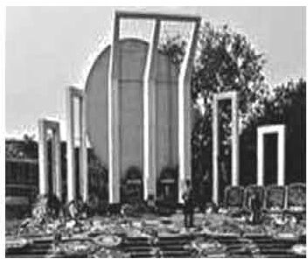

_

* 1. Whafs the place in the picture?
  2. Why was it built?

1. **Read the text.**

21 February is a memorable day in our national history. We observe the day every year as International Mother Language Day. The day is a national holiday.

On this day, we pay tribute to the martyrs who laid down their lives to establish Bangla as a state language in undivided Pakistan in 1952.The struggle to achieve our language rights is known as the Language Movement

The seed of the Language Movement was sown on 21 March 1948 when Mohammad Ali Jinnah, the Governor General of Pakistan, declared in a public meeting in Dhaka that Urdu would be the only state language of Pakistan. The declaration raised a storm of protest all over the country. The protest continued non-stop, gathering momentum day by day. It turned into a movement and reached its climax in 1952. The government outlawed all sorts of public meetings and rallies to stop it.

The students of Dhaka University defied the law and brought out a peaceful protest procession on 21 February 1952. When the procession reached near Dhaka Medical College, the police opened fire on the students, killing Salam, Rafiq, Bark.at, Safiur and Jabbar. As a result, there were mass protests all over the country and the government had to declare Bangla as a state language. This kindled the sparks of independence movement of Bangladesh.

f"'I

1. **Complete the chart.**

|  |  |
| --- | --- |
| **Time** | **What happened** |
| 1947 |  |
| 1948 |  |
| 1952 |  |

1. **Match the words with their meanings.**

**Words** tribute climax

outlaw

defy provoke relent momentum

**Meanings**

to cause or to stimulate to refuse to obey

to give in

the ability to keep increasing or developing an act to show respect or admiration

the most exciting point in time to ban

1. **Answer these questions.**
2. Why do we observe 21 February as the International Mother Language Day?
3. What happened when Urdu was declared as the only state language of Pakistan?
4. "The seed of independence was sown on 21 February 1952". Do you agree? Why?

###### Lesson 4 : International Mother Language Day - 2

1. **Discuss these questions.**
   1. When did the International Mother Language Day celebration begin?
   2. What does the abbreviation UNESCO stand for?
   3. What is the other name of21 February?
2. **Read more about International Mother Language Day.**

21 February is observed as *Shaheed Dibosh* every year throughout the country in remembrance of the martyrs of language movement of 1952. The comme­ moration begins at the early hours of the day with mourning songs that recall the supreme sacrifices of our language martyrs. People wear black badges and go to the *Shaheed Minar* in barefoot processions, singing mourning songs. They place wreaths at the *Minar.* Many of them visit the graves of the martyrs at Azimpur graveyard and pray for them. They also attend various programmes organised in remembrance of the language martyrs.

The UNESCO (United Nations Educational, Scientific and Cultural Organisation) on 17 November in 1999 proclaimed February 21 as the International Mother Language Day in recognition of the sacrifices of the martyrs for the rightful place of Bangla. Two Bangladeshi expatriates living in Vancouver in Canada, Rafiqul Islam and Abdus Salam, sent a proposal to Kofi Anan, the then secretary General of United Nations. They requested him to declare 21st February as the International Mother Language Day. They added that the decision will honour and save all extinct languages of the world. As per their logical expectations Prime Minister Sheikh Hasina then took prompt initiative by sending formal proposal to UNESCO. Finally, on 17 November 1999, UNESCO declared 21st February as the International Mother Language Day. The day is now annually observed worldwide to promote awareness of linguistic and cultural diversity and multilingualism.

1. **Match the words/phrases in the table with their meanings.**

|  |  |
| --- | --- |
| **Words/phrases** | **Meanings** |
| wreath  in remembrance of proclaim  promote diversity multilingualism in recognition of | * encourage * in appreciation of * practice of using several languages * an arrangement of flowers in the shape of a circle * declare * in memory of * variety |

1. **Read the text in B again and answer these questions.**
   1. Why is 21 February called *Shaheed Dibosh?*
   2. Why do people go to the *Shaheed Minar?* How dothey go there?
   3. Why is 21 February now observed throughout the world every

year?

1. Complete the **passage** with suitable words.

On 21 February 1952 was shed at a place between Dhaka Medical College and Dhaka University to establish Bangta as a state -- of Pakistan.

All subsequent movements struggles for independeru:e had their origin in the historic language . *Shaheed Minar* is the

of the supreme sacrifice the mother tongue.

1. **Write briefly how you observed this year's 21February at your schooL**

#### Lesson 5 : Independence Day

1. **Look at** the **picture and ask and**

answer the questions about it.

* 1. What do you see in the picture?
  2. Where is it?
  3. Why was it built?

1. **Read the text.**

26 March. our Independence Day, is the one of the most important state festival. The

day is celebrated every year in the country with great enthusiasm and fervour. It is a national holiday. All offices, educational institutions, shq:,s and factories remain closed on this day. The day begins with a 31gun salute.

Early inthemorning the President andthe Prime Minister, onbehalf of thenation place floral wreaths at 1he National Mausoleum at **Savar.** Then other leaders, political parties, diplomats, social and cultural organisations,educational institutions and freedom fighters pay homage to the martyrs. People from all walks of life also go there in rallies and processions. There are many cultural programmes throughout the day, highlighting the heroic struggle and sacrifice in 1971.

In Bangabandhu National Stadium, school children, scouts and girl guides take part in various displays to entertain thousands of spectators. Educational institutions also organise their individual programmes. Sports meets and tournaments are also organised on the day, including the exciting boat:race in the river Buriganga.

In the evening, all major public buildings are illuminated with colourful lights. Bangla Academy, Bangladesh Shilpakala Academy and other socio-cultural organisations hold cultural functions. Similar functions are also arranged in other places in the country.

1. **Match the words with their meanings.**

|  |  |
| --- | --- |
| **Words** | **Meanings** |
| fervour alike spectator displays illuminate | * acts of performing skills * to light up * in a similar way * a strong feeling of excitement * a person who is watching an event |

1. **Choose the best answer.**
   1. Our one of the most important state festivals is

|  |  |  |
| --- | --- | --- |
| a Victory Day. | b | Shaheed Dibosh. |
| c Pahela Boishakh. | d | Independence Day. |

* 1. The celebration of Independence Day begins with
     1. processions.
     2. gun salute.
     3. placing wreaths at the National Mausoleum.
     4. parade by defence forces.
  2. The National Mausoleum is

|  |  |  |
| --- | --- | --- |
| a on Dhaka University campus. | b | at Ramna Park. |
| c at Savar. | d | near Dhaka Medical College. |
| On Independence Day various displays are held | | |
| a at the National Parade Ground. | b | in the streets. |
| c in the decorated vehicles. | d | in Bangabandhu Stadium. |

4

1. **Write in brief, how you have celebrated this year's Independence Day at your school.**

Lesson 6: Pahela Boishakh

A Look at the picture. Then ask and answer the questions about it.

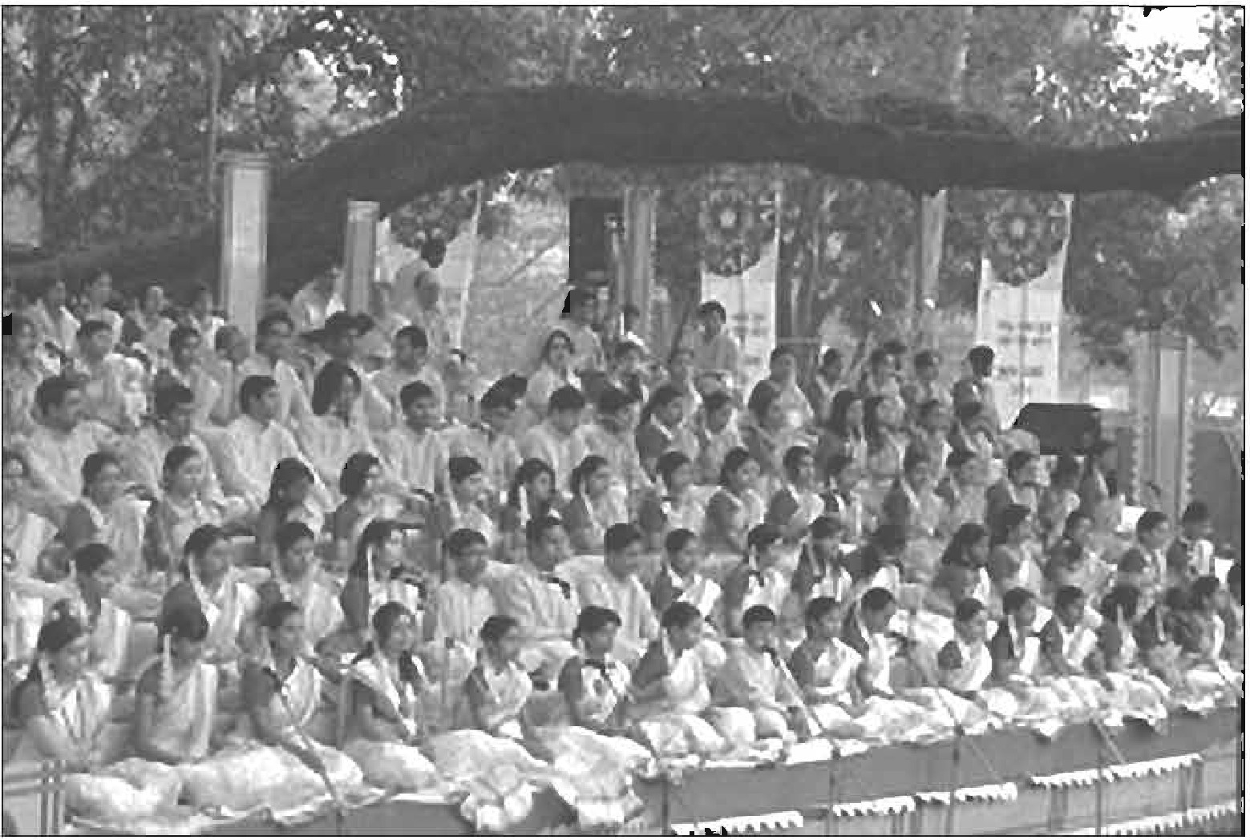

1. What's the picture about?
2. Where do you think the picture was taken?
3. What are the people doing?
4. **Read the text and complete the tasks C and D.**

'Pahela Boishakh' is the first day of Bangla new year. The day is a public holiday. This day has a special significance for us as it is a part of Bangalee culture and tradition. People from all walks of life, irrespective of their ethnic identity or religious beliefs, celebrate the day with traditional festivities. On this day, the whole of Bangladesh is in a festive mood. The day inspires people to start life with renewed hopes aspirations.

Forma-6, English For Today-9-10

Every year the day is celebrated traditionally. People wake up early in the morning, have a bath and wear traditional clothes. Women wear white *sarees* with red borders and adorn themselves with colourful *churis* and flowers, while men dress themselves in *pajamas and punjabis.* It is a day when people love eating traditional food.

One of the most colourful events of the day is held in Dhaka. Early in the morning, people in hundreds and thousands pour in from all directions to attend the cultural function at *Ramna Batamul* organised by *Chhayanaut.* The cultural programme begins just at sunrise and the renowned artists of the country take part in the programme that starts with the famous Tagore-song *Esho-he-Boishakh, Esho Esho* .....Artists also sing traditional folk songs, and perform classical dances to the rhythm of musical instruments.

People also come to join the colourful processions, the biggest carnival of the country, organised by the Fine Arts students of Dhaka University. The procession usually displays the traditional practices of Bangalee culture. The masks and wreaths worn by the people are so fascinating! Often they symbolise contemporary worries or happiness in the national life. It attracts an increasing number of foreign tourists every year.

The day is also observed all over the country. Different social and cultural organisations and educational institutions celebrate the day with their own cultural programmes.

On this day, newspapers bring out special supplements. There are also special programmes on the radio and television.

The celebration of Pahela Boishakh marks a day of cultural unity for the whole nation.

1. **Ask and answer these questions in pairs.**
   1. Do you go out in the morning of *Pahela Boishakh?* If you do, where do you go? If not, what do you do?
   2. What kind of food do you eat in the morning of *Pahela Boishakh?*
   3. Do you wear any special clothes on this occasion?
2. **Complete the passage with suitable words.**

The word *Pahela* means the first and *Boishakh* 1s the month of Bangla calendar. The day is observed not m Bangladesh but m some other parts of the world. It is celebrated in West Bengal, Assam and Tripura. It is also in Australia and the UK. In Australia, the largest for Bangla new year is the Sydney *Boishakhi Mela* held _

Sydney Olympic Park. In England, the Bangalees celebrate the day with a street in London. It is the Asian festival in Europe, Bangladesh and West Bengal.

1. **Describe your own cultural or religious festival that you celebrate. You can use the following words. You can also use other words relevant to the festival.**

colourful cultural

special flowers

traditional food

religious songs

dance festive

###### Unit Four

**Are We Aware?**

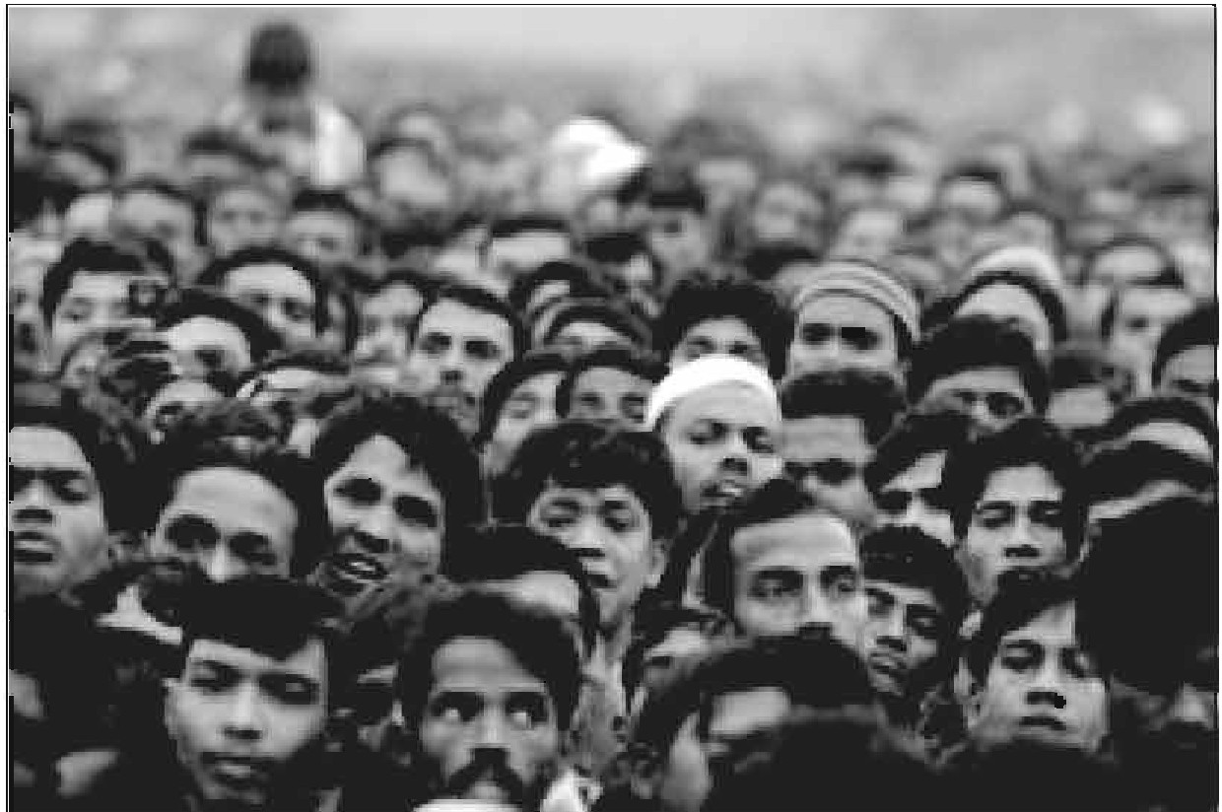

**Learning outcomes**

After we have studied the unit, we will be able to

* ask and tell about problems
* seek and give suggestions
* listen for specific information
* narrate something in writing
* read charts and do a project work.

###### Lesson 1: The Ferry Boat

1. **Look at the picture and answer these questions.**

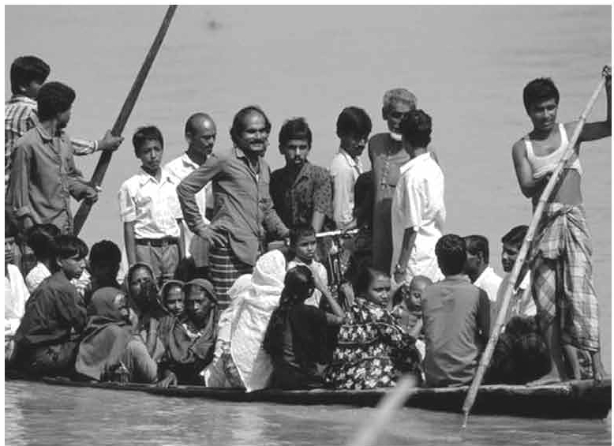

* 1. Where can you fmd this kind of boat?
  2. Why does the boatman carry passengers across a river?
  3. Why do people use country boats?

1. **Read the text and answer the following questions.**

"Is there anybody here who has ever crossed a river by a country boat?"

"I have, teacher," said Jamil. "And I clearly remember what happened in that journey."

"Would you please tell us what happened?,' the teacher asked.

"Okay, teacher. It happened when I was in class 6. On a weekly bazar day, people were coming back with their shopping bags and baskets in hands, on shoulders and heads. They had to cross the river. It was not a big river. There was a ferry boat plying on the river. The boat could cross it in 8-10 minutes. It was just after sunset. The weather was getting bad. The wind started blowing from the north-west. Black clouds were moving fast in the sky.

Everybody was trying to get into the boat. 'No more, no more, please wait,' shouted the boatman. But nobody listened to him."

"What happened then, Jamil?" asked Rumi.

"With too many people on board, the boat sank in the middle of the river," replied Jamil.

"Oh no! What happened then?" asked the teacher. "Thank God. There were no casualties. All the passengers swam to the other side. But some of them lost the stuff they were carrying such as oil, salt and milk," said Jamil.

"Were you on the boat?" asked the teacher. "No, teacher. Seeing the boat overcrowded, I waited for the next boat," replied Jamil.

"You did the right thing, Jamil."

**Questions**

**Tick the best answer.**

* 1. A ferry boat was plying on the river.

Here 'plying' means

* + 1. playing with other boats.
    2. sinking in the river.
    3. travelling along a route.
    4. waiting for passengers.
  1. Why was everybody trying to get into the boat?

Because

* + 1. it was a weekly bazar day.
    2. after sunset no ferry would ply on the river.
    3. everybody had shopping bags with them.
    4. it was going to be a dark and stormy evening.
  1. The boatman requested the people to wait, because
     1. his boat was very small.
     2. the boat had already too many people.

**C** there were other boats they could take.

d he would not ferry people with bags and baskets.

* 1. "With too many people on board , the boat sank ... "

Here the phrase 'on board' means

* + 1. on the boat.
    2. on the wooden board.
    3. outside the boat.
    4. on the notice board.
  1. There were no casualties.

The statement tells us that

* + 1. nobody died.
    2. nobody was rescued.
    3. nobody accepted their fate.
    4. nobody lost anything.
  1. The boat was overcrowded.

Here 'overcrowded' means

* + 1. people were quarrelling on the boat.
    2. the boat was unable to carry any more people.
    3. the boatman did not like a crowd.
    4. people were sitting on the boat's bamboo hood.

1. **Discuss in groups and write answers to these questions.**
   1. Why did some people have little or no patience when the ferry boat was in danger of sinking?
   2. 'No more, No more, please wait' who said this? Explain in 2/3 sentences.
   3. Answer the questions below:
      1. If we have too many passengers at a bus or train station, what may happen?
      2. If we have too many people in a village / town *I* city, what will happen?

**Lesson 2: Are We Too Many?**

1. **Read the text and do the following project work.**

The next day when the teacher came to the class and was about to start the lesson, Shanti Barua stood up and said, "Teacher, can I ask you a question, please?"

"Go ahead, Shanti," said the teacher.

"In our last class, we heard Jamil's story of how too many people made the ferry boat sink. I have also seen crowds of people at bus stand, railway station, launch and steamer ghats. It is not uncommon to see people travelling on top of a bus or train and meeting with tragic accidents. My question is: Are there really too many people in our country?"

"Thank you, Shanti. Please sit down."

The teacher then looked round the class and asked,"How many of you have the same question in mind?"

Almost all the hands went up.

"Okay," the teacher continued. "Finding the right answer to this question is very important for us- for our national development. So we will look at this issue with some facts so that we can find out if we are really too many or not."

**Project work:** Discuss in groups and carry out a survey on the topic: "Too many people'.' You can do the following things:

* Select only one small area such as your village or locality in the

town *I* city where you live.

* Find out its area. (You can do it by walking around it. At normal speed you can cover about one kilometer in ten minutes. )
* Find out the number of people living in it.
* Find out about the people's occupations, unemployment and poverty.

1. **Listen to the Audio . Listen how the teacher talks about the population of Bangladesh and answer the following questions.**

**Listening text 3**

**Questions**

**Tick the best answer.**

* 1. Bangladesh is a small country, because
     1. its land area is small.
     2. it has about 150 million people.
     3. it is the 8th most populous country in the world.
     4. it has limited resources.
  2. Density of population in any country means
     1. all the people in a country.
     2. number of people living in one square kilometer.
     3. 1000 people living in one square kilometer.
     4. too many people living in one square kilometer:
  3. Our yearly population growth rate is a 1.9% b 1.40%

**C 2.1%** d 1.1%

* 1. Our birth rate is per thousand. a 6.1 b 1.40

c 20.1 d 14

* 1. What will be the size of our population in 2050?

|  |  |  |  |
| --- | --- | --- | --- |
| a | 150 m | b | 197 m |
| c | 217 m | d | 250 m |

1. **Listen again and answer these questions.**
   1. How do you get the population growth rate of a country?
   2. Why will the population of Bangladesh be so large in 2050?

Forma-7, English For Today-9-10

1. **Read the chart and fill in the gaps with information from the table Use comparatives and superlatives where necessary. The table shows facts about some countries including Bangladesh.**

**Bangladesh Sri Lanka India China**

|  |  |  |  |  |
| --- | --- | --- | --- | --- |
|  | **Bangladesh** | **Sri Lanka** | **India** | **China** |
| Land area sqkm | 148,460 sq km (approx) | 62,710 sq km | 3,287,263 sq km | 9,600,000 sq km |
| Population in million | 165 m | 21.4m | 1380 | 1420m |
| Density of  population per sq km | 1116 | 341 | 464 | 153 |
| Birth rate (per 1000) | 18.18 | 15.5 | 18.2 | 10.48 |
| Death rate (per 1000) | 5.5 | 4.2 | 7.3 | 7.4 |
| Growth rate | 1.04% | 0.42% | 1.1% | 0.6% |

In terms of land area Bangladesh is (1) (larger) than Sri Lanka, but (2) _

than India. China is, of course, (3) of all the four countries. Sri Lanka has the (4) population among the four countries. However, China has the (5) population shown in the chart. In fact, China has the (6) population in the world and India has the (7) highest population in the world. On the other hand, China has the (8) growth rate among the 4 countries. Bangladesh has (9) growth rate than India, but higher birth rate than (10) and (11)

1. **Write a paragraph about the population situation of any of the countries above. Use the facts given in the chart in D above.**

Are WoAwaro? Sl

Lesson 3: Our Food and Shelter

1. Look at the picturet and answer thae question,.
   1. What do the people do in a tn:c ora boat?
   2. Why do they do so?

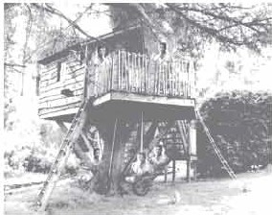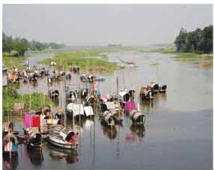

1. Diacuaa what willbe our problems if our population becomes double die lizeit ii now.
2. Read what the teacher Mt Choudhary and her rtudentl are taJJdng

**about.**

The class comes up with different problems. One group leader says, "The scarcity of foodwill be a serious problem in the ycatS ahead. It is true that our agriculturists have developed new varieties of rice and its per acre production has definitely increased. Butthe rateof increasein foodproduction cannot keep pace with the:rateofpopulation growth. Thisis because our landisfixed, i.e.we cannot increase it, while our population is increasing tapidly.11

Another group leader comes up with the houeingproblem in the country, which he says adds much to the food problem. He says, "Families 811: growing larger in sizeand at the same time breaking into smaller families. Each smaller family needs a house to live in. Also, the arable fields are being divided by these smaller families among themselves. Mills and factories are being set up, which occ:upy a cODSide.rable portion of our land. So while we need more land to grow morefoodto feed moremouths, our landis shrinking day by day.

"No way," another student argues. "Trees are being cut, hills are being cleared and water bodies are being filled up --- all to meet the needs of too many people."

"Thank you students," Ms Choudhury says, "You're quite right. Let me tell you about this village where I was born and brought up. Things were not like this in the past. I remember as a child, the village was so beautiful! The green paddy fields and yellow mustard fields seemed to be unending. They used to wave and dance in the breeze. There used to be a wood in the northern side of the village. There was a tall tamarind tree in the middle of the wood. Also there was a big banyan tree which looked like a huge green umbrella, with its aerial roots hanging down. I often used to go there with my friends. We would often have picnic there. While the boys would climb the tamarind tree and pick some tamarinds, I and my best friend Rima used to swing from the hanging roots. But now, look, the wood is gone. The beauty of the crop fields is spoiled by the unplanned houses built here and there."

1. **Tick the best answer.**
   1. The rate of increase in food production cannot keep pace with the rate of population growth.

The sentence means that the food production

* + 1. is as much as needed.
    2. is less than what is needed.
    3. is more than what is needed.
    4. is sufficient for the population.
  1. How can our housing problem add to our food problem?
     1. After making houses, farmers do not have enough time to work in the field.
     2. After making houses, farmers do not have enough money to buy food.
     3. If you do not have a house, you cannot store your food.
     4. For making too many houses, people are using the crop land.
  2. What makes our land shrink day by day mentioned in line no. 13?
     1. Families are growing larger in size.
     2. Houses and factories are being built on it.
     3. Smaller families need smaller houses.
     4. Land grabbers are occupying portions of our land.
  3. Many people may have to live on trees, because
     1. they would like tree houses.
     2. making houses on trees is less expensive.
     3. they may not find land to make houses.
     4. tree houses are safer during floods.
  4. People are cutting trees to
     1. plant more trees.
     2. keep the environment clean.
     3. make articles of furniture.
     4. grow crops or make houses.

1. **Make a list of things Ms Choudhury saw as a child in the village. Why do you think she liked them?**
2. **Write a composition about your village or locality. Describe any change in the things you have noticed over the years, such as houses, fields, trees, plants, etc.**

###### Lesson 4: The Story of Lipi

1. **Discuss in groups and suggest how we can control the high growth rate of our population. Check whether your suggestions include any of the following:**
   1. Raise awareness among the people, particularly in the rural areas, about the bad consequences of having more children in the family.
   2. Stop child marriage.
   3. Keep the size of the family small with two children.
2. **Read the story of Lipi and answer the questions.**

In the next class Ms Choudhury tells her students the story of Lipi.

The year before last, Lipi, a 14-year old girl was in class 9 in a rural school in Rangpur. Lipi is the eldest of five children---three daughters and two sons. Their

"'"l father is a day labourer working on other people's land and mother is a

I""! homemaker and a part-time worker at other people's homes. The parents,

particularly the mother, found it really difficult to raise five children on the small income the father could earn. Perhaps that is why Lipi's father wanted to marry her off. But Lipi was not ready to accept what her parents wanted to impose on her. She wanted to pursue her education. Her mother stood by her, though secret­ ly. When her father arranged her marriage with Tara Mia, the only son of a farmer in the same village, she became greatly upset. Tara Mia was a widower-il­ literate, but well off. His father had a few acres of arable land and was influential in the village. The marriage seemed to be inevitable.

**Question 1**

**Discuss in groups and agree upon an answer to this question: What do you think Lipi should do? Why?**

Lipi first talked with her classmates and then with the Headteacher, who was very sympathetic to her. He called a meeting of the teachers and students of the school. He also invited the school managing committee members and some respectable persons of the village to attend the meeting. The Headteacher explained in detail the serious consequences that would follow Lipi's marriage. She would be having children from very early age -15 or 16. It would create constant health hazards to her. Her education would stop. On top of all, her marriage against her will might shatter her future dream. At one stage, Tara Mia's father stood up and tried to argue, "You are all making mistakes. Lipi would be very happy if she got married with Tara Mia. She would have everything- money, clothes, home and status in the society. Why are you trying to deprive her of this opportunity?"

But no, the big majority, who attended the meeting, supported the Headteacher. Lipi's marriage was called off. She is now studying at Carmichael College, Rangpur.

**Question 2**

**Make predictions. One is done for you.**

If Lipi had married Tara Mia that time, ...

a she would have become a mother of one or two children. b

**C**

d

1. **Fill in the blanks in the passage with will** / **would.**

Ms Anjali Barna, a retired college teacher, is a widow who lives in her own flat in Dhaka. At this stage of her life, she wants to do something for the people of her village in Sherpur district. Her only daughter lives in Khulna with her husband and children. Right now she is in her village home. She is writing about her future plan in a diary.

"I don't exactly know how I should go about my plan. But one thing I know for sure, I (1) *_will* need a lot of money for the work. If I had 5 million taka, I (2) start an adult education centre. Then if I found an expert on adult education, I (3) prepare learning materials for the people. If you ask him what the materials (4) look like, he (5) be able to explain in details. I know if the people attended the classes at the centre, they (6) learn how to read, write and count. I (7) definitely give time to

this project. But to carry out the project successfully I (8) have to live in the village almost permanently. Here is a problem . Who

(9) take care of my flat in Dhaka? If I had a good, reliable man, I (10) make him caretaker of my flat. But where

(11) Ifind such a man?

1. **Read the beginning of the story. Write ten new sentences to complete the story in a way you would like.**

Nahar, an 18 year old garments worker lives with her family in a slum. She dreams of having a life full of joy. One day while going to her work place, she found a piece of gold in front of the factory gate.

###### Lesson 5: Let's become skilled workforce

1. **In groups discuss the following question and give your opinion to the whole class:**

**Why should we learn English?**

1. **Read the conversation between Ratan and Rumi to find out about the importance of English.**

Rumi: You remember my brother Raihan, don't you? He applied for a front

"'"I desk officers' job in a 5-star hotel. Ratan: What happened? Has he got the job?

Rumi: No! He couldn't answer most of the questions in the interview. Ratan: Why? He did well in the HSC, didn't he?

Rumi: Yes, he did. But the recruiting officer in the interview asked him questions in English and he couldn't understand most of them.

Ratan: Sorry, but I have a different story to tell you. My cousin Sheela did her HSC from a college in Mymensingh. She couldn't do as well as Raihan in her exams, but she got a job as a crew member in Biman Bangladesh. She said she had answered all the questions in English both in her written test and interview.

Rumi: Great! She must be good in English. Well, then the key to getting some jobs is English, isn't it?

Ratan: Yes, you're right.

**,C Discuss in groups.**

* 1. Try to find out why English is needed for a good hotel front desk job and a flight crew member.
  2. Choose two *I* three other jobs where English is needed and write why and how English is used in those jobs.

1. **Read what Ms Choudhury says to her students about learning English.**

"Today there are many jobs where you need English. This is because the world has become smaller. Vast distances are shortened by speedy transports. We can talk to a person thousands of kilometers away on the phone or the Internet. So we can communicate with the whole world easily. English has made this communication easier.

There are many countries in the world with many languages, but to communicate with them, you cannot use all the languages. So you need a common language that you can use with more or less all the people in the world. English is that common language. You can talk to a Chinese toy maker, a French artist, an Arab ambassador or a Korean builder in one language- English.

English, for us in Bangladesh, is all the more important. As we have seen earlier, we are too many people in a small country. So if you learn English, you have the best opportunity to find a good job, both within and outside the country. And that is good news for millions of our unemployed youths."

"But Miss, we learn English for 12 or 14 years, yet we do not find good jobs," says Rumi. She then tells the class about what happened to her brother. "Could you please tell us why?" Rumi asks.

"This is a very important question, Rumi. We should learn how to use English both orally and in writing for doing things as needed in our work, such as communicating with others at personal, social, national and international levels. But unfortunately, at the moment we are learning English mainly for our exams," continues Ms Choudhury. "Remember, English can greatly help you become skilled workers."

"But where and how can we learn such kind of English, Miss?" asks Ratan. Ms Choudhury says, "We can learn English both in and outside the classroom. Besides your textbooks, the radio, television, newspapers, magazines, computers and other supplementary materials will greatly help you. During our classroom activities, we'll see how we can learn English."

1. **Write a paragraph by rearranging the following sentences or sentence parts.**
   1. You can learn a common language in and outside the classroom.
   2. You cannot speak all the languages of different people of different countries to communicate with them.
   3. For example, you can do businesses with a Chinese, a Japanese, a French, an Arab or a Nigerian if you know English.
   4. Also other things like the radio, TV, computers and newspapers can help you learn English.
   5. Therefore you need a common language, i.e. English, which is understood by people more or less all over the world.
2. **Discuss in groups and write answers to these questions.**
   1. Describe briefly the things that have made the present world smaller.
   2. Give reasons why a common language is needed in today's world.
   3. Why is English needed all the more in Bangladesh?
   4. How can our youths become a skilled workforce?
3. **Project: Find out how many people in your village or locality can speak or write English for communication. State their age, education and profession.**

Forma-8, English For Today-9-10

Unit Five

**Nature and Environment**

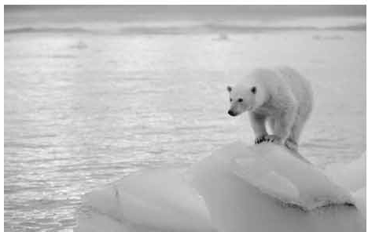

Learnlng outcomes

Aft«wehawstudied this unit, we willbe able to

* demonstra!c understanding11114mmn:narise texts
* ask andanawer queatiOII.I!
* takepart indebat.es ongiventopics
* takepart inroleplay:ingand conversali0:lll
* draft and deliver lecture11on given topics
* write letters to highlighting certain problems
* write slogans fur posters.

###### Lesson 1: The Greed of the Mighty Rivers

1. **Read the following text and answer the questions.**

Meherjan lives in a slum on the Sirajgonj Town Protection Embankment. The whispering wind from the river Jamuna makes the fire unsteady. The dancing flames remind Meherjan of the turmoil in her life.

Not long ago Meherjan had everything- a family, arable land and cattle. The erosion of the Jamuna gradually consumed all her land property. It finally claimed her only

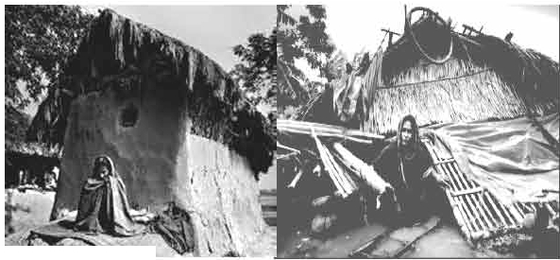

!o,UJt. -

shelter during the last monsoon. It took the river only a day to devour Meher's house, trees, vegetable garden and the bamboo bush. She had a happy family once. Over the years, she lost her husband and her family to diseases that cruel hunger and poverty brought to the family. Now, she is the only one left to live on with the loss and the pain. The greedy Jamuna has shattered her dreams and happiness.

There are thousand others waiting to share the same fate like Meherjan. Bangladesh is a land of rivers, some of whose banks overflow or erode during monsoon. Erosion is a harsh reality for the people living along the river banks. During each monsoon many more villages are threatened by the mighty rivers like the Jamuna, the Padma and the Meghna. It is estimated that river erosion makes at least 100,000 people homeless every year in Bangladesh. In fact, river erosion is one of the main dangers caused by climate change. If we can't take prompt actions to adapt to climate change, there will be thousands of more Meherjans in our towns and villages every year.

1. **For each phrase below choose the meaning that is closest to the meaning used in the text above.**
   1. In paragraph 3 'mighty rivers' mean
      1. rivers that have huge volumes of water and very strong currents
      2. rivers having many rowing boats in them
      3. rivers that make people cry out
      4. rivers that have strong banks
   2. landed property
      1. a rented piece of land
      2. a piece of land on the bank of a river
      3. property in the form of a source of income to its owner
      4. property used only as an agricultural farm
   3. whispering wind
      1. wind that blows from across the river
      2. wind that blows with a hissing sound
      3. wind that helps someone make a fire
      4. wind that blows in summer
   4. dancing flames
      1. a traditional form of folk dance
      2. flames that make people dance around them
      3. flames that are made unstable by the blast of air

d flames made by people to remember their past

1. **Ask and answer the following questions in pairs.**
2. What does Meherjan use to make fire for cooking her meals?
3. What property did Meherjan lose due to river erosion?
4. What do you know about Meherjan's family?
5. In which season is river erosion most likely to occur?
6. Why is the phrase 'greedy Jamuna' used to describe the river?

What greed do you notice in the description?

1. **Complete the summary ofMeherjan's life with words/phrases from the box.**

Meherjan is a typical (1) ..................... woman who lives m a slum. She

lost her shelter and properties (2) ..................... the erosion of the river Jamuna. She also lost her family. Her husband had died of diseases caused by poverty and (3) .................. Now, she is only a (4) .............. Like Meherjan there are many people who have become the (5) ............ of river erosion. River erosion is still posing (6) to the lives

and properties of thousands of people. People living (7) the

rivers are the most likely victims of river erosion. Each year about

(8) ..................... people become homeless due to river erosion in

Bangladesh. Meherjan's life is just one (9) ..................... of how climate

change (10) the lives of thousands of people

victims

threats

affects

example

close to

due to

slum dweller

shortage of food

homeless

one lakh

1. **Debate: Form two groups of 3/4. Decide which group will speak for/against the motion given below** . **In your group, first, discuss and note down five/six points to support/oppose the motion. Then select the speakers from each group to start the debate.**

**Motion:** Humans can't do anything to control the course of nature.

###### Lesson 2: Environmental Pollution

1. **Look at the pictures below and discuss the questions.**
   1. What do you see in each picture?
   2. What are some of the common sources of environmental pollution?
   3. Which of these sources are most threatening for your environment?

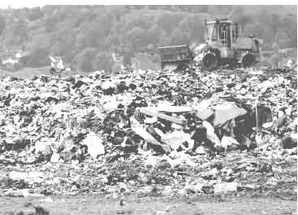

|  |  |  |
| --- | --- | --- |
| . | · | & |

Picture 1 Picture 2

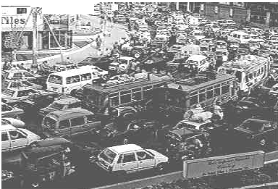

*..,. , :*

,

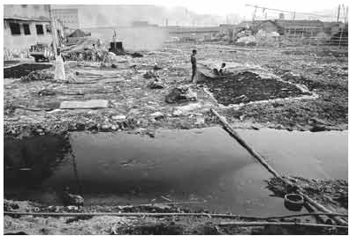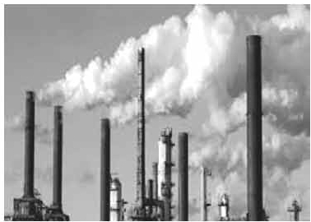

Picture 3 Picture 4

1. **Now read the following passage to know more about environmental pollution in Bangladesh.**

Bangladesh is now in the grip of all sorts of pollution like air pollution, soil pollution and water pollution. The dwellers of the urban areas are the worst sufferers of such pollution. The indiscriminate industrialisation process in Bangladesh over the past decades bas created significant environmental problems. We will now read about some of the most common types of environmental pollutions and ways of coping with them.

**Air Pollution**

Air pollution comes from a wide variety of sources. In Bangladesh poisonous exhausts from industrial plants, brick kilns, old or poorly-serviced vehicles and dust from roads and construction sites are some of the major sources of air *""* pollution.

We can minimise this type of pollution by making less use of motor vehicles and avoiding the use of vehicles older than 20 years. We may also use proper lubricants to lessen the level of emission and pollutants. We can encourage people to use Compressed Natural Gas (CNG) or Liquid Petroleum Gas (LPG) for fuelling their cars. The government may relocate hazardous industries like brick kilns to areas away from human habitations.

**Water Pollution**

Water pollution can occur in oceans, rivers, lakes, ponds and underground reservoirs. As different water sources flow together, the pollution can spread easily and quickly. Causes of water pollution include:

* increased sediment from soil
* eros10n
* improper waste disposal and littering
* leakage of soil pollution into water supplies
* organic materials that decay in water supplies

In fact, polluting the land means polluting the water. Throwing away a toxic substance on the ground near a water source means it eventually reaches the body of water. As a result, the water is polluted. Industrial wastes must not be disposed in rivers or lakes. We need to be more careful about disposing household wastes too. Use of pesticides means that when it rains, chemicals used in the lawn or garden wash into the water bodies. Therefore, we must be aware of the dangers of using pesticides as they may pollute our rivers, canals and lakes.

**Soil Pollution**

Among the most significant causes of soil pollution is the enormous volume of industrial waste which is being produced every day but not disposed properly. The mismanagement of household wastes, particularly the polythene shopping bags, has caused serious threat to the soil and the drainage system. Another cause for soil pollution is the use of agricultural pesticides, fertilizers, etc. Sometimes fuel leakages from automobiles may get washed away by rain and seep into the nearby soil.

Pesticides and fertilizers are useful for plant growth but their overuse has led to ""'I soil pollution. Natural fertilizers and compost can be used instead of their chemical alternatives. Recycling is another way to reduce and control soil

pollution. Recycling papers, plastics and other materials reduces the volume of refuse in landfills. De-forestation also causes erosion, pollution and the loss of fertility in the topsoil. Planting trees and re-forestation help prevent soil erosion and pollution.

1. **From your reading of the above text complete each blank space in the table with no more than two words and/or numbers.**

|  |  |  |
| --- | --- | --- |
| **Pollution** | **Causes** | **Suggestions** |
| Air pollution | * Toxic smokes from   . plants   * Vehicles which are old and poorly ............ * Smoke from the   . fields | * Don't drive motorcars which are older than   . years.   * Use car lubricants of good   quality to keep the  ............. level minimum.   * Use CNG or LP gas as car   .................. |
| Soil pollution | * Industrial wastes not   . properly.   * Use of ...............   shopping bags   * Use of agricultural pesticides and   ................. | * Use compost for agricultural purpose. * paper,   plastics, and other  materials.   * Plant more trees to help prevent loss of fertility in   **the .....................** |

1. **In groups of four, prepare a summary in 100 words of the topic below. First, work together to prepare a draft. When the draft is complete, select a group member to read** it **to the class.**

**Topic:** Polluting the land means polluting the water

1. Look at the three posters below. What messages do they give? Which

one do you like the most? Tell your friend whyyou like it.

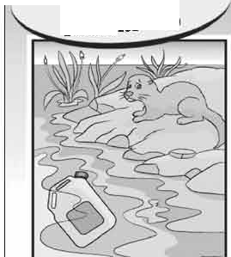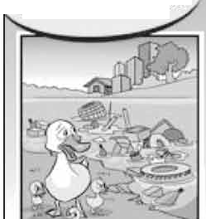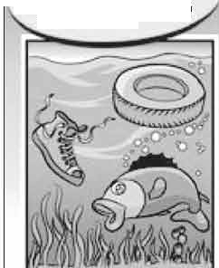

**yOUl\OWNHOMS,DOYOU1**

**WJ{Y'll\ASH MOOi1**

**FAMILY sWJMMING**

**TRASH** IN **MY**

**pLA.YGROUND**

###### Lesson 3: Man and Climate

1. **Discuss the questions in pairs.**
   1. Can man influence the climate? If the answer is yes, explain how?
   2. Which human activities are responsible for increasing carbon dioxide in the atmosphere?
   3. How can trees help save our environment?

**Now read the text below and find answers to the above questions.**

Humans can neither change the sun's radiation nor the earth's orbit around the sun. But they can control the increase in the amount of greenhouse gases and its effect on the atmosphere. Only during the last hundred years the carbon dioxide concentration has been raised alarmingly in the atmosphere and we humans can be held responsible for this.

The main cause of the increase in carbon dioxide level in the atmosphere is the burning of fossil fuels. Since the end of the 19th century, industrial activities increased rapidly giving rise tomany factories. These factories required energyt which was produced through the combustion of coal. Besides coal, other sources of energy such as mineral oil and natural gas were also burned to heat our houses, run cars and airplanes or to produce electricity. Nowadays, about 85 million barrels of crude oil are burned daily. Every time a fossil raw material is burned, it releases carbon dioxide into the air.

Forma-9, English For Today-9-10

Therefore, it is clear that more and more greenhouse gases like carbon dioxide are being generated worldwide by humans. Moreover, we are also strengthening the greenhouse effect by deforestation, which means cutting down trees. Every year enormous areas of forests are destroyed by people to obtain wood and to clear regions for mining and to create pasture. This loss of the forest causes dual problems. Trees that are burned up release large volumes of carbon dioxide gas into the air. On the other hand, as forests absorb a lot of carbon dioxide from the air and deliver oxygen instead, we also destroy an important storehouse of carbon dioxide when we clear forests.

1. **Read the statements below and say if they are True/False.** If **false, give the correct information.**
   1. Fossil fuels are burned at an alarming rate due to industrialisation.
   2. Coal is the only fuel used for generating energy.
   3. At present, nearly 85 million barrels of crude oil are used weekly.
   4. Deforestation is caused by nature.
   5. Forests help consume carbon dioxide gases from the air.
2. **Match the meanings in column B and the words/phrases in column A.**

|  |  |
| --- | --- |
| **A** | **B** |
| 1. Sun's radiation 2. Fossil fuels 3. Combustion of coals 4. Crude oil | 1. energy that is transmitted from the sun in the form of rays or waves or particles 2. the process used by plants to convert light energy captured from the sun to chemical energy   **C.** a basic material or substance used m the production or manufacturing of goods  d. non-renewable sources of energy that come from the remains of plants and animals |

|  |  |
| --- | --- |
| 1. Raw materials 2. Deforestation 3. Photosynthesis | 1. intentional destru.ctions or removal of trees and other vegetations for agricultural, commercial, housing or firewood use 2. a naturally occurring, unrefined petroleum product that can be refined to produce usable products such as diesel, gasoline, heating oil, jet fuel, kerosene, etc. 3. burning of coal usually in industrial plants. |

1. **Write a letter to the Editor of a newspaper expressing your concern about growing deforestation in your area. Describe how deforestation is changing your environment. Also suggest what actions could be taken to stop cutting down trees. Follow the clues below.**

* dangers caused by deforestation
* increase of carbon dioxide in the atmosphere
* the greenhouse effect
* making people aware of the adverse effect of deforestation
* making an actionplan to stop deforestation

1. **Look at these posters below. They are made to make people aware of the dangers of deforestation. In groups, design a poster to show the dangen caused by deforestation. Then** write **a slogan** for **the poster.**

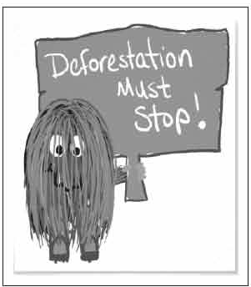

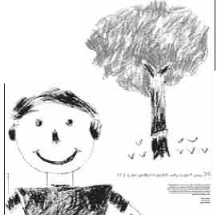

acolour asmile

a life!

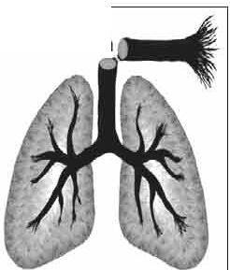

of this too

deforestation

vou're a part

###### Lesson 4: Putting Our Fish in Hot Water!

1.  **Spend one minute thinking about your life as a fish. In pairs, talk to another "fish" about your life as a fish.**
2. **Do you agree with the following statements on fish and fishing? Discuss with your partner(s).**
   1. Fish will never disappear. There will always be enough fish to feed the world.
   2. In many ways, people are like fish.
   3. The hobby of fishing should be banned to help protect fish population.
3. Read the text below and say if the statements that follow are True/

**False.** If **false, give the correct information.**

Fish population is in serious danger from global warming. Climate change is increasing the water temperature in rivers, lakes and seas. This means there is less food and oxygen available for fish. It also means the fish may not grow fully and may have fewer fish fries. Some fishes will become extinct if temperatures rise even by one or two degrees Celsius.

Climate change increases the pressure on fish population. Fishes are one of the world's most valuable biological assets. Forty percent of people in the world eat fish as their main source of protein. If we fail to reduce greenhouse gas emissions, we will increase the pressure on fish. As a result, people who depend on fish will suffer from hunger and poverty.

**Statements:**

1. Global warming will kill all the fishes within ten years.
2. Some fishes can not reproduce if the water is too warm.
3. A two degree Celsius rise in temperature will make some species extinct.
4. Fishes are valuable economic investments.
5. Nearly 14% of people depend on fish for their basic food needs.
6. People will suffer a lot if greater pressure is put on fish.
7. **Role play: Student A** is **a fish. Student B is a fisherman. First write a dialogue between the two. Then act** it **out. Change roles and repeat the**

**role-play**

••••••••••••••••••••••••••••••••••••••••••••••••••••••••••••••••-•

•

**:**-**Role A-A FISH** •

: I am a fish. I know things are getting serious. You are throwing wastes :-

• •

: into water. Moreover, world temperature is rising. Rivers are :

• •

-

: drying up and millions of my cousins have disappeared because of·

: over-fishing. I heard it is because of humans' carelessness and greed.

•

: Let the humans know what is really happening in the oceans and rivers.

•

-**R**-**o**·**l**·**e**·**B**···**-**·**A**···**F**·**I**·**S**·**H**··**E**·**R**··**M**··**A**·**N**········································

I am not worried about my future. I have seen no change in the number of fish I catch each year. There will always be plenty of fish. The oceans are too big to be changed by global warming. I think that

scientists produce reports just to become famous.

•••••••••••••••••••••••••••••••••••••••••••••••••••••••••••••••••

1. **You are a nature lover. Write a letter to the organb:ers of the National Climate Change Conference** in **Bangladesh. Tell them about how global warming** is **changing your environment. Also suggest what they can do to help save fish population.**

**Lesson 5: A** Friend **of the Earth**

1. **Discuss the questions** in pairs.



* 1. Do you throw away empty cans and bottles?
  2. What do you do with your old newspapers?
  3. What happens to the garbage after you throw it

away?

1. **Read the following text carefully to know about how we can save our environment.**

**LET'S SAVE OUR PLANET!**

Everyone must play a part in protecting the environment. There are many things you can do on your own every day to help save the planet. Here are some suggestions.

**REDUCE!**

Really, the best thing we can do for the planet is to use its resources properly. Our unplanned activities are mainly responsible for the environmental crisis. Here are some questions you can ask yourself before buying something, "Do I really need this?" or "Is there another product which would do the same thing but is more sustainable?" Or ask the question, "Will this last a long time?" Some other questions may be, "Do I know how this item was made, how it will be used and how it will be disposed of?"

**REUSE!**

What do you think of using your own ceramic cup or mug at your school or local club? It means there are no plastic cups to throw away. You can wash it and reuse it every day. Unfortunately, we are encouraged to buy a new "improved" item even if the one we have can be repaired or reused. When we buy things, we should buy those that are durable; we should use them properly, and have them repaired when necessary. If we practise this, many things will not only last a life-time, but also be passed on for future use. However, if something is truly unusable for its original purposes, try to be more creative and think of how else it might be used. When you're done with it, think of whether someone else might be able to use it. You can donate some of the things to the poor. You may also sell some of your used items through personal advertisements in a local newspaper or in social media.

**RECYCLE!**

Rather than throwing an item out when neither you nor anyone else can make use of it, have it recycled. And if recycling is not possible, it is better to send goods to a landfill or have them burned up. Find out what types of materials can be recycled in your area. Clean and sort the materials before putting them out in the bin. Recycling your drink and food cans means there will be less trash in a resource recovery facility or landfill. Moreover, a company can use the old cans

8l

to make new ones. l'-l

1. **Now ask and answer these questions in pairs.**
   1. How can you cut down your shopping list?
   2. What can you do to reuse things?
   3. What kind of household goods, clothes and toys, can be donated?
   4. How can you sell your used items?
   5. How recycling may help save our environment?
2. **Complete the blank spaces in the table below.**

|  |  |
| --- | --- |
|  | **What is it Examples** |
| Reduce | To create less wastes, so Using a towel for drying hair that there are fewer items that instead of using an electric hair- must be recycled or dryer.  . away. |
| Reuse | To buy things that can be Using your own ceramic cup at used again and again, or to your school or club means there find out another way of are no ................ cups to  ..............them. throw away. You can it and reuse it  every day. |
| Recycle | Instead of throwing an item Giving/selling used plastic bottles in the garbage, to give it to a to someone to make something person or company who will else from them.  ............... it, or make something else with it. |

1. **To do this exercise, you will need information about recycling in your local community.** If **you don't know, ask your teacher to help you learn what you can recycle from your home. Then choose one item from the box to talk about it following the model below.**

A: What are you going to do with these old magazines? B: I don't know what to do with these.

A: Why don't you reuse/recycle them? B: How can I do that?

A: It's easy. Take them to a shop that buys old newspapers and magazines for recycling.

**Household items**

glass bottles and jars, containers and toys, aluminium foils or trays, aerosol cans, box boards, magazines and catalogues, old CDs

**Unit Six**

### Our Neighbours



**Learning outcomes**

After we have studied this unit, we will be able to

* read, comprehend and summarise texts
* ask and answer questions
* read travel advertisements and talk about them
* select and write headings
* write letters to friends describing places of interest.

Fonna-10, English ForToday-9-10

##### Lesson 1: Nepal, The Land of Everest

1. **Read the following passage on Nepal.**
   1. 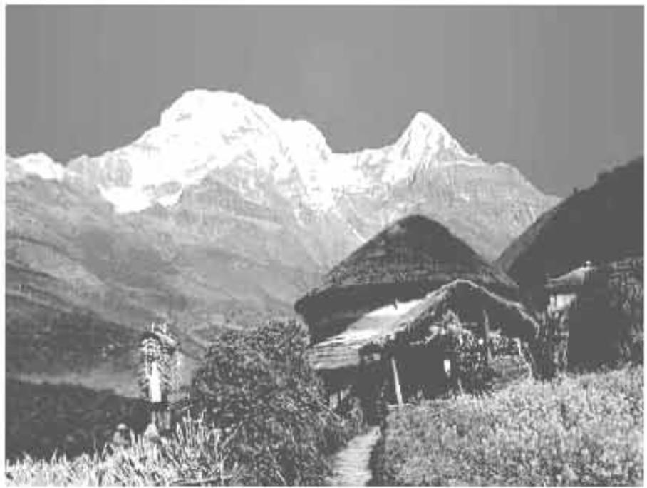Known as the Land of Everest, Nepal is one of the most charming coun1ries in Asia. The Kingdom of Nepal is a small land of sublime beauty. It has some of the world's best and very important temples. It is a country that is rich in scenic beauty and cultural heritage.
   2. Nepal lies between India and the Tibetan part of China. This small country has an area of 147,181 square kilometers. Southern Nepal is tropical low land known as the *Terai Plains.* This part of Nepal has hot summers and warm winters. Here the temperatures reach up to 40°C in April and May and monsoon rains drench this region from June to September. The central

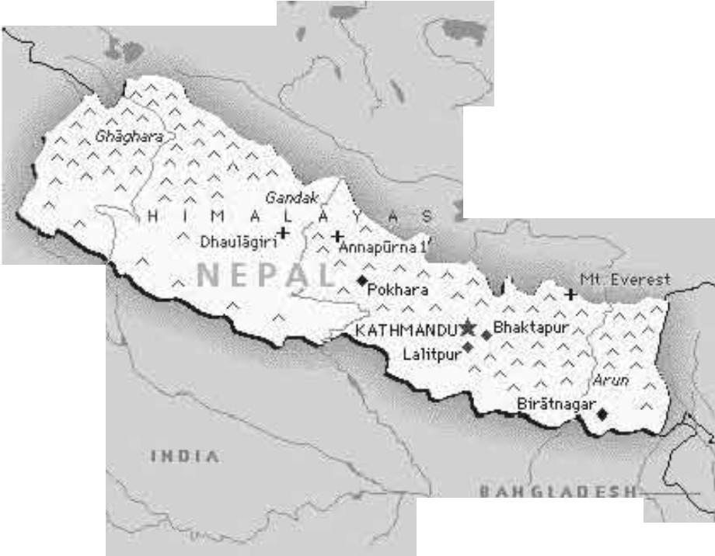

..

**f**

) CHINA

-----------

*\.,; '*

'n

hill-lands including the Kathmandu and Pokhara valleys have a temperate climate and are also influenced by the monsoon. North of that is the slope of the main section of the Himalayan range. This part of Nepal has some of the highest peaks of the world including Everest.

*;7"*

* 1. Nepal is home to nearly 29,000,000 people. The population is primarily rural.Kathmandu, the capital city, has less than one million inhabitants. Nepal's demographic features are complicated not only by dozens of ethnic groups, but by different castes. In total, there are 103 castes and ethnic groups living in this small country. The two largest of such groups are known as *Chetri and Bahun.* Others include *Magar, Tharu and Tamang, Newar, Muslim, Gurung and Damai.* About 48 percent of the people speak Nepali. Among other languages spoken are *Maithali, Bhojpuri, Tharu and Tamang.*
  2. Nepal is the holy land of Lord Pashupatinath and Gautam Buddha where the Hindus and Buddhists have lived together in harmony for centuries. The Temple of Pashupatinath is the most sacred Hindu shrine and one of the four most important sites in the world for Shiva worshippers. Lord Buddha, the light of Asia, was born in Lumbini in Nepal's southern plains, which makes this a sacred pilgrimage destination for the Buddhists as well. In fact, many Nepalese combine Hindu and Buddhist practices; many temples and shrines are shared between the two faiths, and some deities are worshipped by both Hindus and Buddhists.
  3. The Kathmandu Valley is the richest cultural heritage centre of Nepal. The three ancient cities of the Valley - Patan, Kathmandu and Bhaktapur - represent an epitome of harmony in urban design, elegant architecture and refined culture. These cities are famous for religious monuments unequalled in the world. The seven monument zones situated within the Valley have been named as World Heritage Sites by UNESCO.
  4. Many festivals add dazzling colour to Nepal's vibrant culture, which are celebrated throughout the year. *Dasain or dusherra* is celebrated nationwide in October. This is the most important of all Nepalese celebrations and includes the biggest animal sacrifice of the year. *Tihar* is celebrated in November. Other festivals include the Holi and Chaitra Daisan. Some Hindu festivals are the *Haribodhini Ekadashi, Maha Sivaratri and the Krishna Jayanti.* There are Buddhist celebrations too and those include *Mani Rimd, Buddha Jayanti and Losar,* which marks the Tibetan New Year.

1. **The passage has six paragraphs (a-f). Choose the most suitable headings for paragraphs (a-f) from the list of headings below. There are more headings in the box than the paragraphs, so you will not use**

**all of them.**

**List of headings**

1. **Climate** that varies from place to place
2. A land of religious coexistence
3. A land of high peaks and Everest
4. A small country with a huge population
5. A blend of natural beauty and cultural heritage
6. The temples of Nepal
7. Many occasions to celebrate
8. A rich spot of cultural heritage
9. A small population with huge diversity
10. **For each phrase below choose the meaning that is closest to the meaning used in the passage.**
11. tropical lowland
    1. an area of land having humid climate
    2. a land situated on the hill
    3. a low land close to river
    4. a land that lies at the foot of a hill
12. temperate climate
    1. a weather condition of high temperature
    2. a moderate climate
    3. a climate with high rainfall
    4. a climate that is uncomfortable to live in
13. ethnic groups
    1. groups based on their religious faiths
    2. groups of people living in the hills-tracts
    3. groups having distinct racial and cultural features
    4. groups who believe in Buddhism
14. pilgrimage destination
    1. a sacred place where people travel to perform religious rites.
    2. a historical place with many old buildings.
    3. a tourist spot of great scenic beauty.
    4. the birthplace of a famous person.
15. elegant architecture
    1. temples of gods
    2. graceful work of building crafts
    3. buildings of historical importance
    4. well-designed area of cultural acts
16. **Answer the following questions.**
17. How many ethnic groups are there in Nepal?
18. What do you know about the weather of Nepal?
19. "Many Nepalese combine Hindu and Buddhist practices."- Explain this statement with examples from the passage.
20. Which three cities of Nepal will you visit in order to see the rich samples of Nepal's cultural heritage sites?
21. Make a list of the festivals that are celebrated in Nepal.
22. Give at least three reasons why you might be interested to visit Nepal. Also make a list of the places you would love to visit in Nepal.
23. **Look at the advertisement of a package tour to Nepal**

**Dhaka-Kathmandu-Pokhara Package Tour**

**Price:** BDT 39,999/

**Duration:** 4 nights and 5 days

**Package includes:**

* Return air ticket with Bangladesh airport taxes & Kathmandu departure taxes
* 2 nights' accommodation in Kathmandu
* 2 nights' accommodation in Pokhara
* Buffet: Daily Breakfast and Dinner
* Both way airport transfers in Kathmandu
* Kathmandu-Pokhara-Kathmandu by AC bus
* Half day sightseeing in Kathmandu Valley

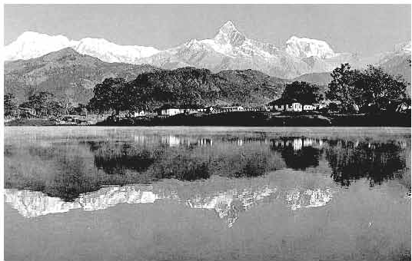

**Now, discuss** If **the following statements are True/False. Give the correct**

**Information** if **a statement** is **false.**

* 1. The package includes the cost of travelling from K.Bthma.ndu airport to the hotel in Ka1hmandu.
  2. The tourists will be provided with breakfast, lunch anddinner.
  3. The tourists do not have topay extra for a half-day sightseeing in Pokbara.
  4. The tour operators will bear all visa related costs.
  5. The tourists will goto Pokhara from Kathmandu by domestic airlines flights.

1. **Imagine that you have chosen the package tour shown** In E **to visit** Kathmandu and Pokhara. Now, write a letter to your friend highlighting the main attractions offered by the package. In your letter you should cover the following points:

* Duration of travel
* Means of transport used:
  1. Dhaka-Kathmandu-Dhaka
  2. Kathmandu-Pokhara-Kathmandu
* Accommodation facilities
* Breakfast, lunch and dinner
* Total cost of the package
* Any other cost that is not covered by the package offer

###### Lesson 2: Sri Lanka: The Pearl of the Indian Ocean

1. **Look at the picture. Ask and answer the following questions in pair.**
   1. What is the name of the country?
   2. What is the country surrounded by?
   3. What do you know about the country?
2. **Now read the following passage to find your answers to the questions in A.**

a Anyone visiting Sri Lanka may often hear the word *Ayubowan.* This word means 'May you have the gift of long life'. It is with this traditional greeting that everyone is welcomed to Sri Lanka. Sri Lanka is variously known as: Serendip, Ceylon, Teardrop of India, Pearl of the Indian Ocean, etc. These names reveal the richness and beauty of this island nation. Many travellers, from ancient mariners and merchants to present day tourists, have been attracted by the beauty of this island.

1. 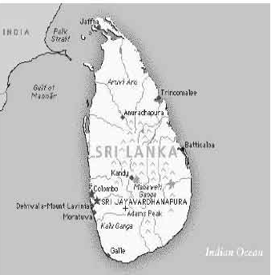Sri Lanka is located in the Indian Oc just off the south-eastern coast of India. Shaped like a teardrop, the island of Sri Lanka measures about 415 kilometers from north to south, and about

220 kilometers from east to west, with a total land area of about 65,600 square kilometers. It has more than 1340 kilometers of coastline.

1. Despite its modest size Sri Lanka has a population of about *20* million. Sri Lanka is a multi- religious, multi-racial and multi- lingual countty. The four major ethnic groups are the Sinhalese, Sri Lankan Tamils, Indian Tamils and Sri Lankan Moors or Muslims. A fifth group, the Veddhas are the original inhabitants of the island. The ancient history of Sri Lanka is depicted in the Hindu epic the *Ramayana* and in the

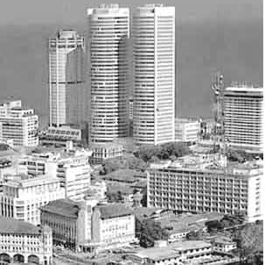

----------

'.

Mahavamsa or 'The Great Chronicle'. Colombo: The capital city

1. Sri Lanka's economy has traditionally been based on agriculture. The emphasis is on exporting crops such as tea, rubber, and coconuts. In fact, Sri Lanka is the largest tea exporter of the world. The country is also a major producer and supplier of a variety of spices such as cinnamon, cardamom, pepper, cloves, and nutmeg. Cinnamon first originated in Sri Lanka and was introduced later to the world by the Arab merchants.
2. Sri Lanka's archaeological treasures may be compared to other civilizations of the past like the Golden Age of Greece, the Roman Empire and Mayan

citadels. The culture has been influenced by the western colonisers and eastern traders. That resulted in developing a unique mix of races and religions, arts and crafts, festivals and costumes in this small country.

Besides the man-made riches, one may find the God-given blessings of nature in Sri Lanka. The island is circled by azure seas and is blessed with sandy beaches, green hills, cascading waterfalls, abundant wildlife and a variety of flowers and fruits. The country abounds with coconut groves, spice gardens, tea estates and many other gardens and woods. Travellers from all over the world come to Sri Lanka. Here, a weary traveller can pass a relaxing day by a palm-shaded lagoon looking at the endless ocean. And for the adventurous, days can be full of excitement snorkelling, swimming, fishing or sailing.

1. **From your reading of the above text complete the table with no more than two words and/or numbers.**

**Sri Lanka: Facts**

|  |  |  |
| --- | --- | --- |
| **People** | **Economy** | **Natural beauty** |
| There are , | Agriculture is a | Sri Lanka is blessed with |
| four main ethnic | traditional form of | awesome natural beauty. |
| groups. They are | economic activity in | There are blue seas, sandy |
| Sinhalese, Sri Lankan | Sri Lanka. The | beaches, green hills, and |
| Tamils, ................ | country exports many | flowing ................ |
| and Sri Lankan Moors | crops and ............... | The country has a very |
| who are also known as | Sri Lanka tops the | rich wild life. A wide |
| . The | world in tea export. | variety of fruits and |
| earliest residents of Sri | The spice | . are also |
| Lanka are known as  .................... | . was  found first in Sri | available there. Traveller  can enjoy the ............... |
|  | Lanka. | view sitting by the palm |
|  |  | shaded lagoons. |

Forma-11, English For Today-9-10

1. **The passage** in **B has six paragraphs (a-f). Choose the most suitable headings for paragraphs (a-f) from the list of headinwa below. There are more headinWJ** in **the box than the paragraphs, so you will not use all of them.**

**List of headings**

1. A beautiful island with natural richness
2. Teardrop of India
3. Geographical features
4. A rich multicultural setting
5. Some religious groups of Sri Lanka
6. A traditional economy
7. The land of cinnamon
8. A melting pot of the past civilizations
9. Tourist attractions and leisure activities
10. A country with beautiful beaches
11. **Read the brief descriptions of some of the best tourist places in Sri**

**Lanka. Then discuss the questions that follow.**

**Anuradhapura**

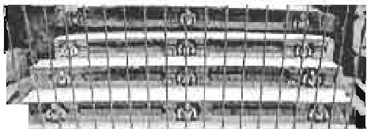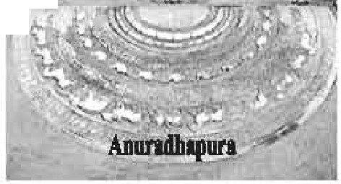

**l**11**t**.\**'T->-: ,,;:wil**

,

Anuradhapura is one of the ancient capitals of Sri Lanka. The old city is today surrounded by monasteries, covering an area of over sixteen square miles. The city is also significant in Hindu legend as the capital of King Ravana.

**Bundala Nati.onal Park**

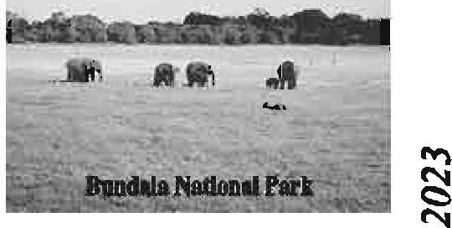Bundala National Park is one of Sri Lanka's leading destinations for birdwatchers. The park is also home to large populations of elephants, crocodiles, turtles and leopards.

Our Neigbbours 33

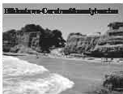**Blldwtawa-Coral** red & **sandy beacllefl**

Hikkaduwa is a little town on the south C08Bt of Sri Lanka It is well-known for its beach and corals. It is principally a tourist destination, and serves as a great beach with options to snorkel and enjoy the sun.

**Damlndla**

Major atiJ11ctions of this city include the biggeat and greatest potted cave temple complex of Sri Lanka. It is also famous for the R.angiri Dambulla Global Stadium, which was built in just 167 days.The city also boasts of the biggest rose quartz mountain :range in South Asia and the iron wood fon:st

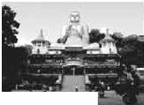

**i..;:::..!IIIJll!I...**

**NowdiacWll the following questions** in **pain.**

* 1. Whichof the following tourist placesdo you liketo visit?
     + Places with beaches
     + Places of historical importance
     + Places that preserve wil.dlire

Explain whyyou like such a place.

....

* 1. lfyou an: givenanoff'crto visit any two of the four Sriurolran cities above, which two cities will youchoose. Explain why.

1. **Write a paragraph on some of theinten!l1ing places to "Yhit** In **Sri Lanka. Use your own words and the information &fven** in **,ection E.**

Lesson 3: The Maldives

1. **Disc11.11 Ule que.stiont** in pain.
   1. Have you ever visitedany island or seenanyisland on TV?
   2. Have you everhcaniofa coral island? Isthereanycmal islandin Bangladesh?
   3. What do youknow about the Maldives?
2. **Now read the text below and answer the questions in C, D and E.**

The Republic of Maldives is an island country in the Indian Ocean. It has 1199 islands that are clustered into 26 major atolls. An atoll is a ring-shaped coral reef or a string of closely spaced coral islands. The natural coral reefs of the Maldives are surrounded by the sea all around and stand out as a pearl in the Indian Ocean. The Maldives is the eighth smallest country in the world with an area of only 300 square kilometers . It is the smallest Asian country in terms of population and size.

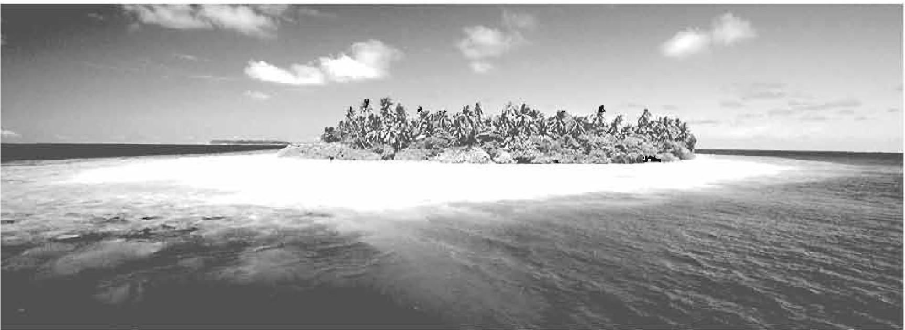

People have been living on the islands of the Maldives for nearly 3000 years. They set sail from different parts of the world - Asia, Arabia, Europe and America - to come to these islands. The earliest settlers of the Maldives were probably from southern India and Sri Lanka who came to these islands in the fourth and fifth centuries BC. In the 12th century AD, sailors from East Africa and Arab countries came to the Maldives. *AB* a result, the Maldivians who were originally Buddhists were converted to Sunni Islam in the mid-12th century. In 1344 lbn Batuta, a famous Arab historian and scholar travelled around the Maldives.

In the 16th century, the Portuguese conquered the Maldives and ruled the country for 15 years. Although governed as an independent Islamic sultanate for most of its history from 1153 to 1968, the Maldives was a British colony from 1887 to 1965. Following independence from Britain in 1965, the sultanate continued to operate for another 3 years. On November 11, 1968, the sultanate was abolished and replaced by a republic and the country assumed its present name.

The Maldives is famous as a tourist destination because of its pleasant weather, heavenly beaches and lagoons, luxurious holiday resorts and the peace-loving ,.,., people. The Maldives was ranked as the best country for beautiful beaches and

facilities for recreation in 2008.

The Maldives is well known for being the lowest country in the world. Unfortunately, this small country with idyllic natural beauty is under threat from rising sea levels due to global wanning. Most of the country is just 1.5 meters above sea level with the highest point of2.3 meters! Many predictions have been made with respect to Maldives being swept away by the rising water level in the Indian Ocean. when the power tsunami of 2004 hit the island nation, many of the island's dry parts were flooded by the sea water. The government of the Maldives has begun to purchase land from nearby countries for resettling

its people in case the islands go under water! In order to highlight the threats of global warming to its low lying

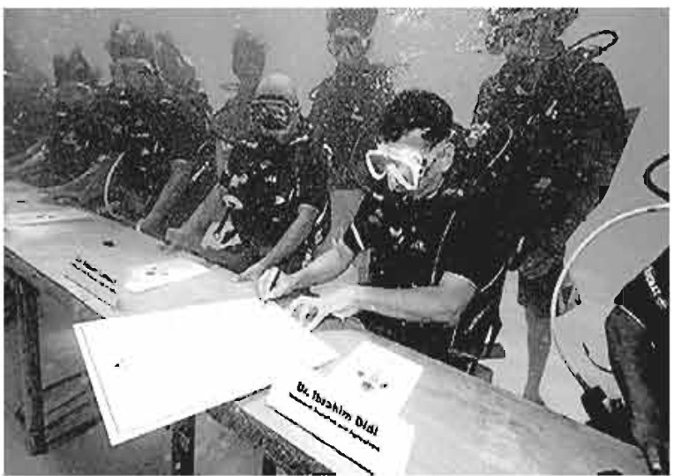

-

islands, the government of Maldives held a cabinet meeting undeiwater in 2009.

That was the first ever underwater cabinet meeting in the world. The meeting took place about *5* meters underwater, in a blue-

green lagoon on a small island. While undeiwater, the cabinet signed a document

calling on all nations to cut their carbon **Underwater meeting**

emissions.

1. **Ask and answer the questions.**
   1. What is an atoll?
   2. How many countries in the world are smaller than the Maldives in ·size?
   3. When was Islam introduced in the Maldives?
   4. What makes the Maldives an ideal place for the tourists?
   5. What dangers of climate change might affect the Maldives?
   6. Do you support the idea of having a cabinet meeting underwater? What could be the reason for holding such a strange meeting?
2. **Complete the table with no more than two words and/or numbers.**

|  |  |
| --- | --- |
| Time | Facts |
| 4th and 5th centuries  BC | The early inhabitants of the Maldives arrived and  settled from Southern India and Sri Lanka. |
| 12th Century | The sailors from African and Arab countries started to settle in the islands. Buddhism was  . by Islam. |
| ------------------ | A famous scholar and historian named Ibn Batuta  visited the islands of the Maldives. |
| 16th century | the Portuguese occupied the Maldives and became  the of the country for 15 years |
| 1887 | Beginning of the British era. |
|  | Maldives became independent from the British rule. |
| 1968 | End of Islamic sultanate and ..........................  of the Republic of Maldives. |

1. **Say if the statements are True/False. Give the correct information in case of a false statement.**
   1. Only seven countries in the world are smaller in stze than the Maldives.
   2. No other South Asian century has a population smaller than the Maldives.
   3. The islands of the Maldives were inhabited in the 12th century.
   4. The Maldives was an independent Islamic sultanate from 1153 to 1968.
   5. The Maldives was ranked as the second best country for natural ""l

beauty in 2008.

###### Lesson 4: India: Unity in Diversity

**A Read the following text and complete the activities** in **section C and D.**

India is our closest neighbour. It is the largest ,..-..- among South Asian Countries. In fact, India is

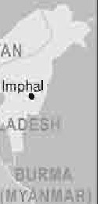

Ml,IWAIIO

"••t/J

* S:1r.agar

the seventh largest country in the world with an area of 3,287,590 square kilometers. India is bounded by the Indian Ocean on the South, the Arabian Sea on the West and the Bay of Bengal on the East. It is bordered by Pakistan

to the West; China, Nepal, and Bhutan to the North; and Bangladesh and Myanmar to the East. India is the world's second most

* Amritsar

NEW DELHI

0

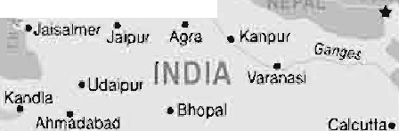

lAJoUIT•! •,'1-

. ,.,. •Nagpu,

Alll,81>,Jj •'tumb;J.1

'"

Hy abad *V"f'"""''nam*

p,v, jl

Ma,ma.g¥t. 10.1.



Calicut. *·1,1* • l • •Poodic!'lerry

Cochin ll<och1)• M-acturai

Trivar,drum!ll/ll,I, *l,JfnfU*

Kovalam L NK '°'

populous country after China. Its population is around 1.5 billion. New Delhi is the capital of India and about 13 million people live in the city.

India is a land of ancient civilization. The social, economic and cultural diversity of this vast country is the result of invasions by different races in the process of history. Indian history begins with the birth of the Indus Valley Civilization and the coming of the Aryans. During this period, Aryan culture flourished in this part of the world. The fifth century saw the unification of India under Ashoka, and it is in his time that Buddhism spread in many parts of Asia. In the eighth century, Islam came to India for the first time and by the eleventh century it had firmly established itself. In 1206, Qutbuddin Aybeck founded the Delhi Sultanate. This was finally succeeded by the Mughal Empire in 1526, under which India once again achieved a large measure of political unity.

It was in the 17th century that the Europeans came to India. This coincided with the disintegration of the Mughal Empire, paving the way for supremacy of the English, the French, the Dutch and the Portuguese who were vying with each other to gain control of India. The English emerged as the 'victors'. In 1774, Warren Hastings was appointed the first Governor General of India by the East India Company. In 1876, Queen Victoria was given the title 'Empress of India' by

""I the British Parliament and India came under the British rule . The British ruled

f"l

India for nearly two hundred years. This period was marked by India's struggle

118 Brlgli.ahForToday

forindependence. Througha seriesof heroic andpatrioticmovements to miton:

freedom, India got its independence in 1947.

Theculture of Indiais oneof theoldest andthe most uniquein theworld. There i11 emszine cultural. diversity throughout the country. The South. North, and Northeast have their own distinct cultures and almost every state hascarved out its own cultural distinction. There is hardly any culture in the world that is as variedand unique as India.There are 17major languages and 844 dialects used by the people of India.

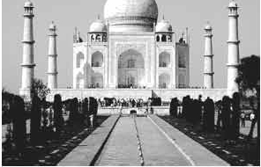

l

India is a *tourists'* delight. The Taj Mahal. Fatehpur Silai, the Qu1b Minar and the Red Fort are a few of **the** many wonders which attract people from all over the world. Kashmir bas been described **as a** paradise on earth. The country of mountains, valleys, deserts, rivers

and lakes offer the richness of a mini

TheTajmahal

world within a single cou:mxy.The Nilgiri moimta:ins, hill stations likeOoty and Darjeeling and the temples of Saudi India, Ajanta and Ellora caves are the placesonecancxplon: inIndia.

1. **Di.lc1USthefollowln1quediou**in patn.
   1. What doyou know about the population and geographical area of India?
   2. When didBuddhism. spread in India?
   3. Whathappened to India during the MugbalEmpire?
   4. What are some of the tourist aUractiODS in India?
2. Complete **the.flow dtart below to show dle history ofIndia. Useone**

word to fillin eachgap.



Indus Valley Civilization and the coming of the Aryans.

[ 8th century: ...................... came to India for the first time. ]

+

1206: Establishment of the Delhi Sultanate by .....................

**i**

**i**

1526: Beginning of the Dynasty

15th Century: the of India under Ashoka

and spread of Buddhism.

*r*

!

1774: Warren Hastings was the first

Governor General of India by the East India Company

"I

\..

*,)*

*r*

!

In 1876 Queen Victoria was given the title,'Empress of India', by

the British ..................

'I

\..

!

I 1947: India achieved its ............................

I

###### Lesson 5: Bhutan: The Land of Happiness

1. **Read the following text and answer the questions.**

Bhutan is called the Jewel of the Eastern Himalayas. This small, landlocked country is located along the southern slopes of the Himalayan range, bounded by Tibet in the North and India from the other sides. The official name of Bhutan is *Druk-yul* which means 'land of the thunder dragon'. It earned this name because of the fierce storms that often roll in from the Himalayas. The country

Forma-12, English For Today-9-10

90 Euglillh'°'Today

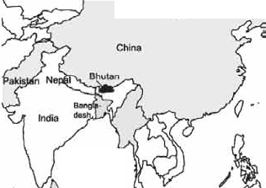

.

,,...,,.,., ,.,

*I*

has an area of 38,394 sqkm anda population of 716,896. Since it is cut off from the rest oftheworldby the Great Rimalayas, a unique culture and tradition based on gentle Buddhist beliefs have evolved there overtime.

Bhutanese men wear Oho- a knee length robe - and women wear Kira-a sheetlike cloth piece.

Bhutanese houses arc built from mud and stone, withwooden shingle root The Bhutanese never useiron nails in their buildings. Usually, the Bhutanese build each other's houses by eYcbanging labour within the community. Different Festivals arecelebrated allyearround in Bhutan.Colourful masksm:eU8edin1he festivals whichreflect the rich Bhutanese culture. Dances are performed by the Buddhist monks to protect the valleys and ward off evil spirits. The main religioua femval is called *1:ihechus.* The teachings of Lord Buddha are enacted through mask dances for three to five days in the courtyard of the monasteries. People attend these eventsin their best clothes, carrying picnicbaskets.Another major festival is called *Losar.* It is celebrated on Lunar New Year. People cook special dishes and wear new clothes. It is a time for family gct-mgetb.er. Men play archery or darts while womensingand dance.

Pure mountain air, crystal blue skies and• irt

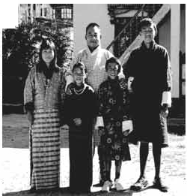

pristine vegetation cover he:ve made this small [t, countly anidealdestination for lheenvironment lovers. The ecosystem of this small nation trupports the exist.ence of ricli. flora and fil1ma which arc protected by strict l.a.ws. Anyone found guilty of kiUing even a black-necked cranecouldbe aentenced1D lifein prison.

The government of Bhutan has taken a. number of steps t.o protect its bio-divcrsity.

..,

A Blm1Bneae1ilmilyin lrllditionalcla1hea

"I

Bhutan is the first country in the world with specific constitutional obligations on its people to protect the environment. According to the constitution, at least 60 percent of the country must remain under forest cover at all times. Efforts are also taken to protect the nation against the intrusion of foreign cultures and values. The first foreign tourists were allowed into Bhutan in 1974. Now, tourism is encouraged but is controlled and limited to about 6,000 visitors a year. Bhutan is one of the last countries in the world to introduce television and the Internet to its people. The government lifted a ban on TV and the Internet only in 1999. The Bhutanese government has made it mandatory for all Bhutanese to wear only their national dress in public.

Finally, the most interesting fact about Bhutan is that they are the only country that measures success in Gross National Happiness rather than Gross National Product! In 2006, ***Business Week*** rated Bhutan as the happiest country in Asia and the eighth happiest country in the world.

1. **Choose the most suitable answer for each of the questions below.**
   1. A unique culture and tradition has evolved in Bhutan because
      1. fierce Himalayan storms often hit the country.
      2. it is cut off from the other parts of the world.
      3. it has a very small area.
      4. it is called the Jewel of the Eastern Himalayas.
   2. Bhutanese houses are built from
      1. mud, stone, woods with iron nails.
      2. a sheet of cloth and wooden roof.
      3. mud and stone with wooden roof.
      4. bamboo and wood.
   3. Which of the following activities is mentioned as a way of celebrating

*Losar.*

8l

!'.l

1. cooking special dishes and wearing new clothes
2. playing chess and badminton

**C** having a trip to the neighbouring households d harvesting crops

* 1. According to Bhutan's constitutional obligations
     1. 60% of the country must remain under forest cover.
     2. foreign nationals are not allowed to visit Bhutan even now.
     3. citizens can not use the Internet in their houses.
     4. people must always wear traditional Bhutanese clothes.
  2. The progress of Bhutan as a nation is measured by
     1. Gross National Income.
     2. Gross National Happiness.
     3. Gross National Product.
     4. Per Capita Income.

1. **Group work- You read about some countries. Which one do you like.**

**Make a chart adding more information to it.**

Unit Seven

People Who Stand Out

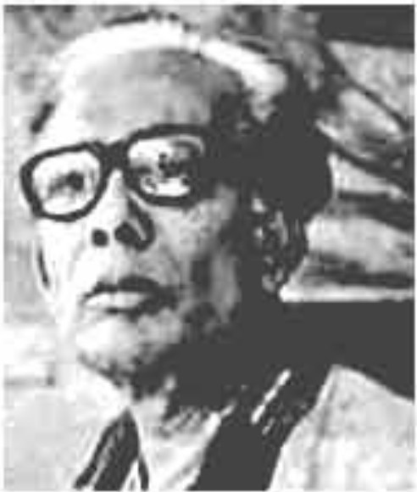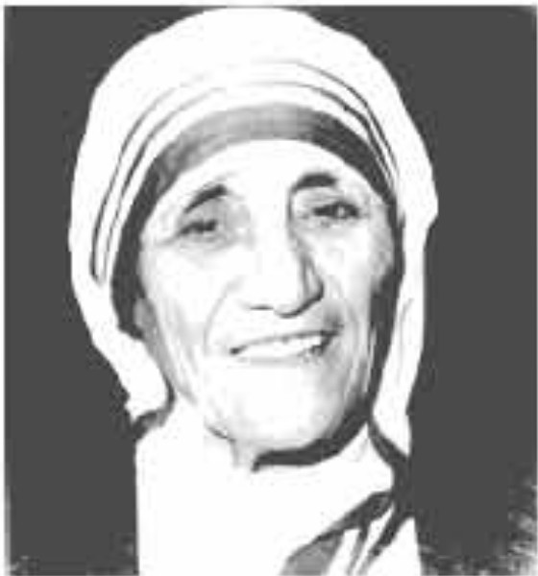

**Leaming ou.teome**■

After we have studied this unit, we will be able to

* read and demonstrate the understanding 1mtB 1hrough silent reading
* ask and answer questions
* listen to an audio text for specific information
* write & dialogue.

**Lesson 1: Zainul Abedin, The Great Artist**

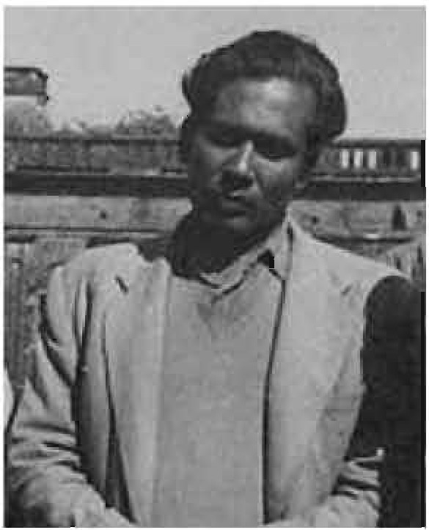

29 December 1914

**Born** Kishoregonj, East Bengal, British India (now Bangladesh)

**Died** 28 May 1976 (aged 61)

Dhaka, Bangladesh

**Nationality** Bangladeshi

**Education** Government Art School, Kolkata Art School, London

**Known for** Painting, drawing

*The Struggle*

**Notable** *Rebel cow*

**work** *Famine paintings Nobanno*

*Study of* a *Crow*

*Two* faces

Zainul Abedin in 1955

* 1. **Work in pairs and discuss the following questions.**
     1. Do you know this person? Why is he famous?
     2. Can you name some of his world famous sketches?
  2. **Now read the text below and answer the following questions:**

ZainulAbedin (29 December, 1914 - 28 May, 1976) was a Bangladeshi painter. He had an extraordinary talent and was internationally recognized for his paintings. He became well known in 1944 through his series of paintings on the great man-made famine in Bengal during British Colonial rule.

He played a vital role in the art movement in Bangladesh and was the founding Principal of the Government Institute of Arts (Now Faculty of Fine Arts) at University of Dhaka. His paintings on Bengal Famine are considered as his most characteristic works. His homeland honoured him with the title 'Shilpacharya', or the great teacher of arts for his artistic and visionary qualities. He was a pioneer of the modem art movement and was rightly considered as the founding father of Bangladeshi modem arts.

Abedin was born in Kishoregonj on 29 December, 1914. He spent most of his childhood near the scenic banks of the Brahmaputra River. The river and the open nature inspired him from his early life. The Brahmaputra later appeared in many of his paintings and remained a great source of inspiration throughout his r-ri career. As his tribute to the river Brahmaputra, he drew a series of water colour f"-1

paintings in 1hill regard. Thia helped him eam Governor's Gold Medal in all India Bxln"bition in 1938.This was die first time when he came under spotlight and this award gave Abedin the confidence to create his own visual style.

Abedin got admitted to the Government School of Art in Calcuna (Now Government College of Art and Craft, KolbJa, India). Here he learned European academic style for five years.Later he joined1he faculty of the same school after his gt'8d11ation. He was the first Muslim student to obtain 'First Cius• withdietinction fromthe school.In 1951, Zainul wentto London to study at Slade School of Art for two years. From the dissatisfaction of oriental style and the limitations of European academic style, he was attracted to realism. After hisreturnfromLondon, hestmted a **new** stylecalled 'Bengali Style'.Later herealized the limitations of'Bcngali Style•.Therefore, he went back to rurture, rural life and the daily struggles of men to make art that would be realistic but modem in appearance.

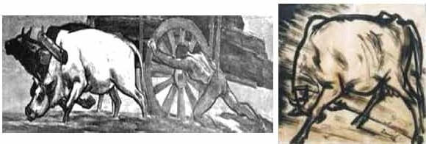

Struggle Rebel cow

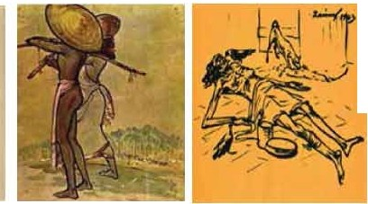

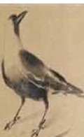

Rebel crow Labourercouple Famine sketch

In 1943, he painted a series of sketches on the man-made famine, which had spread throughout Bengal.The famine killed thousands of people.The devastating famine touched his heart.He used Chinese ink and brush and drew sketches of the devastations of the famine on cheap packing paper. The series of those sketches are known as 'Famine Sketches'. Through those sketches, he drew the helplessness and deprivation of the poor people, their miseries and death without having food. He painted those starving people who were dying by the roadside. These sketches are his most remarkable works, which spread his name and fame around the world as a famous and humanitarian artist. Abedin not only documented the famine but also showed its sinister face through skeletal figures of people fated to die of starvation. He depicted the inhuman story with very human emotions. These drawings became iconic images of human sufferings. These sketches helped him to find his way into a realistic approach that focused on human sufferings, struggle and protest. Through a 65 feet scroll, he depicted the mass movement of 1969 and with a 30 feet scroll painting called 'Monpura'; he showed the devastating cyclone of 1970 and the sufferings of the people. Through the later sketch, he remembered the people who died in that calamity.

In 1975, Zainul Abedin set up a folk museum at Sonargaon and a gallery in Mymensingh named Shilpacharya Zainul Abedin Museum. He became actively involved in a movement to preserve the heritage of Bengal and reintroduce Bengal art from the roots of Bengali culture. He passed away on 28 May, 1976 in Dhaka.

*Sources: Banglapedia and wikipedia*

C.

* + 1. How did Zainul Abedin become famous?
    2. What were the themes of his famous sketches?
    3. Give information regarding his education.
    4. How did river Brahmaputra influence his sketches?
    5. After the failure of 'Bengali style', which style did he adopt for his sketches? Why?
    6. Why is he called humanitarian artist?

1. **Why did he establish the 'Folk Museum at Sonargaon' and 'Shil pacharya Zainul Abedin Museum' at Mymensingh'?**
2. **Look at the pictures in the text. Work** in **group and talk about them. Then write briefly about what each picture portrays.**
3. **Now write a paragraph on one of the pictures in the text.** If **necessary, take help from 'Google'.**
4. **Write an email to your friend about your recent visit to Folk Museum at Sonargaon'.**

###### Lesson 2: The Art of Silence

1. **Look at the pictures. Get into pairs and ask and answer the following questions.**
   1. What can you see in the two pictures?
   2. Do you think they are different from each other? Why?

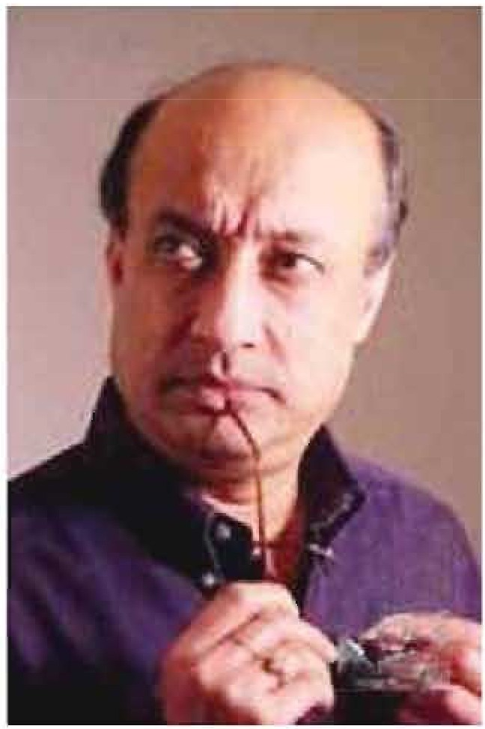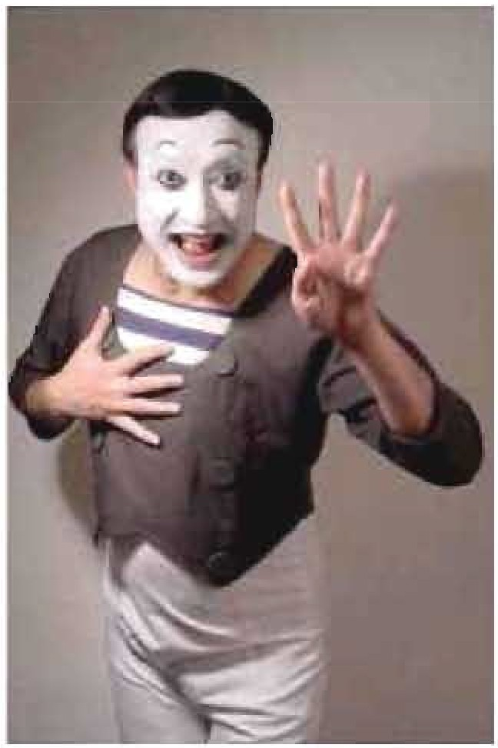

Forma-13, English For Today-9-10

1. **Read the text and choose the correct answer.**

Culturally rich Bangladesh is the homeland of an artist whose fame took him across the border and honoured him with different national and international awards. Have you heard about Partha Pratim Majumder? He is a maestro performer of miming art.

If food is the nutrition for a body, art is the nutrition of soul. To keep the souls alive and fresh different arts like music, dance, paintings have evolved during the ancient time. Humankind has tried to express himself from the very begin­ ning of civilization. These expressions have taken the forms of art with the touch of his creativity in expressing the untold in silence. It is an art of depicting a character, mood, idea, or narration through gestures and bodily movements without any utterance. This ancient dramatic entertainment represents the primi­ tive time when people would use signs as a medium of communication.

In Bangladesh, the boy named Partha Pratim Mojumder from Pabna overwhelmed people with this Art. He left people mesmerized by his graceful presentations of art of silence. It was like a new era in theatre art in Bangladesh when Partha came with effort to make people look at their everyday experience, but in a new form. He made people reveal meanings for all trivial things of life which they usually would overlook. He used to depict stories of sadness, laughter, different characters, birds, insects or even animals through his miming. Some of his topics are the portrayal of a thief stealing, one-sided love, picking up flower and hurting it, delicate changes in nature etc. His actions often led audience to their conscience on different issues. He is regarded as the pioneer of miming in Bangladesh.

Partha cherished a passion for art from his very childhood. He was born in a very cultural minded family on 18 January in 1954. His photographer father nurtured him as a passionate lover of art. The family resided in a village called Kalachandpara. There used be a lot of cultural programmes in Kalachandpara in those days which had an impeccable influence on Partha's affection for art.

Destiny introduced Partha to a mime artist Mr. Jogesh Dutta in 1966 when he went to live at his aunt's home in Chandernagar, 30 kilometres away from Kolkata. Partha could foresee his future and got admission in Mr. Dutta's mime academy in Kolkata. The major lift up of his life was when he presented a solo

performance at Bangladesh Shilpakala Academy in 1979. The then French Ambassador in Bangladesh Mr. Loic Moreau, having observed his talent as an audience in that programme, offered him a scholarship at France.

Partha took all the opportunities to learn from Mr. Etienne Decroux and Mr. Marcel Marceau, both of whom were legendary genius of miming at that time in Paris. He was trained in the mime school called 'Ecole Internationale de Mimodrame de Paris Marcel Marceau'. Gradually he became a very busy artist performing in Europe and America and he was highlighted in media too. Later on this Bangladeshi legendary mime artist received 'the Moliere Award' in the year 2009 which is the highest honourable accolade in the French Theatre. Next year, he was honoured with 'Ekushey Padak' for the contributing to Bangladesh. He was also awarded with Chevalier de l'odre des Art et des Letters' (Knight in the order of Arts and Humanities) in 2012 for his contribution all over the world.

This great artist is now looking forward to opening an international miming institute in Bangladesh. We hope more Partha Pratim Majumder comes out from the dream institution.

1. **Questions: Choose the best answers.**
   1. Miming is a
      1. solo dance b. drama without sound
2. music b. recitation
   1. What is not synonym for the word mesmerize mean?
      1. make spell bound b. overwhelm

c. hypnotise d. shock

* 1. Who was not Partha Pratim's trainer?
     1. Marcel Marceau

c. Loic Moreau

* + 1. Jogesh Dutta

d. Etienne Decroux

* 1. Which year did Partha Pratim Majumder receive 'Ekushey Padak'?
     1. in 2010 b. in 2009

c. in 2011 d. in 2012

1. **Read the text B again. See if the following statements are True or False.**

If **false, give the correct information.**

1. Partho Pratim belonged to a culturally enlightened family.
2. Kalachandpara was 30 kilometres away from Kolkata.
3. Ecole Internationale de Mimodrame de Paris Marcel Marceau is an international award.
4. Partha Pratim took his topics from very trivial issues of everyday life.
5. Performance at Shilpakala Academy created the major opportunity for him.
6. **Read the statements below and form appropriate questions for each of them.**
7. The birthplace of Partha Pratim Majumder is in Pabna.
8. Partha Pratim developed a passion for art from his childhood.
9. Jogesh Dutta was a renowned mime artist in Kolkata.
10. Partha Pratim performed in Europe and America.
11. Partha Pratim's dream is now to open an international miming school in Bangladesh.
12. **Listen to the audio and complete the chart about Partha Pratim.**

I**Listening Text: s**I

|  |  |  |
| --- | --- | --- |
| Year | Achievement | From where |
| 1987 | Master of Mime |  |
| 1987 |  | Journalist Association of Malayasia |
| 2009 |  |  |
|  | Munir Chaudhury Award |  |
| 2010 |  | Bangladesh |
|  | Knight in order of Arts and Humanities |  |

1. . Project: Do yon knew aayoae who bu lkilll toperfat:m • 1peeial fit?

**Write ahout the penon Wt'el'lq the following pobdl.**

* the fint time 1he person came t.o know about it
* tbe time the person began to practise it
* people who supported him/ her
* hill her achievements/ recognitions

**Lesson** 3: The Beginning

1. **Look. the pidure ud dbcuu the fdowiq qaestiODI** In **pain.**

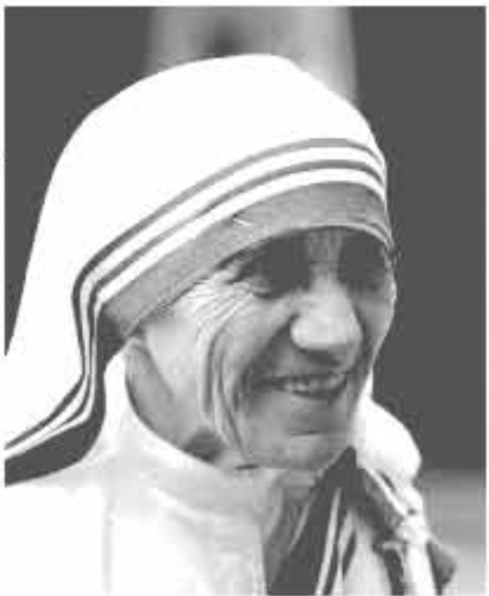l Who is1here in thepichmt?

2 Why is she famoua?

1. **Read the** tat **and choo1e the hat DIWK.**

It was late summm; 26 August 1910. A little

girl waa born 1o a rich Catholic merchants'

:family of **Albanian descent** in a amall 1own

called Skopje, Macedonia, She was 1he

}'01JDga,t of the three mnUmgs and was named Apes **Gomba** Bojaxhin. Who could imagine st the time th8t this little girl would one day become 'the mother of humamly, loving and serving the poorest of

1he poor. Yea, we are talking about none other than Mother Teresa.

At the age of 12, she hearda voice fromwithin that urged her to spread the love of Christ. She decided that she would be a missiomiy. Ai the age of 18 she left her parental home. She thenjoined anI:r.iahcommunity of mma celled the Sittm ofLoreto. whieh had miuious in India.

.Afmr a few months of training at the Institute of the Blessed *Vqin* Mary in Dub Mo1her TflftlSa came to India. On May 24, 1931, she took her initial vows as a nun. From 1931 to 1948 Mother Teresa taught geography and theology at St Mary's High School in Kolkata (1hen Calcuua). However, the widespread poverty in Kolkata had a deep impact on MotberTCfflia and in 1948 she ieccived pennis&ion from her superiors to leave the convem and devace herself to cariilg for thepoorest of thepoor in the alums oflC.olbta.

* 1. What does 'mother of humanity' mean in the text?
     1. a good mother
     2. a kind mother who has many children
     3. a mother who likes humans
     4. a mother figure who serves the poor like her own childem
  2. Why did Mother Teresa want to be a missionary?

Because she heard

* + 1. the voice of her neighbours discussing it.
    2. a voice in her dream.
    3. a voice within herself.
    4. the voice of her parents talking about it.
  1. Mother Teresa set out to join the missionary of the Sisters of Loreto in the year

a 1927.

**C 1929.**

b. 1928.

d. 1930.

* 1. Mother Teresa took her first vows as a nun at the age of

a 18. b. 19.

c 20. d. 21.

1. **Read the text in A again and answer the questions.**
   1. Where did Mother Teresa's ancestors come from?
   2. Where was her father's home?
   3. Why did she want to become a missionary?
   4. What made her different from other girls at such an early age? What words and expressions are used in the text to describe this difference?
   5. What did Mother Teresa do in the first seventeen years in India?
   6. Who did she work for? How?

###### Lesson 4: Love for Humanity

1. **Listen to the Audio and fill in the gaps.**

I**Listening text: 6**

To prepare herself to work with the ,Mother Teresa took an intensive medical with the American Medical Missionary Sisters in ,India. Her first course of action in Kolkata was to children from the slums and start to teach them. Financial support and volunteers came to give a hand to Mother Teresa in her work for .In 1950 her group, now called the Missionaries of Charity, received status as a religious community. Members took the vows of poverty, chastity (purity), and ,but they added a fourth vow - to give free

to the most poor.

The Missionaries of Charity received publicity, and Mother Teresa used it to her work. In 1957 they began to work with lepers (those suffering from leprosy, which is a terrible infectious disease). Gradually from one school they to nine elementary schools in Kolkata. They also opened a home for and abandoned children. Soon they were in more than Indian cities. Mother Teresa also visited other such as Sri Lanka, Australia,

Tanzania, Venezuela and Italy to begin new foundations.

Mother Teresa's group to expand throughout the 1970s. They opened new in places such as Amman, Jordan, London,

; and New York. By 1979 Mother Teresa's groups had more than different operations in over twenty-five

countries around the world'

with dozens more ventures to follow.

1. **Read the completed text and say if the following statements are True or False.** If **false, give the correct information.**

1 Mother Teresa took a thorough medical training from the USA.

""'I 2 At first she collected children from the streets and gave them food and clothing.

1. She and her group started to look after and care for the lepers.
2. It took them a long time to go to other cities of India.
3. Mother Teresa went to several countries.
4. **Read the text in A again and complete the chart given below.**

|  |  |
| --- | --- |
| **Dates** | **Events** |
|  |  |
|  |  |
|  |  |
|  |  |

**D** · **Read the text in A again and answer the following questions.**

* 1. What did Mother Teresa initially do before beginning to work for humanity?
  2. How many vows did the Missionaries of Charity take? What were they?
  3. What did Mother Teresa and her group do?

**Now write the answers in your exercise book.**

**E Do you know anyone in your locality who helps the needy and does so to make others happy? Write a short composition about him/her.**

###### Lesson 5: Love for Humanity

**A Read more about Mother Teresa.**

Mother Teresa was moved by the sight of the sick and dying on the streets of Kolkata. She founded a home for the dying destitute and named it 'Nirmal Hriday', meanmg 'Pure Heart'. She and her fellow nuns brought the dying people off the streets ofKolkata to this home. They were lovingly looked after and cared for. Since then many men, women and children have been taken from the streets and carried to Nirmol Hriday. These unloved and uncared for people get an opportunity to die in an environment of kindness and love. In their last hours they get human and divine love, and can feel they are also children of God. The

Missionaries of Charity try to find jobs for those who survive, or send them to r-ri

homes where they can live happily for some more years in a caring environment.

Regarding commitment to family, Mother Teresa said, "May be in our own family, we have somebody, who is feeling lonely, who is feeling sick, who is feeling worried. Axe we there? Axe we willing to give until it hurts in order to be with our families, or do we put our interest first? We must remember that love begins at home and we must also rem.ember that future of h\Jrnanity passes through the family".

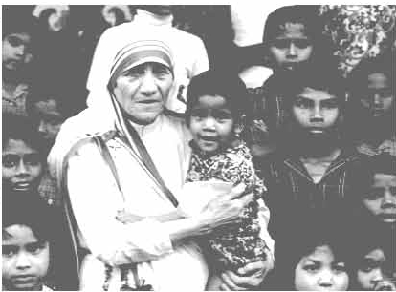Mother Teresa's work: has been recognised throughout the world and she received a number of awards. These include the Pope John XXIIl Peace Prize (1971), the Nehru Prize for Promotion of International Peace & Understanding (1972), the Balzan Prize (1978), the Nobel Peace Prize (1979) and the Bharat Ratna (1980).

Mother Teresa died at the age of 87, on *5* September 1997.The world salutes her for her love and compassion for humanity. She has taught us how to extend our band towards those who need our love and support irrespective of creed, caste and religion. The picture of Mother Teresa, draped in a white and blue-bordered sari, with a wrinkled face, ever soft eyes and a saintly smile, lives on in our mind.

1. **Now say whether the follow.Ing statements areTrue or False.** If **false, give the correct information.**
   1. Mother Teresa was moved to see the diseases that spread in the streets of Kolkata.
   2. She opened a home for the orphans.
   3. She and her group brought in the dying people from the streets of

Kolkata.

Forma-14, English For Today-9-10

* 1. 'Nirmal Hriday' was founded so that the poor people who are dying can get love and care before death.
  2. Mother Teresa said that humanity passes through charitable organizations.
  3. We have learnt from Mother Teresa how to come forward to help only those who belong to a special caste.

1. **Read the text in B again and write the answer to the following questions in your exercise book.**
   1. Why do you think Mother Teresa won so many awards?
   2. What does 'Nirmal Hriday' stand for?
   3. Why do you think the home is named 'Nirmal Hriday'?
   4. Why did Mother Teresa want the dying people to feel that they too deserve care and love?
   5. What are the things that we have learnt from Mother Teresa?

###### Lesson 7: The Wizard of Apple

1. **Look at the picture and ask and answer the quesdons.**
   1. What do you see in the box beside?
   2. What does this logo stand for?
   3. Which company uses this logo for its products?
   4. Do you know the logo of any Bangladeshi product?
   5. Do you like it? Why/Why not?
2. **Read about Steve Jobs.**

Steven Paul Jobs ( 24 February 1955 - *5* October 2011) , most popularly lmown as Steve Jobs was the co-founder, chairman and chief executive officer of Apple Inc. He was the pioneer of the personal computer revolution. He was famous for his career in the electronic field of computers and consumers. This became possible through the marketing of Apple computers.

In 1985, Jobs left Apple after losing a power battle with the board of directors. He then founded NeXT, a computer platform development company specializing in the higher education and business market. Apple, howover failed to bring up any new operating system during Job's absence. Jobs returned to Apple as an adviser, and took control

of the company as an interim CEO.

By 1998, Jobs brought Apple back to profitability from the verge of bankruptcy. He supervised the development of iMac, iTunes, iPod, iPhone and iPad. These devices are so simple and user friendly that even a child can operate them.

He supervised the company's Apple Stores, iTunes Stores and the App Stores too. The success of these products and services brought about steady financial returns for several years and pushed Apple to become the world's most valuable publicly traded company in 2011. This triumph is regarded as the greatest turnarounds in the business history.

Steve Jobs has been highly acclaimed as a visionary leader. He has changed people's perspective towards the computer and how they use it, consume personal media and how they communicate with each other. Hence iBooks, iPhones, iPods and iPads have become extremely popular. Jobs saw and felt the need ofWi-Fi (wireless Internet connection) in laptops. It is he who made Wi-Fi a standard feature of every laptop, and of many other devices worldwide. So Jobs' dream to be anywhere anytime became a reality.

Jobs also co-founded and served as chief executive of Pixar Animation Studios. He became a member of the board of directors of The Walt Disney Company in 2006, when Disney acquired Pixar.

1. **True or False?** If **false, give the correct information.**
   1. Jobs spent his entire career working for Apple.
   2. He became famous because he knew how to market computers and keep the buyers happy.
   3. He became the chairman of The Walt Disney Company.
   4. Jobs left Apple in 2001.
   5. Jobs was a visionary.
2. **Read the text** in **B again and answer the following qustions.**
   1. Write about Jobs' successful career.
   2. What does 'power battle' mean?
   3. How did Jobs manage to bring Apple back to profitalriity?
   4. Why was he called a visionary?
   5. Why did Jobs feel that Wi-Fi connection was needed in laptops?
3. **Pairwork: Write a dialogue about the contribution of Steve Jobs on ICT and do a role play.**

###### Lesson 8: Jobs' Childhood

1. **Read the text and write answers to the questions that follow.**

A car mechanic Paul Jobs and his wife Clara Jobs adopted Steve who was abandoned at birth. Paul and Clara loved Steve very much. They made him feel that he was 'chosen' and very 'special'.

One of his colleagues, Del Yocam said about Steve, "I think his desire for complete control of whatever he makes derives directly from his personality and from the fact that he was abandoned at birth."

Jobs' mother taught him how to read and write before he went to the elementary school. So when he went to school, he found out that he knew everything that the teachers were teaching. He got bored and played pranks to keep himself busy. This continued for the first few years. It was clear from his behaviour that he could not accept other people's authority. He said, "I encountered authority of a different kind that I have never encountered before, and I did not like it."

A turning point came when he was in grade four. His teacher Imogene Hill watched him very closely for some time and soon found out how to handle him and get things done by him. In order to get things done she used to give him money and food. One day after school, she gave Jobs a workbook with math problems in it. She said,"I want you to take it home and do this." She showed Jobs a huge lollipop and said, "When you are done with it, if you get it mostly right, I will give you this and five dollars. "Within two days, Jobs solved the math problem and returned the book to his teacher.

This continued for a couple of months and Jobs enjoyed learning so much that he did not need any return. Also he liked his teacher very much and wanted to please her. In Ms. Hill's class, Jobs felt he was special. At the end of the fourth grade, Jobs did very well. It was clear not only to Jobs and his parents but also to the teachers that he was exceptionally intelligent. The school proposed that Jobs should skip two classes and go into the seventh grade. This would mean that Jobs would find the study challenging and he would be motivated to study. His parents had him skip only one grade.

Source: Steve Jobs by Walter Isaacson

**Questions**

* 1. What do the words 'chosen' and 'special' mean in the text. Explain.
  2. Why didn't Jobs enjoy school?
  3. What did he do to keep himself entertained?
  4. Why couldn't Jobs accept other people's authority at school? Why hadn't he come across other people's authority before?
  5. Why did Jobs have the wish to control everything?
  6. How did Jobs' teacher Imogene Hill keep him busy?

1. **Match the words with their meanings as used in the context.**

|  |  |
| --- | --- |
| Words | Meanings |
| adopted | deserted /left alone |
| abandoned | encourage |
| encounter | power |
| authority | mischiefs |
| pranks | legal y took and raised another's child |
| motivate | face |

**Unit Eight**

### World Heritage

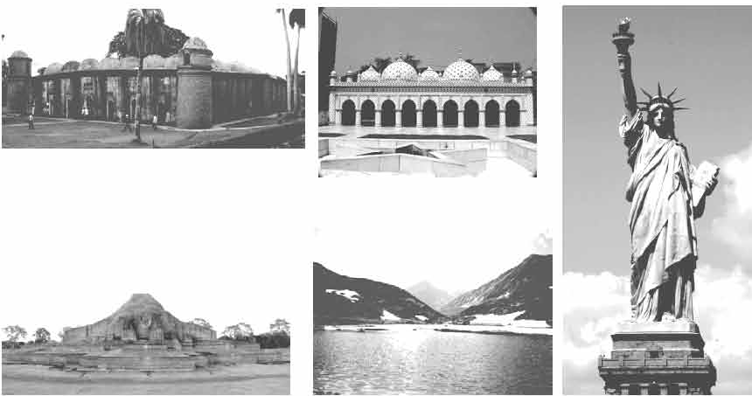

**Learning outcomes**

After we have studied this unit, we will be able to

* listen for specific information
* read and understand texts through silent reading
* ask and answer questions
* describe a place.

Lesson 1: The Shat Gambuj Mosque

1. **Look at the picture. Work in pairs. Talk about the picture and ask and answer the following questions.**
   1. 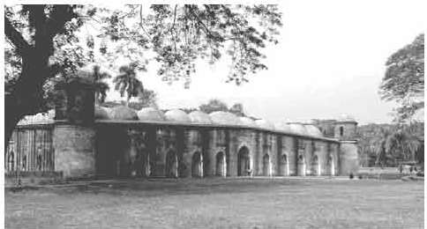 What can you see in the picture?
   2. Do you have a building like this in your town/village?
   3. What do we call it?
   4. What is it used for?
2. **Read the text and complete the table given after** it.

'Heritage' is what we inherit from the past, live with in the present and then pass on to our children or future generation. Our unique source of life and inspiration is our cultural and natural heritage. When we speak of 'World Heritage', it indicates places and sites that we inherited from the past and pass on to the future generation of the entire world

The'Shat Gambuj Mosque' in Bagerhat is sucha heritage. It became a UNESCO World Heritage Site in 1985.

Originally, the historic Mosque City was known as ' Khalifatabad'. It is situated at the outskirts of Bagerhat town--- not very far from the dense mangrove forest of the Sundarbans. Khalifatabad was a Muslim colony. It was founded by the Turkish general, a saint warrior Ulugh Khan Jahan in the 15111century. The infrastructure of the city reveals significant technical skills in many mosques as well as early Islamic monuments. Baked bricks were used for the construction of the buildings. The planning of the city was dominated by the tradition of Islamic architecture and the decorations were a combination of Mughal and Turkish architecture.

Khan Jahan built a network of roads, bridges, public buildings and reservoirs to make the cityhabitable. There were about 360 mosques in the city. Among them the most remarkable is the multi-domed Shat Gombuj Mosque. The mosque is unique in the sense that it has 60 pillars that support the roof, with 77 lowheight domes. The 4 towers at 4 comers have smaller domes at the top as well. The

vast prayer hall has 11 arched doorways on the east and 7 each on the north and south for light and ventilation. It has 7 aisles running along the length of the mosque and 11 deep curves between the slender stone columns. These columns support the curving arches created by the domes. The thickness of the arches is 6 feet and have slightly narrowing hollow and round wall.

The west wall in the interior has 11 'mihrabs' (niche in mosque pointing towards Makkah). These mihrabs are decorated with stonework and terracotta. The floor of the mosque is made of brick.

Besides being used as a prayer hall, Khan Jahan used the mosque as his court too.Today, it is one of the greatest tourist attractions and one of the best architectural beauties of Bangladesh.

|  |  |
| --- | --- |
| **Shat Gambuj Mosque** | **Information** |
| Founded by |  |
| When |  |
| Number of domes |  |
| Number of pillars |  |
| Arches |  |
| Thickness of the arches |  |
| Mihrabs |  |

Forma-15, English For Today-9-10

1. **Look at the picture of** the **Star Mosque** in **Dhaka. Read** the **information and write a description of the mosque with the help of the given clues.**

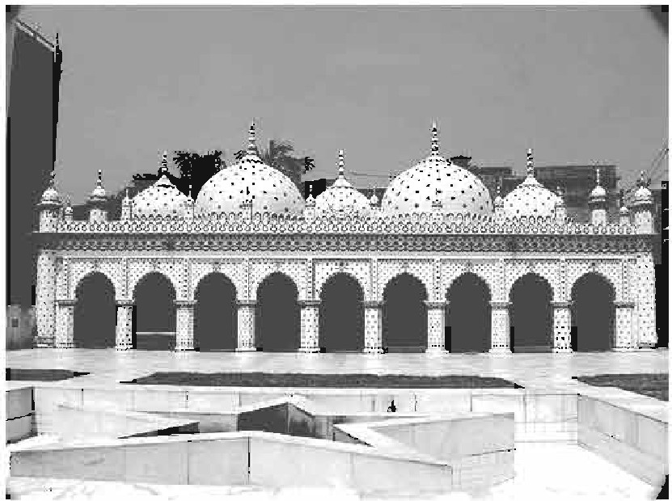Location: Dhaka, Abul Khairat Road Style: Mughal

Number of domes: *5*

Decoration: different sizes of stars on dome and outside wall

Materials used for decoration: chlnaware and white cement

Interior of the mosque: mosaic floor, floral tiles on the wall

Built by: Mirza Ghulam Pir- a respectable Zamindar of Dhaka

Time: early 18th century

###### Lesson 2: The Somapura Mahavihara

1. **Read the** text.

Paharpur is an important archaeological site situated in a village named 'Paharpur' in Naogaon district of northern Bangladesh. Naogaon is mainly plain land but in the middle ofit stood a hill covered with jungle. When the jungle was cleared and the hill excavated, there emerged a lofty ruin of an ancient temple. The temple is about 24 meter high from the surrounding level. 'Pahar' means hill. Hence the name Paharpur.

The Paharpur site has been excavated and re-excavated a number of times by archaeologists. Sir Alexander Cunningham, archaeological surveyor of India, visited the place in 1879. He intended to carry out an extensive excavation but was prevented by the land owner. Nevertheless, he was satisfied with whatever excavation he was permitted to carry out. The site was declared to be protected by the Archaeological Survey of India in 1919 under the Ancient Monuments Preservation Act of 1904.

Systematic and regular excavation started jointly by the Archaeological Survey of India, and Varendra Research Society ofR.ajshahi and Calcutta University in 1923. Theyexcavated the south-west comer of the monastery. Next, in 1925-26, historian and archaeologist RD Banerjee excavated the northern part of the cen­ tral mound. From 1926-27 onward, excavation was carried out under the super­ vision of KN Diksbit.

The Deparbnent of Archaeology of Bangladesh brought the site under further excavation after independence. The operations took place in two phases. The first phase was initiated in 1981-82 and continued till 1984-1985. The second phase was started in 1988-89 and continued till 1990-91.

Pre-liberation expeditions have revealed the architecture of a vast Buddhist monastery, the Somapura Mahavihara. It is dominated by the central shrine, attracting immediate attention by its lofty height and unusual architectural design.

Somapura Mahavihara was one of the most famous Buddhist institutions for monks of ancient Bengal and Southern Asia The excavated complex at Paharpur has been identified as Somapura Mahavihara built by the second Pala

king Dharmapala (781- 821 AD). Some clay seals from the rums bear the

inscription *Shri-Somapure-Shri-Dharmapaladeva-Mahavihariyarya-bhik­*

*su-sangghasya.*

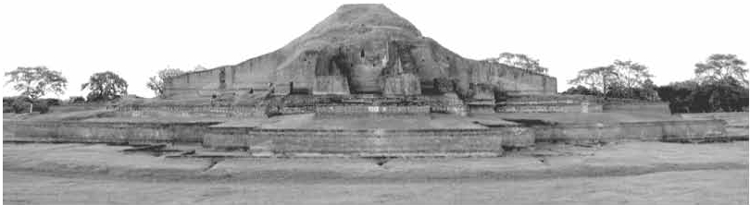

The Pala rulers were devout Buddhists and they founded a number of monasteries throughout their growing empire. Some of them became great centres of learning and their reputation quickly spread throughout Asia. Somapura Mahavihara's close relationship withthe ruling dynastyimplied that it shared the political ups and downs of its benefactors.

1. **Match the words with their meanings.**

|  |  |
| --- | --- |
| **Words** | **Meanings** |
| archaeological | rubbles/wreckage |
| excavate | widespread |
| lofty | ancient cultural remains |
| extensive | p10us |
| systematic | uncover something with difficulty |
| debris | grand |
| devout | done methodically |

1. **Read Text in A again and choose the correct answer.**
   1. Paharpur is

a a typical Bangladeshi village. b an extraordinary village.

c a very small village. d a village on top of a mountain.

* 1. After excavation, the archaeologists discovered a huge

a king's palace.

c Buddhist monastery.

b emperor's courtyard. d Hindu temple.

* 1. How many phases of excavation of Paharpur have been mentioned in the text?

a four

1. **SIX**

b five

d seven

* 1. What objects indicate that the site was built by the second Pala king?
     1. earthen seals c stone seals
     2. ceramic seals d iron seals
  2. The word ' benefactors' in the text means
     1. banks.

c people with money.

* + 1. famous businessmen. d financial supporters.

1. **Read the text again. Work** in **pairs. Ask and answer the following questions. Then write the answers** in **your exercise book.**
   1. Why is the village named Paharpur?
   2. Where is it located?
   3. What is it famous for?
   4. What did Cunningham find when he was digging the Paharpur site?
   5. Why was the site officially stated to be preserved?
2. **Do you have any old or ancient relic** in **your city/town/village? Write about it with the help of the following questions. *H* you don't, surf the Internet for a relic** in **Bangladesh that you find interesting and write about it.**

* When was it established?
* How does it look like?
* What was it for?
* Why do you like it?

###### Lesson 3: The Statue of Liberty

* Who built it?
* How big is it?
* What is its present condition?

1. 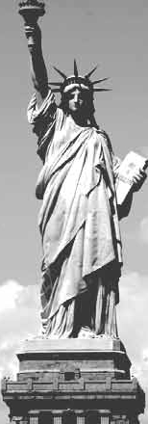**Look at the picture and talk about** it in

**pairs.**

1. **Read the questions first. Now listen to the audio about the Statue of Liberty and answer the following questions.**

I **IJstenlng text** 7

1. Where is the Statue of Liberty situated?
2. Which country gave the statue as a gift?
3. The gift was meant for which country?
4. On what occasion was it given?
5. When was the statue given?
6. What does the statue represent?
7. **Listen to the text again and complete the chart.**

|  |  |
| --- | --- |
| Statue of Liberty | Information |
| situated |  |
| artist |  |
| gift from |  |
| reason for the gift |  |
| presented on |  |
| occasion |  |
| the statue symbolises |  |
| framework made of |  |
| amount of copper used |  |
| weight |  |
| year it was declared a UNESCO World |  |
| Heritage Site |  |

1. **Read the text and answer the following questions.**

The French sculptor Frederic Auguste Bartholdi was assigned to design and complete a sculpture *Liberty Enlightening the World* within 1876, so that it could be a gift for the Americans on the occasion of the hundredth anniversary of the American Declaration of Independence. The statue was a joint venture between the USA and France. The French people built the statue and assemble it in the States, and the people of the USA built the pedestal for the statue.

Raising money for the pedestal was completed in August 1885. The construction of the pedestal was finished in April 1886. In the meantime, France completed the Statue in July 1884. They sent it to New York by the French war ship 'Isere' in 1885. While transporting the statue, it was split up into 350 pieces and packed in 214 crates.

It took four months to put the Statue together and place it on the pedestal. Thousands of people saw the unveiling ceremony of the Statue of Liberty on 28 October 1886.

The Freedom that the Statue stands for is not stationary. The broken chain wrapped around her feet, sticking out from the bottom of her robe, symbolizes her free forward movement, enlightening the world with her torch, free from oppression and slavery.

The Statue's original torch was the first part constructed in 1876. It was replaced by a new copper torch covered in 24K gold leaf in 1984. The torch is lighted by flood light at night. The original torch is currently located in the lobby of the monument. Access to the torch has been closed since 1916.

From 28 October 2011, on her 125th anniversary, the Statue of Liberty was also named "Liberty Enlightening the World Wide Web". The credit goes to a series of new web cams placed around her torch. Several amazing views will be just a click of a mouse away. On clear days, three cameras provide unobstructed views of scenes far and near. Two cameras provide an ultra wide-angle interactive view of the famous golden torch. The remaining camera looks downwards towards the crown of The Statue of Liberty, her face and the tablet she is holding. So a person can have access to the web cam's live feed of The Statue of Liberty from anywhere in the world.

**Questions:**

* 1. On what occasion did the French government give the Statue of Liberty to the USA?
  2. When did she reach her destination?
  3. How was she transported?
  4. How has new technology made it possible for people to see the statue from anywhere they are?
  5. What do you understand by the expression 'enlightening the world'?

Lesson 4: Lake Baikal

1. 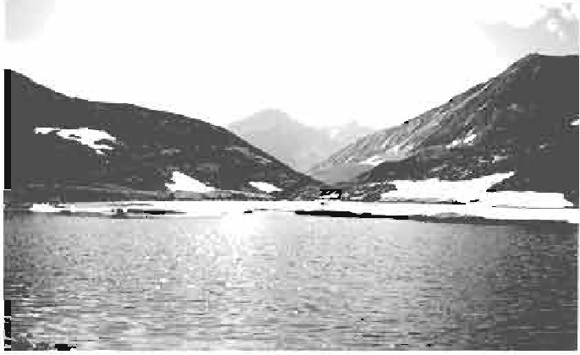**Look at the picture. Work in pairs and ask and answer the following questions.**
   1. What do you think it is?
   2. Where is this situated?
   3. Are you familiar with something like this? Lake Baikal
2. **Read the text to find out if your guess about questions 1 and 2** is **right.**

Lake Baikal is the deepest and one of the biggest and most ancient lakes of the world. It is situated almost in the centre of Asia. Lake Baikal is a gigantic bowl set at 445 meters above sea level. This grand, enormous, unusual and charming miracle of nature is located in the south of Eastern Siberia, in the Buryat Autonomous Republic and region of Irkutsk, Russia.

The lake covers 31,500 sq km. It is 636 km long and on an average of 48 km wide. The widest point of the lake is 79.4 km. The water basin occupies 557,000 sq km. and contains 23,000 cu km (cubic kilometer) of water, which is about one fifth of the world's reservoir of fresh surface water.

The average water level in the lake is never higher than 456m. The average depth of Lake Baikal is 730 m, and its maximum depth in the middle is 1,620 m. It would take about one year for all the rivers of the world to fill Baikal's basin, and would take four hundred years for all the rivers, streams and brooks now flowing into Siberian lakesea to do the same.

There are hot springs in the surrounding area of Lake Baikal. The quality of the water of these springs is excellent. The lake acts as a powerful generator and bio filter producing this water. Baikal is a stormy lake. Autumn is the most stormy time. The wind blows in various directions.

The weather depends on the wind. If it is blowing from the north, the weather is bright and sunny. The water of the lake looks green and dark blue. But if the winds get stronger, Baikal turns black, waves rise high with white crest. The beauty of Lake Baikal is exceptional.

1. **Match the words with the meanings.**

|  |  |
| --- | --- |
| **Words** | **Meanings** |
| miracle  basin brook | small stream top  outstanding |
| crest | an act believed to be caused by God |
| exceptional | bowl-shaped depression filled with water |

1. **Read the text in C again and complete the chart.**

|  |  |
| --- | --- |
| Lake Baikal | Information |
| location |  |
| setting/placed |  |
| length |  |
| width |  |
| maximum depth/ utmost/highest depth |  |
| extended over an area/occupies an area |  |
| amount of water |  |

1. **Make a list of attractive features of Lake Baikal.**
2. **Have you seen a lake or river that has attracted you very much?** If **yes, write what aspects of the lake or river appealed to you.** If **not, go and see a lake or a river. Then write about it.**

Fonna-16, English For Today-9-10

**Unit Nine**

# UnconventionalJobs

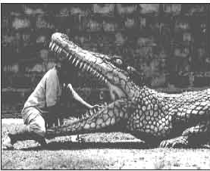

**Learning oimoma**

Afterwe he.ve studied this unit, we will be able to

* descnoe familiar objecta
* readintensivelyandextemively
* participate in debate, discussion
* Write about jobsand situations
* read for skimming, scanning. andinfening

[ Skimming - to readquickly to get thegist of a text

Scanning- to readquickly to getspecific information

lnfeniog=to read text to beable tomake logical conclU8ions. ]

###### Lesson 1: Jobs that People Do

1. **Many of us think that we must have a steady big job to be happy**

in **life. Is that always true? Why/Why not?**

1. **Read the text.** It **is about a young entrepreneur, Sayeed Kamal Notice what he thinks about job and happiness. Then answer the questions that follow.**

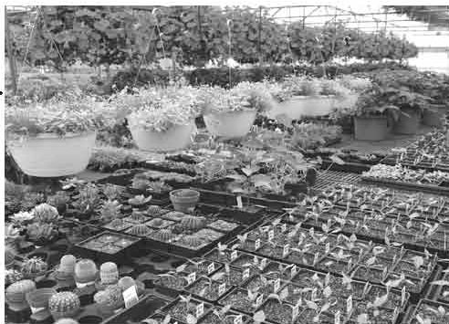I know you will wonder if I say the best thing that everhappened

to me was when I left my lastjob.. f1 1.i!

Yes, really!

I was a desk clerk in an office. But believe me I never likedmy job. Nothing can be more boring than being stuck in an office all day with computers and telephone.

So after two years or so, I decided to leave my job though I had a good salary. Now I'm the owner of a nursery. Planting seeds, budding, grafting, taking care of saplings, cleaning the flower beds and spending time with trees are different parts of my full time job. I start work very early. In summer I usually leave home at 5:30 in the morning, but in winter not until about 7. I've a small hut in my nursery. There cannot be any more pleasure for me than when I see the moon from there or walk through the trees in the soft moonlit night. The winter is just over. So I'm cleaning up the winter flower garden. Now I'm busy producing more timber and medicinal plants which people will buy from July. Every

season is so different and I love them all. When I compare my present days with the past, I simply can't understand how I could survive in my previous job. I love nature. I just love working outside in the open air after all those months in a stuffy office. Gadgets never attract me and perhaps never will.

rm not married. I do my own work, even cook my own food. I try not to depend on others for the work which I myself can do. Oftenmy friends are annoyed with me. They **say,** I should engage a maid for household chores. They are not happy to see me in this 'rustic life'. They are professionals. They earn a lot Maybe

124 English For Today

much more than what I do, but I think I enjoy my work more.

At weekends, I often go to the countryside. Sometimes with my friends, sometimes alone. I love collecting unknown saplings. I have another hobby. I love collecting stamps. I have a Russian stamp from the period of Lenin. I don't watch TV.

The only problem I face is I do not earn enough money in all seasons. The winter and the monsoon are two busy seasons for me. But it's OK. Maybe I do not earn enough like many other people around me. But I at least earn enough for my family, employees, and myself to run a decent life. I must say I'm a very happy man!

**Questions:**

1. What is the best thing that ever happened to this man?
2. Why didn't Kamal like his last job?
3. What are the advantages and disadvantages of his present job?
4. When does he earn most money?
5. What attitude of Kamal is reflected in the lines: 'Maybe I do not earn much like many other people around me. But I at least earn enough for my family, employees, and me to run a decent life'?
6. **Ask and answer questions about Kamal. Use the clues given.**

Example:

. married?

Q: Is he married?

A: No, he isn't. He isn't married.

* 1. happy?
  2. When leave home in summer?
  3. What plant after winter?
  4. What do at the weekend?
  5. What collect?

1. Look at the following table. The left column shows some positive aspects of Sayeed Kamal's character. Add some more to the list. Also find out some aspects of Sayeed that you think are unconventional and write them in the right column.

|  |  |
| --- | --- |
| Good aspects of Sayeed | Unconventional aspects of Sayeed |
| 1. simple 2. diligent 3. loves nature d.caring   e.  f.  g. | 1. old fashioned 2. loner   C.  d. |

1. Write a paragraph on Sayeed Kamal Take your cues from D.
2. 'I must say I'm a very happy man!'--- Do you agree with Sayeed?

Write why/why not?

12.6 Bnglisb F<xToday

Lesson 2: Weird Jobs Around

1. Look at11lefollowing pldurea and cllacu.u with your partner what

yousee in them.

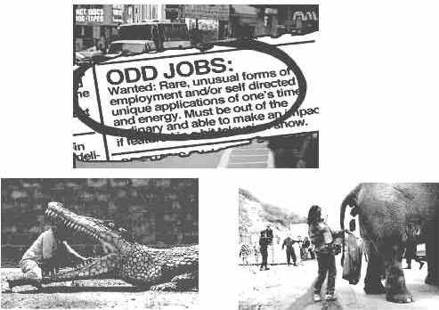

1. **Read** tiletat and amwer diefollowln& question,.

What type of job do you want to have? *Is* it a highly paid and high-profile conventional job most people lib? Yes, you can have it. It is matter of your choice and 1111 important decision that would help you advauce in your life.But haveyouever1houghtof othertypesofjobsoutthere- cool, fun, exciting, even strange or weml jobs you never knew existed? What are they? Did you ever wonder who picks up1he chewing gum left on a pai:k bench or who assesses whe!hcr **a** piece of furniture is comforlable enough or who con.sb:ucts glasseye­ ball$ or who farms oysters in the middle of 1he ocean? These are all odd. unexpected. wild, unconventional, atmnge or just plain weird jobs and careers. They are not your 1radi.tionsl career choices, but somebody out there does all

tw:scthings, gets pa.idfor it, and enjoys lifelike anybodyelse.

There are hundreds of such jobs to take if you want to travel the less taken

ways of life.You have to decide OD.several questions:

* + What companies will recruit/hire me?
  + Do I actually get a paycheck?
  + What type of education/diploma will I need?
  + Can I make a living doing this?

Your answers to these questions will help draw your career roadmap and help you decide if you are ready to take the challenge. Decide if you want a change. A lot of strange jobs also allow you to work part-time or towards a freelancer when it fits your schedule. This way you can get a taste of freedom, a secondary income, and gain experience at the same time.

Do you have interests beyond writing memos and attending boring meetings? If so, you may wonder how you can find a strange job. Hobbies are a good place to start. What do you do for fun? Do you stuff animals, act like Charlie Chaplin, or make model cars? There are people out there working in fields, making money off their hobbies. May be they are testing mountaineering equipment, developing fragrances, or saving sea turtles. And they are getting paid good wages too.

**Questions**

1. 'But have you ever thought of *other types of jobs* out there----?' What does 'other types of jobs' mean here?
2. There are four particular strange and weird jobs mentioned in para one of the text. Which one of them seems to be most weird to you and why?
3. Before going for an unconventional and strange job the author has suggested several questions to decide on. Rearrange them, beginning from what you think is the most important to the least. Add some more questions to the list that might be important to consider.
4. What are some other strange part-time jobs mentioned in the text?
5. What type of job is referred to by the expression 'writing memos and attending boring meetings'? Do you think the author's observation on the particular job is justified? Why/Why not?
6. **Look at the following dialogue and act it out in pairs.**

**X** Have you heard of a job like *picking up the chewing gums*

*!el.ft on a park bench?*

y Yes, I have. I know one person who does that job.

**X** What do you think of the job?

y Sounds rather funny/odd/crazy/ though. But what's wrong?

You can go for it as long as you enjoy it. And if it pays, I think it's fine.

**Now make dialogues on the following:**

1. Assessing the comfort of a piece of furniture
2. Farming oysters in the middle of the ocean
3. **Arrange a debate in the class in favour of and against strange jobs.**
4. **Work in pairs. Make a list of adjectives used in the text to describe strange jobs** (**at least 10**). **Are you familiar with all of them?** If **yes, use them in your own written sentences. Compare with your partner's.**

If **no, try to guess their meaning from the context. Then look up a dictionary to get the meanings. Finally use them in your own sentences.**

1. **A number of strange jobs have been mentioned** in **the text. Do you know any one around you who does one of the jobs?** If **yes, write a paragraph on him/her.**

If **no, first select a job. Then try to imagine who around you could successfully do that particular job. Write why you think so.**

U11.0011ven1i0tllllJobs 129

Lesson 3: Floral career

1. Look at 111:e **pictures and say what** you aeein 111:em.

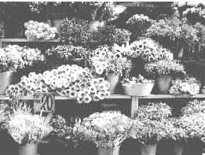

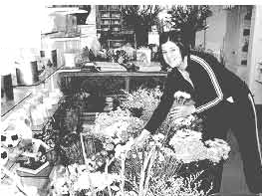

!

BWork ln pain.Choose a Job from111:e box below bllt dontt t.dl yolU' partner.**Ask and** answer the follow.mg Yes/No questiou tofilld out **what 111:e** job11.

Archiu:c:t, taxidriver, dentist, farmer, lawyer, photographer, accoumant.

mechanic, soldier, ha:irdresser, wt politician, nurse.plumber, florist

Use these **questions** to helpyou.

|  |  |  |
| --- | --- | --- |
| Doyou...? | **Doyoahave** to... ? | **Didyou.ha've to•••?** |
| work inside | wear a uniform. | study atcollege |
| cam a lot | WOik in shifts | doa lotofaaining |
| worl.c withpeople | use your hands | do internship |
| use a computer | getupearly |  |
|  | speakEnglish |  |

1. **Readthe text and answer thefollow.Ing queatlom.**

Have you ever thought of a very creative career? Have you dreamt of **a** rosy cnviromncnt full of colour and ftagrancc? How much would you love it if you were placed in a store fullof tlowenthe whole wry?I'm.just going to give you some clues aboutsuc:ha jobwhichcanalso be a business.

Foima-17, English li'or Todsy-9-10

Yes. Daisies, violets, tulips, marigolds, dahlias, lilies, jasmines, roses and all those things of beauty can also earn you a living if you handle them professionally. If you start such a profession you will be called a florist. A florist's career is a good choice as an unconventional job for many around the world. Wherever you see eye-catching floral displays, you actually see the professional performance of a floral designer. Using both real and artificial flowers with other greeneries, florists prepare flower displays for a variety of events such as weddings, birthdays, anniversaries, Valentine's day, official receptions and even funerals. Every flower comes with its distinct colour, design, value and meaning which flower designers have to know well. There are conventions and meanings associated with flowers. We know that conventionally roses are meant for romance and marriage anniversaries and tulips for birthdays.

Although formal education or a diploma is not always essential for florists, they must have good taste, a good eye for colours, shapes and proportion. They have to have good sense for selecting flowers, ribbons and other accessories to make beautiful arrangements. Professional florists are knowledgeable about not only flowers but also designs and techniques. Most florists learn the trade mainly through apprenticeship in a flower farming job and also by attending formal floral schools and courses. However, a true passion for flowers and a bit of aesthetic sense are all that can make a florist's career successful.

Flower designers earn fairly handsome money. But the bonus is that they work in a fresh and beautiful environment which their clients also enjoy. They work with flowers all day long in a pleasant and fragrant atmosphere with vivid colours around.

**Questions**

* 1. How is the career of a florist?
  2. What qualities do you need to have for a florist's job?
  3. How do most florists learn the trade?
  4. What is the extra advantage of a florist's job?

1. **Suppose you have met a florist in a flower shop. Write an imaginary interview with him/her.**
2. **Write a short paragraph giving reasons why you like or don't like the job of a florist.**

C'.I

**Unit Ten**

# Dreams



*k***t**

After WOhavomlffiedf.bouait,WOwill bo ablolO

* liatfflforspecific lnfonnatioa
* partio:ipate ill oonve:raatiom **1111d**cli..,.1..,inu
* imdenlal1dandll8lT&le problems
* fllbandgivo
* eomplelo a grid.

###### Lesson 1: I Have a Dream

1. **Read these texts and say what is common among them.**

Hi, I'm Moitry Mutsuddi. My father is a freedom fighter and my mother is a teacher. They both dream for a golden Bangladesh and inspire me to do something significant, something positive for the country. Often I think what to do to fulfil their expectations in future. Finally I've decided to be a politician and work for my motherland. How is it?

I'm Amitabho Kar. When I say to my friends that I would like to be a space traveller, they laugh. But I really want to be that. If people from other countries can conquer the moon, and roam in the space, why not we? To be honest, I visualise that one day I'm stepping on Mars from a space shuttle. Please wish me the best so that my dream comes true.

Hello! I'm Mofakkhar Hasan. I live in a slum with my parents and sisters. I know how cruel poverty can be! My heart bleeds to see the poor, suffering people in my slum. After I have finished my education, I'll be a social worker and fight against social injustice and poverty. 'Change' is the word I believe in to make Bangladesh a golden Bengal.

My name is Ruth Antara Chowdhury. I believe that a society cannot be enlightened without proper education. Education lights the candle in people's heart. So I will be a teacher. Some people appreciate my decision but some people say teachers are not reverred properly nowaday. I tell them, I don't care who tell what. I want to be a teacher because I'm brilliant. Teachers need to be creative and innovative.

1. **Read the texts again and then work in pairs. Which person do you think is most like you and why? Write a similar text stating your own dream.**
2. **Read this interview between Swati, a successful student in JSC and a newspaper reporter, Animesh Roy. The interview is jumbled up. Read the text and then organise the conversation properly.**

Animesh : So you mean learning from each other?

Swati: There is no magic behind my success. I just worked hard. I followed our teachers' advice, 'The more you read, the more you learn'. I'm grateful to my teachers and parents for guiding me properly.

Animesh : Well Swati, we are really so proud of you for your brilliant performance in the JSC exams. Please tell us how you could achieve this success.

Swati : Ohh....and I'm grateful to my school and friends too. Animesh : That's great!

Swati : In my school, we had a nice study group. Whenever we had any problem, we discussed it in our group first. We tried to help each other. And it always worked. Never forget, two heads are better than one.

Animesh : I understand why you are grateful to your school but would you explain how you are grateful to your friends, please?

Swati : Exactly that!

Animesh : By the way, Swati, what are your dreams for the future?

Swati : To keep up the success in next exams and make my dreams come true. I want to be a scientist. Since my childhood I've known that many people in Bangladesh are under arsenic threat. They are taking arsenic directly from their drinking water and indirectly from the crops and vegetables they eat. It's a kind of slow poisoning. People are helpless. They are suffering from many kinds of diseases. Therefore, I have a dream to carry out a research on how to get rid of this problem, using our own recourses and expertise.

Animesh : Wish you luck.

1. **Now listen to the Audio and check whether your answer is correct.**

**I Listening text 8**

1. **Work in pairs. Make questions for your partner to know about his/her dreams and take his/her interview.**

###### Lesson 2: What I Dream to Be

1. **Work in groups. Read the following words. How are they related to dreams?**

imagination, emotion, passion, obsessions, strong desire, colour, rosy, future, mind, brain, plan

1. **Work in groups, and discuss the following questions:**
   1. Do you consider dreams important for life? Why/ Why not?
   2. What do you dream at this moment as a student?
   3. What, according to you is the dream of Bangladesh at present?
   4. Give examples of some dreams that are commonly shared by Bangladesh as a nation.
   5. Do you think the world has any common dream? What is that?
2. **Listen to the Audio. Three persons are telling about their dreams. Take notes in the following grid to show what they plan to do and what they don't want to do.**

**Listening text 9**

|  |  |  |
| --- | --- | --- |
|  | plans to | doesn't want to |
| 1. Catherine Aich |  |  |
| 2. Masum Billah |  |  |
| 3. Nirmal Drong |  |  |

1. **Listen to the texts again and check** I( X) **the statements.**
   1. Masum Billah desires to study agriculture as his teacher suggests him to do that.
   2. If Masum qualifies, he will get admitted to a university in his rural area.
   3. Catherine's mother died in a doctor's hand.
   4. If Catherine's family had brought a trained nurse, her mother might have survived.
   5. If Najmun Sultana came a few months ago, Nirmal could take admission to a foreign University.
   6. If Nirmal's dreams come true, his near and dear ones will be more conscious about their rights.
2. **Now make sentences from the following substitution table.**

|  |  |  |
| --- | --- | --- |
| IfMasum | becomes a nurse | he will be a leader in the field |
| If Catherine | deserves any merit | of education. |
| IfNirmal | has opportunities | she will serve her community. |
| IfNajmun | called a trained medical person | she could save her mother's life. |
| Sultana | came to Nirmal's class a few days ago | he will be a farmer's friend. they could learn more. |

1. **Work in pairs and make sentences reflecting your own life using** *if*

***clauses* as in the table above.**

1. **Write a composition about an event in your life that has inspired you to have a dream. Then briefly describe the dream. Make predictions and possibilities.**

136 Bqllah1'orToday

Lesson 3: They Had Dreams (Part-1)

1. **Shanta WM** ehatdng wtih one of **a.er** forefp Mencia **Jeany. Read**

the«llalocue and Cell wlult the nbfect orthelrffnvmadonla.

Jenny : Shanta, what'syourdream for 1he future?

Shanta. : To **bea good** human being nmand thenworlc for mycoumry-no

matter whether I become & BOcialwm:ker, anartiat.or a profc!i&imml.

Jenny : Wow! I Illl1ll}, app1ec:u.te your thought! By the way, Shanta, does

anyone inspi%e youin yourcl!eams?

Shanta : Certainly. rm alwaysini1ue:nced bythegreat personalities in ourcoun­ try andabroad. **Wbenevr:r**I readthebiography cf greatpeople, I try to understand how thc,ir dr:t!111111 helped them to **be** what they have been.

Jc,nny : Wouldyou please tell meaboutsome of your mvourite dreamers?

Shanta. : Sure! Read 1hc following texta to know about IKlllle dreamer&

in my comiuy.They an, my icon.a as well.

1. **Read**the ten and c:ompkte the tub C IUldD.

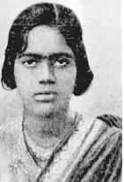Pritilata Waddedar was bom in Chattogram on *S* M&y 1911. She waa a mernonoos ftladent at Dr Khastagir Gavemme:nt Girls' School in Cbattogram and Eden. Colleg-e, Dhaka. She **gr,di•ated** in _philosophy with distinction &om Bethune College in Kolkata. In her college days, Pritilata was an activist in the anti-Brilish movement All through her life.,she dreamtof two thinga: a society without gender discriminati.on, andhermo1herland:lice:fromBritishcolonial r:ule.

So she decided to fight against tho British rule.

Soon after, Pritilata became the **head1-:her** afNandmkaonn Apama Cha.ran School in Chattogram. Gradually iho involved herself in Slllja Sm's mmed "'

...

t;i

D.rcam8 137

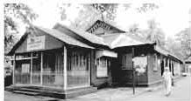reaistance movement. Surja *Sen* was a :fiim0118 am:i-British movemait organiser and revollllionaey activist in Chattogram area at that time. In 1932, Smja Sen plam!ed III attack on the Pahartali European

Club. The club wu well-known for ill!

notorioU.8 sign at its entrance: *Dop and Indian:, not alwwed.* Surja Sen assigned Pritilata toloada team of 10-12 men toattack 1heClub.Theraidwa& succ:essfw butPritilata.

dressodas a man, milcidtogetoutof thoClub. -.-run,p. o.i.

Shecommitted. suicide by taking pofas.flum cyanide to avoidmn1st. She proved 1hat women can worlt like men. She also proved 1hat women too needed to **be** prepared to sacrifice their livl.'.1for freedom ftom1he British colonial role. Her dream finally came true. The British rule came *to* an end in 1947 though she couldn't seeit during her lifetime.

1. **Beadtt.t fflllldtm.Oiom11Aaod m•tth** them **withthe,meanings**ht Cohunll**B.**

|  |  |
| --- | --- |
| ColumnA | ColumnB |
| gradua1cd | a memberof a certainsocial *or* political group |
| activist | fight |
| movement | tooka univcmtydegree |
| gender discrimination | ruleby a powmul country overa weakerc:ounb:y |
| col.onial rule | battle |
| combat | inequality between male and female |
| gradually | slowly |
| resistance | give responsibilities |
| notorloua | activities |
| assign | dishonourable |

Forma-111, Rnglisll 'forToday-9-10

1. **Now answer the questions.**
   1. Where did Pritilata fight?
   2. When did she fight?
   3. Why did she fight?
   4. What was Pritilata's profession?
   5. What do you learn from Pritilata's life?
2. **Now make questions from the substitution table and match the answers.**

**One is done for you.**

|  |  |  |  |
| --- | --- | --- | --- |
| When, | *I*  was  did | she graduate in? | _On 5 May 1911. In Chattogram Philosophy.  To fight against the British rule. For its notorious sign-Dogs *and Indians not allowed.*  Surja Sen.  She committed suicide by taking potassium cyanide. |
| Where | Pritilata born? ---- |
| What | assigned Pritilata to attack |
| Why | the Club? |
| What | Pritilata die? |
| Who | the Pahartali European Club |
| How | famous for? |
|  | she born? |

 139

Lesson 4: They Had Dreams (Part l)

1. Look at the picture. Heu a great10n of our country. Who ii he?

What do you know about him?

1. Read the text.

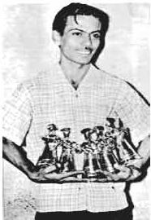Zahir Raihan was one of the most talented film makers in Bangladesh. He was bom on 19 August 1935 in the village Majupur in Feni district He was an active worker of the Language Movement He was one of the ten students to go out in a procession on 21 February 1952 despite a ban on such activities imposed by the authorities. As **a** result,, he and many others were arrested and taken to prison. Raih.an wasalso present at the historical meeting of Amtala on 21February 1952. He also took part in the mass movement in 1969. In 1971, he joined the Liberation War.

All through his life, Zahir Raibao dreamt of a democratic society, a society that would ensure freedom of speech. He had many dreams about our film induatty too. He made a legendary film *Jibo,s Theke Neya* based on the Language Movement of 1952. It was a protest against the autocratic government then ruling our country. The family portrayed in that film symbolically represented East Pakistan. The family was ruled by an autocrat who hadto go to prison for her conspiracy. Duringthe Liberation War in 1971, this film wasshown outside Bangladesh. Celebrated film makers like Satyajit Ray, Mrinal Sen. and Ritwik Ghatak appreciated the film. R.aihan gave all the money the film made to the Freedom Fighters' trust Besides, his great documentary on Pakistani atrocities, *Stop Genocide,* helped create worldsentiment in favour ofour liberation war.

On 30 December 1971, someone informed Raibsn about anaddress somewhere at Mitpurwhere hemight findhisbrother, the famous writerShahidullah Kaiser, who had gone missingfrom 14 December 1971. Kaiser was capturedandkilled by thePakistani armyandthe local collaborators during thelast daysof the war. Accordingly, Raibso left home to get hisbrother back but henever returned.

Zabir **R**aiban's dream was fulfilled. But it's a pitythatthis dreamer couldnot

"" liveto see his dream come true.

C"4

1. **Use appropriate information from the text above to complete the grid.**

|  |  |  |  |  |  |
| --- | --- | --- | --- | --- | --- |
| **Zahir Raihan** | | | | | |
| participated in | famous as | best document ary | movie based on language movement | m1ssmg smce | his dream |
|  |  |  |  |  |  |

1. **Read the following sentences and complete them.**
   1. Zahir Raihan is famous as ...............................
   2. Raihan was imprisoned because ....................................
   3. He participated in ......................................... and ................
   4. *Jibon Theke Neya* symbolises ............................................ .
   5. He donated ................................................................... .
   6. He worked to organise by

his great documentary *Stop Genocide.*

* 1. His disappearance is a great........................................ .

1. **Work in pairs. Discuss.**
   1. Why is Zahir Raihan considered a freedom fighter though he was a film maker?
   2. How does the title of the lesson fit the story of Zahir Raihan?
2. **Project. Work in groups. Meet a freedom fighter in your locality.**

**Interview him/her. Then write a paragraph on him/her.**

**Unit Eleven**

### Renewable Energy

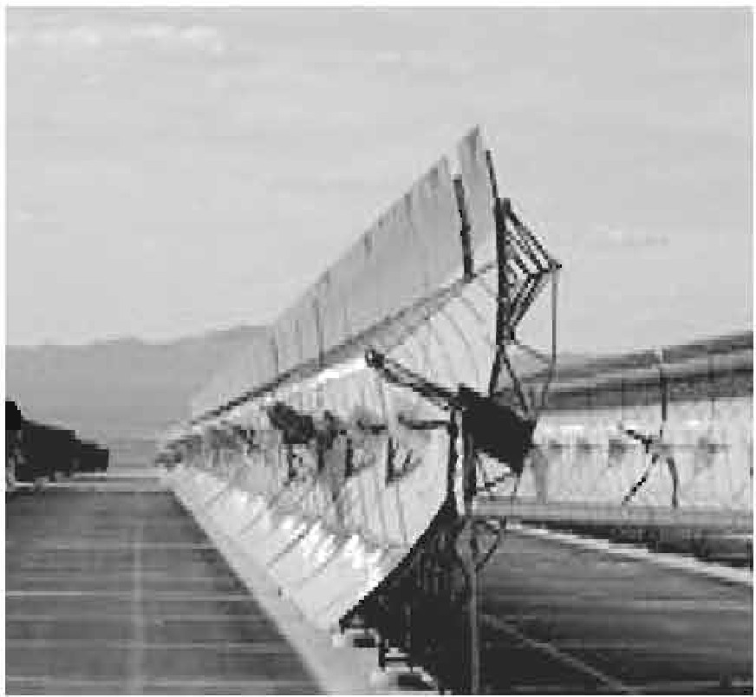

**Leaming outcomes**

After we have studied this unit, we will be able to

* describe familiar objects
* participate in conversation, discussion
* read intensively and extensively
* write formal letters.

142 Bll&llehForToday

Lesson 1: Renewable Energy Sources (Part 1)

A Palrwork.Read the wordsin the box.Which of the won.la are related.

to eaergy?

|  |  |  |  |
| --- | --- | --- | --- |
| 1. fuel | 2. desert | 3. fossil | 4.sun |
| oil | forest | relic | wind |
| gas | valley | nmmant | water |
| soil | waterfall | sign | coal |

Now wadertine the odd word ill eaeh collllllll that cloe811't belong to the group. Then compare with your partner. Clueck the meanings of the new **word1**in • **dictionary.**

1. Read thetext and 8.llffler thefollowin& quettions.

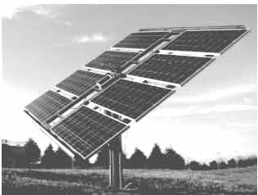1n a speech at the 9()lh Soience Congress, internationally acknowledged scientist and farmc.r **Indian** president **Mr APJ** Abdul Ka1am mentioned a Vf:!Y importmit aspect of thismankind's fu1ure energy crisis. He pointed out that1he era of woodand bie>­ mass has almost ccme toan.Clld.

The age of oil and natnra.1 gaa

would soon be over within the next few decades. Massive buming of world's coal reserves maylead to a worldwide ecological disaster beca11ae coalburning emits the highest amountof carbon in the atmosphere. So according to Kalarn, the onlysolutionth.at mankind canlook to is1he massive U8C of solar eneigyin

:future because it has someadvantages ovc,r otherforms ofnmewable c,n.ergies.

Now, why has Kalam put so much importance to the issue of energy? The energy sources have always been a major factor of change throughout history. The world's petroleum consumption has increased from 3 billion barrels annually in 1930 to 37 billion barrels annually today. In the next quarter century, the world's population is expected to be about 8 billion which is 30 percent higher than today. Developing countries will grow their economies about two times faster than industrialised countries. Global economic growth is expected to continue at 3 percent per year. Consequently, the global demand for energy will grow at about 1.7 percent per year on an average. It indicates a 50-percent rise of energy consumption by 2030. If the world's daily petroleum consumption is 100 million barrels now, it will rise to 150 million barrels by that time. The present reserve of hydro-carbon energy resources is limited and it will not be sufficient to meet the future energy challenges of the world. Hence, leading industrial countries have taken initiatives to use alternative energy sources mainly known as green or renewable energy sources. The bottom line of Kalam's speech indicates the concern of mankind in the 21st century.

**Questions**

* 1. What is the scientist Kalam concerned about?
  2. Why do you think the massive burning of coal may lead to an ecological disaster?
  3. What do you mean by the potential danger of nuclear energy?
  4. What according to Mr Kalam is the solution of future energy crisis?
  5. Why does Mr Kalam put so much importance on the issue of energy?
  6. Why does Mr Kalam put much importance on solar energy?

1. **Make sentences using the substitution table.**

|  |  |  |  |
| --- | --- | --- | --- |
| The energy industries |  |  | the use of renewable energy |
|  |  | taken | sources. |
| The global petroleum consumption | have has | been  emphasised | a major factor for change throughout history. |
| Major industrial economies |  | increased | to three billion barrels per year. |
|  |  |  | initiatives to tap alternative |
| Scientists |  |  | energy sources. |

1. **Complete the following passage with words from the box. There are more words than necessary.**

|  |  |  |  |  |  |
| --- | --- | --- | --- | --- | --- |
| suggested | radiates | would | effective | conducted either | energy |
| affected | cns1s | use | were |  |  |

To answer the energy.......... inthe world, scientist, professor, and former Indian president Mr APJ Abdul Kalam has ........... that solar energy can be harnessed by establishing space stations in outer space in order to.......... solar power round

the clock.

Mr Kalam said that the sun .......... about 10 trillion times the energy which humans consume across the world today.

If we ...... .... able to extract even a small portion of this energy from the sun, it be sufficient to secure the energy demands of our future.

Pointing out that space based solar power plants do not get by

weather, the scientist said that it would thus be far more m

efficiency and power generation than the surface based systems.

Professor Kalam suggested that the energy should be transmitted from space back to earth .......... through microwave or any other technology like laser. Careful research of the impact and safety concerns would have to be in

this regard.

1. **'Massive burning of world's coal reserves may lead to a worldwide ecological disaster** ...'--- **Do you support this view? Explain why/why not.**
2. **In Sohan's village, some people headed by Mr Asadul Islam came from an organisation to hold a meeting at the local Union Parishad (UP) Office. Their objective was to introduce alternative power supply systems in rural households. Read the dialogue between the UP Chairman and Mr Islam.**

Chairman What's your alternative power supply system?

Mr Islam Well, it's solar power and we are going to use solar power units in rural areas.

Chairman What is it? Is it something new?

Mr Islam Not exactly. It's already familiar in many parts of the world. We've introduced it in our country too. But yes, in this locality it's something new.

Chairman I see. Why do you call it 'alternative power supply system'?

Mr Islam Because solar power is a substitute for conventional electricity. It's actually a renewable energy source. Our solar units can be installed on open roof tops or at any open place where sunlight is available.

Chairman Sounds good. How much electricity can they give? Can they run my irrigation pump?

Forma-19, English For Today-9-10

Mr Islam I'm afraid Mr Chairman, they can't. Our solar panels are small and are designed for domestic purposes only. They can produce enough electricity to run say, two or three tube lights, two fans, a TV set and the like. But larger units can run...

Chairman Sorry to interrupt Mr Asad. I've to go to the bus stand now to receive a friend. Anyway, several villages in our Union are still without electricity. I hope people will welcome your 'alternative power supply system'.

Mr Islam : Thank you, Mr Chairman. Goodbye. Chairman : Goodbye, Mr Islam. See you again.

1. **True or False?** If **false, write the correct answer.**
   1. Alternative power supply system is a completely new system m our country.
   2. A renewable energy source can be a substitute for conventional electricity.
   3. Solar power units of Mr Islam are for commercial use only.
2. **What questions would you like to ask Mr Islam about solar panel, solar unit, energy sources, 'alternative power supply system', its capacity, its advantages and disadvantages, etc? Make a list of your probable questions.**
3. **Role play. Work in pairs. You take the role of the Chairman and your partner the role of Mr Islam. Rewrite the dialogue and act it out.**

Lesson 2: Renewable Energy Sources (Part 2)

1. Look at the following pictures and discuss with your partner what you see in them. How are the two pictures related to each other?



1. **Read the text and answer the following questions.**

Countries of the world rely heavily on petroleum, coal and natural gas for their energy sources. There are two major types of energy sources: renewable and non-renewable. Hydro-carbon or fossil fuels are non-renewable sources of energy. Reliance on them poses real big problems. First, fossil fuels such as oil, coal, gas etc, are finite energy resources and the worldeventually will run out of them. Secondly, they will become too expensive in the coming decades and too damaging for the environment. Thirdly, fossil fuels have direct polluting impacts on earth's environment causing global warming. In contrast, renewable energy sources such as, wind and solar enezgy are constantly and naturally replenished and never run out.

Most renewable energy comes either directly or indirectly from the sun. Sunlight or *solar energy* can be used for heating and lighting homes, for generating electricity and for other commercial and industrial uses.

The sun's heat drives the wind and this *wind energy* can be captured with wind turbines to produce electricity. Then the wind and the sun's heat cause water to evaporate. When the water vapour turns into rain or snow and flows downhill into rivers or streams, its energy can be captured as *hydroelectric energy.*

Along with the rain and snow, sunlight causes plants to grow. Plants produce biomass which again can be turned into fuels such as fire wood, alcohol, etc that are called *bioenergy.*

Scientists have identified *Hydrogen* as another form of renewable energy source. It is the most abundant element in nature. But it does not exist separately as a gas. It is always combined with other elements, such as with oxygen to make water. Hydrogen, separated from another element, can be burned as a fuel to produce electricity.

Our Earth's interior contains molten lava which gives off extreme heat. This heat inside the Earth produces steam and hot water which can be used as *geothermal energy* to produce electricity for heating homes, etc.

*Ocean energy* comes from several sources. Ocean's force of tide and wave can be used to produce energy. The surface of the ocean gets more heat from the sun than the ocean depths. This temperature difference can be used as energy source too.

**Questions**

* 1. What do you mean by renewable energy sources?
  2. What are the problems with non-renewable energy sources?
  3. What are the major differences between renewable and non-renewable energy sources?

1. **Which of the renewable energy sources mentioned in the text have you heard of before? One of those resources is used in the Chittagong Hill Tracts (CHT) to produce electricity. Can you say what it is? Browse the net in groups to find out the answers to the following issues and present them to the class.**
   1. What is the name of the project?
   2. Where in the CHT is the project located?
   3. When did it start operation?
   4. How much electricity is being produced from here for the national grid?
   5. How many units are working there?
   6. What is the positive impact of the project on our national development?
2. **Read the dialogue between Raju, a student of class ten and his uncle, Mr Barua who works at Sangu Gas Field and answer the following questions.**

MrBarua Raju MrBarua Raju

MrBarua

Raju MrBarua

Raju

**Questions**

What are you reading, Raju?

English, Uncle. A chapter on renewable energy sources.

I see. Do you know renewable energy is also called green energy?

Green energy?... No Uncle, I don't know. Nothing is there about green energy in the text either.

Are you sure? Anyway, renewable energy sources provide us with energy which doesn't harm environment during its production or consumption. Say, solar energy. You see, there's no burning, no smoke, no emission of gases. It's a sort of clean technology and clean energy source.

Oh exactly. That's what our teacher said, I remember.

On the other hand, burning fossil fuels, say oil or coal, emits greenhouse gases that harm the environment.

1. ... I see. Yes, I've got the clue, Uncle. Thanks a lot. I now understand the relation between the two pictures in section A. Green energy sources make a green globe.
2. Why is renewable energy called green energy?
3. 'Nothing is there about green energy in the text either'. --- Do you think this statement of Raju is correct? Explain why yes/no.
4. 'I now understand the relation between the two pictures in section A'. What does Raju mean here? What does he really understand? Do you agree with Raju's view here? Why?
5. **Read the dialogue and act it out in pairs.**
6. : What's *solar energy?*
7. : It's one of the renewable energy sources.
8. : Why is it called green energy?
9. : Well, it's green energy because it helps us keep the Earth green. I mean it doesn't emit any pollutants in the atmosphere when we produce and use it.
10. : I see. Then it must be a clean source of energy.
11. : Exactly. And that's why it's also called clean energy.

**Now complete the following dialogue taking cues from the above model.**

1. : What's wind energy?
2. : It's one of the .................................
3. : Why's it called ?
4. : Well, it's green energy because the

Earth green. I mean it doesn't ......................................

. when we produce

and use it.

1. : I see. Then it source of energy.
2. : Exactly. And that's why clean energy.
3. **Now write dialogues on *hydroelectricity, ocean energy, geothermal energy, hydrogen energy,* using the model in E above.**
4. **Both South and North Dhaka City Corporation are installing solar panels in place of conventional electricity connections to illuminate roads in many areas. Write a letter to the editor of a daily newspaper appreciating this initiative and saying why this should be followed by other city authorities too.**

**Unit Twelve**

## Roots



**Leamln& outcome,**

After we have studied'the unit, we will able to

* participate in conversations and debatea
* ex,;:hange personal information
* narrate incidents and events in a logical sequence
* presentownideas, give **andask** fur information
* wriw letters to newspapers
* lodge complaint
* prcsc:ntinfurmation in a chart.

152 Bvgfisb ForToday

Lesson 1: My Roots

1. How do you feel looking at the photo?

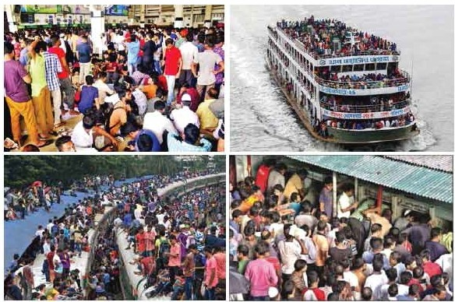

People rush to their roots ondiffi:rcnt occassions

1. **Read** the following tat.

Eid is the main religious festival of the Muslims iri Bangladesh. Eid means happine99. Bveyone want.a to share this happiness with near and dear ones. So mostof the people, who areliving outside their homesfordifferent reasons have a strong desire to get ha.ck home during lhe Eid vacation. As a result, there is **a** mad IU9h to board buses. trains, or laull(:bes for goinghome.This often causes

tmnsport accidents that take away many lives. However, these cannot step people from going home to meet their family, in-laws, or friends. What makes people rush for their homes in 8l)ite of serious hazards? This is nothing but people's desire to returnto the roots. Dohuman beings have roots like the trees? The amwer is 'yes' but unlike the roots of the trees they are invisible, they lie in our minds. It'sthese roots that make a bond 'between us and tamil.y

members, in-laws, friends, neighbours or even between us and the land where we were born and grew up. In that sense our families, our land of birth, relatives, our culture, traditions, or surroundings are our roots. And wherever we stay, we feel the power of our roots. It's our roots that develop our identity making us what we are. When we lose that bond, we become rootless. Human beings who do not have any roots are a non-entity. In other words, they do not have an identity. They don't know where they are from, and/or where they are heading to. This often makes them feel empty and lost.

1. 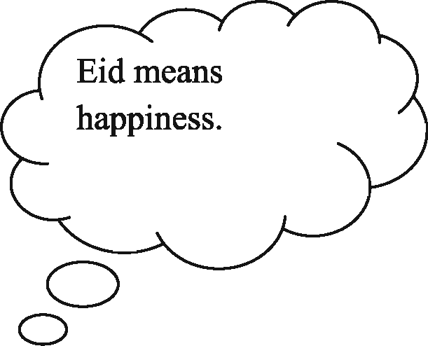 **Read the text in the speech bubbles. Make questions based on the bubbles and then compare them in pairs.**

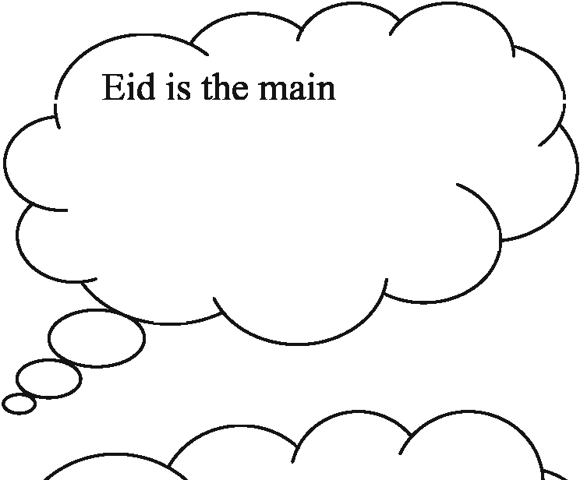

religious festival of

the Muslims in Bangladesh.

In that sense our families, our land of birth, relatives, our culture, traditions, or surroundings are our roots.

0

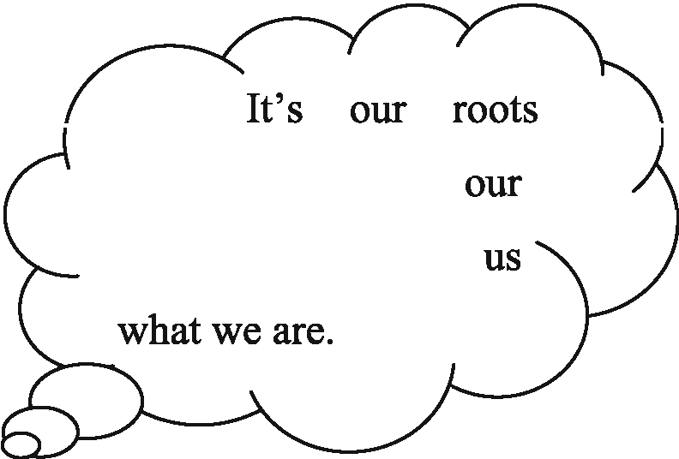

that develop identity making

Forma-20, English For Today-9-10

1. **Fill in the grid with appropriate information from the text above.**

|  |  |
| --- | --- |
| That makes our roots | The problems of a rootless person |
| 1. .................................... | 1. ........................................... |
| 2. .................................... | 2............................................ |
| 3. .................................... | 3............................................ |
| 4. .................................... | 4............................................ |
| 5. .................................... | 5............................................ |

1. **Work in pairs. Talk about these questions.**
   1. Do you have any root other than the place where you are living now? If

yes, where is it and who live there? If not, why not?

* 1. How do you label your roots? I have my roots in

CJ a remote rural village CJ a village CJ a semi-urban area (upazila)

c=J a small town c=J a midsize city c=J a suburb c=J a city

1. Do you feel any attraction for your roots?
2. How do you nourish your roots?
3. What, according to you, are the reasons why people become rootless?
4. **Make a classroom survey and present in a chart the types of roots your classmates have.**

###### Lesson 2: My Roots -2

**A Read the following remarks and find out who is like you.**

I simply just can't bear the people who don't have any respect for their roots.

- Haridas Soren

We have a moderately big house in a town but we frequently go to our village home as well. I always feel so at home when I visit my village and stay with my near ones.

* Bidisha Yasmin

I live in a small apartment with my mom, dad, and my little sister. Most of my relatives live in a village. I seldom go over there as I don't like village life.

* + lfti Mahmud

Some people are so eager to leave their own homes, friends, and everything behind only to be a part of the city life. They are not for me.

-Antara Gomes To be frank, I don't get used to visiting my relatives in the village.

* + Jhilik Ahsan

I live in a city but I never forget my parents are from a tiny but beautiful village. I know I have my roots there and I'm so proud of that.

-Anupom Chakma

I just can't stand the people who have grown up in the village but forget it once they are out from there.

- Debashish Biswash

**Now make your own statement about your roots.**

1. **Read the above statements of different people again and make two lists- one stating what they like and the other stating their dislikes.**
2. **Do you agree/disagree with their statements? Write down why.**
3. **Read the following text.**

Mainul Islam is a qualified farmer in Naogaon. Mr Islam was very brilliant as a student. He took his higher education from Bangladesh Agricultural University in Mymensingh. He then came back home and started advanced farming. He has two other brothers who are graduates in different disciplines. The specialty of the Islam family is that they all are living in their village and all are renowned in their own fields. Mr. Islam's younger brother, who is a Rajshahi University graduate, is a science teacher in a local school. His youngest brother is a social science graduate who likes to start a local NGO to work for this area. When asked "What makes you decide to stay here in this village?" Mr Islam smiled and said, "Look, it's true that we could leave this village for city life. I could be banker or my brothers could be bureaucrats. But it didn't attract us. We are sons of this soil. Yes, we have education but does education prepare a person only to be an officer? Don't we have any obligation to the soil that has made us what we are?" He also added that not every educated individual should be a job seeker. He added that since his discipline was agriculture, after his education he took the occupation of a farmer. In response to a question whether they had any frustration living in a village, he confirmed that they were indeed very pleased with their life. He said, "I work in my own farm, stay with my family members, pass time with my old friends, and sleep at my own home. All these count a lot."

Mr Islam is right. Many people go to cities and forget or loosen their roots knowingly or unknowingly. Mr Islam and his brothers are great-they haven't forgotten their roots. They not only stuck to their own roots, they have been torch bearers for others to be respectful of their roots.

1. **Work in pairs.** If **you are given a chance to meet Mr Islam, what questions would you ask him? Make both wh-questions and yes/no questions.**
2. **Read the statements in columns A and B. Then match them to make complete sentences.**

|  |  |
| --- | --- |
| **Column A** | **ColumnB** |
| 1. Mr Islam 2. The specialty oflslam's brothers is 3. Mr Islam never believes that 4. Mr Islam also believes 5. Staying with the roots | 1. if anyone has education she/he must have a job. 2. has multi-faceted opportunities.   **C.** graduated from Bangladesh Agricultural University.  d in the duty toward roots.  e. that city life couldn't attract them. |

1. **Do you like Mr Islam? Why/ Why not? Write down some reasons** in

**favour of your opinion and share with your partner.**

###### Lesson 3: The Return of the Native

**A Read the following text.**

Michael Madhusudan Dutt, was a celebrated 19th century Bangalee poet and dramatist. He was born in Sagordari on the bank of the Kopotaksho River, a village in Keshabpur Upazila under Jashore district.

From an early age, Michael aspired to be an Englishman in form and manner. Though he was born in a sophisticated Hindu family, he converted to Christianity as a young man, much to the ire of his family, and adopted the

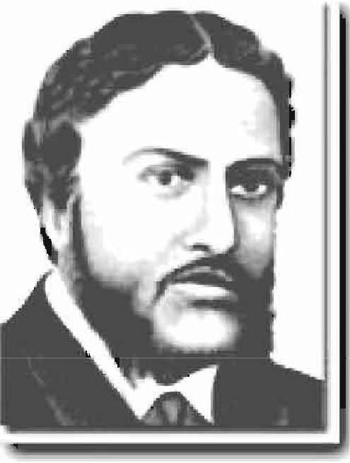first name Michael. In his childhood, he was recognised by his teachers as a precious child with a gift of literary talent. His early exposure to English education and European literature at home and his college inspired him to imitate the English in taste, manners and intellect.

Since his adolescence he started believing that he was born on the wrong side of the planet, and that his society was unable to appreciate his talent. He also

'""'I believed that the West would be more receptive to his

**":a**

creative genius.

Madhusudan was an ardent follower of the famous English poet Lord Byron. So after adopting Christianity, he went to Europe and started composing poems and plays in English. They showed his higher level of intellectual ability. However, he failed to gain the right appreciation. To his utter frustration he found that he was not esteemed as a native writer of English literature. Out of his frustration, he composed a sonnet in Bangla "Kopotaksha Nad" which earned him huge reputation in Bangla. Gradually he could realise that his true identity lay in Bengal and he was a sojourner in Europe. Afterwards he regretted his fascination for England and the West. He came back to Bengal and devoted himself to Bangla literature from this period. He has written the first Bangla epic *Meghnad BadhKabya.*

1. **Write notes about Madhusudan under the followin headin1:.,s. One is done for you.**

|  |  |  |
| --- | --- | --- |
| Madhusudan as a man | Madhusudan as a poet | Attitude to his roots |
|  | * celebrated 19th century Bengali poet and dramatist |  |

1. **Read some more information on Madhusudan. Make questions for those statements.** a................................................................................

He introduced *amitrakshar chhanda* (blank verse) in Bangla literature. b................................................................................

Madhusudan passed most of his European days in Versailles, France.

**C.**.............................................................................. .

His days in Europe were full of hardship.

1. ...............................................................................

It was unbearable to him as he had to suffer extreme poverty.

1. ...............................................................................

It was Iswar Chandra Vidyasagar who helped him to pay off his debts and return to India.

1. ...............................................................................

Madhusudan married twice. While living in Madras, he married Rebecca Mactavys of English descent.

1. ...............................................................................

Later he married Henrietta Sophia White, who was also ethnic English. h................................................................................

His second marriage lasted until the end of his life.

**1.** ...............................................................................

Madhusudan and Sophia had a son Napoleon and daughter Sharmistha.

**J.**...............................................................................

Madhusudan died in Calcutta General Hospital on 27 June 1873, three days after the death of Henrietta.

1. **Work in pairs and decide how the story of Madhusudan is related to the unit theme *Roots.***

**Lesson 4: In Search of Identity**

1. **Do you ever read the Problem Page in magazines or newspapers?**

**What kinds of problems do people often write about?**

1. **Here are two letters from the problem page in the** *Daily Bangladesh.*

**Read them and discuss with a partner what you think the content of**

"'"I **the letters is. Use a dictionary to check any new words.**

## Avajon's Problem page



*Yo-w cu-Wt ..*

DearAvajon

Often I'm so sorry to see the city's footpaths occupied by floating people. They are living in some makeshift shacks. I simply cannot think how father, mother grandfather, grandmother and kids-all live in such a tinyplace. Within the few square yards in their possession they sleep , socialise , cook and even beautify themselves. These people are living in such an inhuman condition! This cannot be the picture of life in a civilized society. Also they are polluting the area. They are leastbothered about their health and hygiene.Out of curiosity, I talked to some of these people. They have their own homes and identity in their own village. They are here thinking that life in the city will be better. What an irony! Can't the society or the state do anything for these people? However, I must admit that I'm amazed to see how they sometimes tidy up their places especially in the evening! Home, sweet home after all !

Mithun

DearMitbun

Iunderstand yourconcern. The movement of people from the rural areas to the urban areas isa big social problem in many countries like ours. These floating people are definitely a burden to the cities where they migrate. When the number is huge, it is difficult for any state to rehabilitate them quickly. See from the other side. The people you have referred to have lost their roots and they are unable to assimilate in the new culture. Maybe many of them are attracted by the charm of the cities, but I'm sure it was a need to many others. People become rootless sometimes due to climate change, river erosion, social discrepancies, or poverty. However, you cannot solve this problem overnight. But you can certainly take steps to improve their lifestyle. Why don't you form a committee with other young people in your locality that will teach them basic health and hygiene? It may help them to minimise pollution. Give it a try.

Yours

Avajon

1. **Look at the texts. Say who/what *they, their, this, that, it* refer to in the following sentences.**
   1. They are living in some makeshift shacks.
   2. Within few square yards in their possession they sleep, socialise, cook and even beautify themselves.
   3. This cannot be the picture of life in a civilized society.
   4. Why don't you form a committee with other young people in your locality that will teach them basic health and hygiene?
   5. Give it a try.
2. **Work in pairs. First write two problem letters. The problems can be personal or of your locality as in B. Read your partner's problem and give suggestions.**
3. **Work in groups. Take roles as a TV Anchor, Mojnu Mia, Fazlur Rahman, and Nilima Chowdhury as given in the following text. Put suitable verb form into each gap of the text related to your role. Then act out the talk show.**

TV Anchor : Viewers, ................... to our program 'Looking back to roots'.

Today we ................... three guests with us-Mr Mojnu Mia, a slum dweller, Mr Fazlur Rahman, an immigrant to UK, and a social scientist Nilima Chowdhury. Today we ...................

to see how people ................... when they are detached

from their roots, what might some consequences,

and how a social scientist ................... them. Let me

................... to Mr. Mojnu Mia. Mojnu Mia, where ............ you from and why and how have you ................... to this city?

Forma-21, English For Today-9-10

Mojnu Mia : I'm from Sherpur. You ................. it's a river erosion-prone area. The river has washed away most of my agricultural land. It has ................... my home as well. Now you can

................... that I'm a refugee. I and my family members.

.. .. .. .. .. .. .. .. .. . to this city with our last savings. But I'm

fed up with the life here. I ................... vegetables as a hawker. I ...................very hard. I can't ................... any time to my wife or kids. I ................ in a slum. It's very dirty. People are sometimes involved in different sorts of crime. My kids don't ................... it. Neither my wife nor me. In the

village, everybody used to . .................. us but here no one knows me. I have nowhere to ..............., none to ...............

beside me. Nobody ................... me. I the city

will give me a moderate life. But I'm mistaken.

TV anchor : Right. We are really sorry to ................... about your situation.

Now let us ................... to Mr Fazlur Rahman. Mr. Rahman,

why did you ................... your country and how are you feeling in the UK?

Fazlur Rahman: Well I was young when I went to UK. My first few years were terrible. I .. .. .. .. .. .. .. .. .. . all kinds of odd jobs. Gradually I .. .. .. .. .. .. .. .. .. . experience. I ................... different professional training courses. And over the period my language .................... Now I'm a citizen there. I

................... my own detached home, personal car, and

business. When I .. .. .. .. . .. .. .. .. .. there I was a poor man but

now I'm a rich man. I ................... a good amount of

income tax but to be honest, when I .. .. .... .. .. .. .. .. . to my own

country, I wish I should not .. .. .. .. .. .. .. .. .. . to UK. It's my

own country. I .................. my friends and family members *81*

C'.I

here. I miss my culture, tradition, food, and what not? I

.. .. .. .. .. .. .. .. .. . there for more than 15 years but still there is a distinction between the native people and expatriates like me. Perhaps we will never shake off our identity as foreigners.

TV Anchor : Ok, let us ................... the explanation of these problems from a social scientist, Nilima Chowdhury. Ms Chowdhury, what are your interpretations of these problems?

Nilima Chowdhury: You see, this problem is often diaspora.

A diaspora is created through migration, or scattering of people away from an established or ancestral homeland. There might be different reasons for that. It may be due to government action, political decisions or for avoiding conflict and war. Diaspora has some common consequences. Once people are away from their roots, they have a kind of culture shock. They take time to

......................to the new culture. Sometimes they never integrate. This ............. them a feeling of home sickness. In spite of their strong fascination for homeland or hometown diaspora

people ....................to get back to their roots because of

ecomomic and social realities. As a result, they have a kind of mental conflict and identity crisis which make their life restless. Sometimes a lack of social acceptance coupled with economic hardship, inadequate education, and loose family ties people

. mvo1ved' m

.cnmes. Yiou may ask", D

oe.s 1t. ..........

that people won't ...................to other cities/ countries?". People will, as it is 21st century when the world is a big global village. But we .................. to be aware of the problems

created by migration. It's a reality that people with better ties with their roots suffer less from this problem. So instead of being allured by the 'better life' we can .................. to be happy with what we have and gradually try to develop our condition without forgetting our roots.

Unit Thirteen

### Media and Modes of E-communication



**Leaming outcome&**

After wehave studied thisunit.wewill be able to

* surf theInternet
* readand write emails
* nmate incidents ina logical sequence
* understand text.s
* readintensively andextensively
* participate indebates.

Lesson 1: Media and Modes of E-commuoication

1. **Look at** the **pictures and say what you see** in **them.**

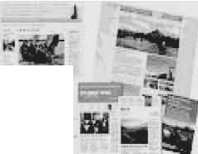

1. **Work** in **pairs. Discuss which of the following words you are familiar**

with. **How are they related** to e-communication?

facebook, e-mail, web site, blog, e-commerce, twitter, e-leaming, iPod,

tablet pc, information super high **way,** social network, smart phone

**C Read the text and answer the questions that follow.**

Let's imagine a citizen's

ordinary day at work. The •

morning probably starts with a llJll.tlralt

o:

CC:



*, 1*

Subj,ttllel•Mn

Da11:Thl,,*61'"* 200l22Jl-53•10IOO

cup of coffee/tea, followed by

!l!!illW

**W.\l! r,,.!I** ,,

...,.

greeting the colleagues. Then GJfJWJll

comes the inevitable, which is

SilWl

log in the computer. For many ll!!Jii!d ►

!i'.lilMtill.

of us the third step has become

an automatic behavior and it dominates the rest of our work • Ut.ltJr..., day, receiving and sending c.f" dozens of emails.

An e-mail is an electronic

**mail.** It **isa computer-aided**

way of exchanging digital text

H1wArij \'llUI

Lon time Inc."'"w r,In t ,,taLL

Hoad rhaLy uar• ·•ul1g,pr,n1011 a1,;1e 1or mannier,

,;I 11yt..,lwhh1ttlo1 U,•rnme.

I a,n ine nne ouL!ere, w°"1s;;,o l!"fng( .

I••P '" v,uch.

s."_"'_"'"'_•bl_"'-"'_m_•B_e•_.P. _"r_1u,_111_0_,,._.,_-,,_.,.. _no_,.._•t• ,"'

messages from a sender to one or multiple recipient/s. E-mails operate through a network of computers linked by the Internet. There are commercial server agencies such as Yahoo, Gmail, Ymail, Hotmail, etc. that accept the text message from the sender, forward it and deliver instantly to the digital mailbox of the recipient. If the recipient is not online, the message is stored and delivered later when the recipient is online. It works instantly just with the click of your mouse. It has been a powerful communication tool in modem life.

**Questions**

1. What is an e-mail?
2. How do e-mails operate?
3. How do the commercial servers serve in the process of an e-mail?
4. 'It has been a powerful communication tool in modem life.' Explain the statement.
5. How do e-mails affect our daily work schedule?
6. **Work in pairs and discuss the steps of your normal days, weekends, etc.**
7. **Pairwork. Read the following e-mail exchanged between two friends. Like an informal letter, an e-mail to a close one is casually written. Identify the mistakes in the main body of the message, discuss with your partner, and correct them.**

**Subject: Details of Dhaka Tour**

FROM: TO:

Alexa [Dowson<alexa.dowson@yahoo.com>](mailto:alexa.dowson@yahoo.com) Moutushi [Laboni<moutush](mailto:moutushil997@ymail.com)il [997@ymail.com>](mailto:moutushil997@ymail.com)

Monday, 21 May 2012 6:20 AM

Hi Moutushi!

Thanks for your mail. rn fly from Ottawa on 7:36 hours local time on 13 July with Qatar Airlines via London-Doha and land Dhaka on 15 July around 13:41 hours local time. Wish to stay 2 days in the Cox's Bazar and 1 day in Khulna. Return flight on 21 July at 3:04 hours local time.

Keep in touch and stay fine. Hope to see you soon! Alexa

1. **Pairwork. The e-mail in section E is a reply by Alexa to Moutushi's previous e-mail. Imagine what Moutushi might have written to Alexa. Write that e-mail.**
2. **Read the following text.** It **gives the information about the origin of the e-mail. Choose the appropriate forms of the verbs from the box to complete the sentences. You can use a verb more than once.**

send say use remam call expand allow develop spread

Sending text messages electronically could be to date back to the

Morse code telegraph of the mid 1800s and the 1939 New York World's Fair. In the fair, IBM ................ a letter of congratulations from San Francisco to New York on an IBM radio-type, ................ it a high-speed substitute for mail service in the world of tomorrow. Teleprinters were in

Germany during World War II. The use ... ...... ... .... until the late 1960s when there was a worldwide Telex network. Additionally, there was the similar American system ................ TWX which important

until the late 1980s.

With the introduction of MIT's Compatible Time-Sharing System (CTSS) in 1961, for the first time multiple users were ......... ....... to log into a central system from remote dial-up terminals. They were also able to store and share files on the central disk. Informal methods of using this to pass

messages ................ and were ................ to create the first true e-mail system.

1. **Read the following grid first. Then listen to the Audio and tick the right box in the following grid.**
2. **Listening text 10**

<Y-i **Comparison among e-mails, phone conversations and face to face meetings**

8

|  |  |  |  |  |  |  |
| --- | --- | --- | --- | --- | --- | --- |
|  | time-consuming | | reliable | | efficient | |
| less | more | less | more | less | more |
| E-mails |  |  |  |  |  |  |
| Phone convenations |  |  |  |  |  |  |
| Fto F meetings |  |  |  |  |  |  |

I **Group work. Arrange a debate in the class on the advantages and the disadvantages of the e-mail.**

###### Lesson 2: Social Network Services

1.  **Look at the following logos. Are you familiar with them? Discuss with your partner what they are and how they are related to** the **field of e-communication.**



**facebook**

1. **Read the text and answer the following questions.**

The Internet technology has helped desgin a large number of web sites to facilitate social relations among people around the world. These are known as social networking services or social networks or social media. At present, Face­ book is the *most popular social media site. Google+,* Twitter, Linkedln, etc. are other frequently used social services. Social network services are web-based and hence, provide ways for the users to interact through the Internet. *These services* make it possible to connect people across the borders and thus *have made the users feel that they really live in a global village.*

Why are social networks expanding so fast? The answer is simple. Most of the social services are cost-free. You can make use of them free, paying a very little to your Internet service provider. *Secondly,* you can make your personal profile public before the entire online community. It is like presenting yourself before the entire world. You can also look into other people's profile if you are interested. It is simple and easy. *Thirdly,* social networks allow users to upload pictures, multimedia contents and modify the profile. Some services like Facebook allow users to update their profiles. *Fourthly,* networks allow users to post blog entries. User profiles have a section dedicated to comments from friends and other users. *Finally,* there are privacy protection measures too. A user himself or herself decides over the number of visitors/viewers, and what information should be shared with others.

**Questions**

* 1. What do you understand by social networks?
  2. What are some uses of social networks?
  3. 'These services ... have made the users feel that they really live in a global village'. Do you agree with this view? Why/ Why not?
  4. Make a list of the arguments as to why social networks are expanding so fast. Why do you think this is happning?

1. **Read the second paragraph of the text in section B again. Notice the words in italics and write how they work in maintaining logical sequence in the paragraph.**
2. **Choose the best answers.**
   1. The technology has helped social networking sites to emerge. a Linkedin b Google+

c Internet d Twitter

* 1. Users have to pay for

a social networks. b c multimedia contents . d

their online connections. uploading pictures.

* 1. User accounts have protection measures.

a virus b identity c personal secrecy d network

* 1. User profiles have a section for

a others' remarks. b outsiders' editing.

c outsiders' moderation. d outsiders' uploading.

Forma-22, English For Today-9-10

1. Fillin the following dialogue box to open a Facebook account.



"'

,S.i,gtcnCUpWro:,.,FQaIaMbo(odkw+tlil .,. ,.,.. ffN(I' -,..,..

nfrllMr.,.".."..'".,'E-l "o",r.,.G,..m..,•tG

1. 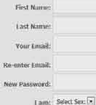 **Look** at **the following table adapted from Wikipedia.** It **shows some data on worldwide use of social networks.**

|  |  |  |  |
| --- | --- | --- | --- |
| **Social Networks** | **Individual usen** | **Percentage (o/o) of**  **J)Opularity** | **Regions covered** |
| Facebook | 792,999,000 | 55.1 % | worldwide |
| Google+ | 250,000,000 | 17.7 % | worldwide |
| Twitter | 167,903,000 | 11.7 % | worldwide |
| Linkedln | 94,823,000 | 6.6% | Asia and Europe |
| MySpace | 61,037,000 | 4.2% | USAandCanada |
| Others | 255,539,000 | 17.8 % |  |
| **Total** | **1,438,877,000** | **100%** |  |

**Now complete the following dialogues about Facebook and MySpace, and provide your own questions and answers on the rest of the social** networks in the table. Act them out in pairs.

* 1. Q: social network is the most popular ?

A: Facebook is

Q: individual users use Facebook? A: About 793 million.

Q: part of the world is Facebook mostly used in?

A: Worldwide. It's popular worldwide among individual users.

* 1. Q: the least popular? A: **MySpace** is _ Q: individual users use **MySpace?** A:

Q: mostly used?

A: among individual users.

*(Continue)*

* 1. ... *4...*.... 5.......

###### Lesson 3: E-learning

1. **Look at the following picture. What objects do you see** in **the picture?**

**How are they related? Discuss with your partner and say what these are.**



1. **Work in pairs. Discuss the following questions.**
   * Have you ever experienced any digital education programmes m multimedia or CD/DVD?

172 BllglilhForToday

* + Have you ever usedanydigitized educational resources such as Ox.ford Dictionary, Banglapedia or Wikipedia?
  + Have you ever heard of anyon1ineeducation course?
  + Have you ever seena classroom teaching progxannn.. on TV?

1. Readtile text ancl answer the following quesd.om.

Can you think of a classroom where there is no blackboard or desks? Do you believe thatyoucan bea student without a printedbook ora writingpad oreven pen/pencil? AR you not thrilled to imagine that you have asked a question and your tutoris answeringit while flying in a Boeing fromDubai toDhaka? These arcall possible in a 'virtualcampus' in 1hesystem of e-1.eaming. Nokidding( For quite a long time, educationists have been utilizing the advantages of computer technology. The social networking services have a huge pcrtcntia1 to help educationists in this sector. They have access **to** milliom of people worldwide. Educationists have noticed that a large number of social netwotk users come

fromyoung generation whoespecially belongto student C(\mmnaity. Soside by side with computer assisted teaching-lea.ming software, online education programmes areevolving fairly rapidlyto assist conventional educationsystx:m. Is that e-leaming?

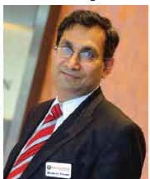We may confuse distant education or computer-based learning or computer­ assisted training or even on1ine education progiannn"11with c-leaming. But we should becautious about the mix-11p. What happens in

anonline education pn,gxamm.,? Maybe you getsome materials online from your tutor. Maybe you submit your assignment throughemail. Or even youmay take your t.est online. But there must be some conventional campus, a department/institute from where your certificate will come. But in e-learning. as said by global e-leaming guruDr Badrul H Khan•,everystep, such as registration, admission. classroom entry and

exit, class wo:tk, attendance, discussion with course Dr Badrul H Khan mat.es, feedback,. exams -IIDd finally certification must take place electronically through computer and the Internet technology in a.virtual campus.

Everything is digitised and conducted by a system called Learning Management System (LMS). So online education programmes blend various components of e-learning.

The revolutionary concept of e-leaming is already in its practice phase in many parts of the world. Professor Khan has developed a framework and important literatures on e-leaming which have been praised by pundits worldwide He is especially enthusiastic about the prospect of e-leaming in Bangladesh.

How would you feel if Bangladesh contemplates establishing South Asia's first virtual university? Won't it be a pioneering step for us in the world of e-leaming? Let's keep our fingers crossed.

*\*Born in Bangladesh and graduated in the United States, Dr Badrul H Khan was a Professor at George Washington University and the University of Texas, USA. He is one of the celebrated theorists in the field of e-learning.*

1. **Write an e-mail to your teacher expressing your feelings and opinion regarding the next mode of education** - **e-learning. Also ask your teacher to clarify if anything in the text is unclear to you.**
2. **Suppose Dr. Badrul Buda Khan has come to visit your school and intends to meet students for a presentation on e-learning. Write a text message to invite your friend to attend the presentation.**
3. **Complete the following sentences with suitable words.**
4. Education experts ............ ............. utilizing the advantages of computer technology a long time.
5. In e-leaming, everything from admission to certification must ..............

. electronically through computer and the Internet technology

in a virtual campus.

1. In some online courses, you ....... ..... your test online.
2. In case of online programmes, there ...................... some conventional campus from where
3. In e-leaming, all activities ....................................... by a system

"'"l called Leaming Management System (LMS).

I""!

UnitFou.rteen

## Pleasure and Purpose

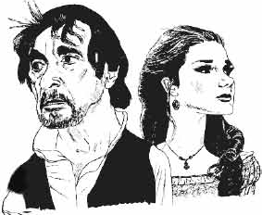

Leanhta Olllall!Ha

Aftorwobavo dlodlbe unit, wowlllbo ableto

* lllldlllle>Ba,lllishllOlllldl, alms,and i:olonllion
* undcatmd 8Ddc:qaylloricsandod!.crtcxta
* inte.tpm,evaluo!&, ml «ammeriJe imlnltytsm.

**Lesson 1: Books**

1. **Ask and answer these questions** in **pairs.**
   1. Do you read any books other than your school textbooks?
   2. If yes, what kinds of books do you read? (stories, poems, etc)
   3. Now write one or two reasons why you read those books and share with your partner.
2. **Read the poem.**

**Books**

What worlds of wonder are our books! As one opens them and looks,

New ideas and people rise

In our fancies and our eyes.

The room we sit in melts away, And we find ourselves at play

With some one who, before the end, May become our chosen friend.

Or we sail along the page To some other land or age. Here's our body in the chair, But our mind is over there.

Each book is a magic box,

Which with a touch a child unlocks. In between their outside covers Books hold all things for their lovers.

**Eleanor Farjeon**

1. **What does the poet say about the good things that reading a book can do to you?**

**What other benefits do you think reading books can give you?**

###### Lesson 2: Two Mothers Remembered

**A Read the poem and answer the following questions Two Mothers Remembered**

I had two Mothers - two Mothers I claim

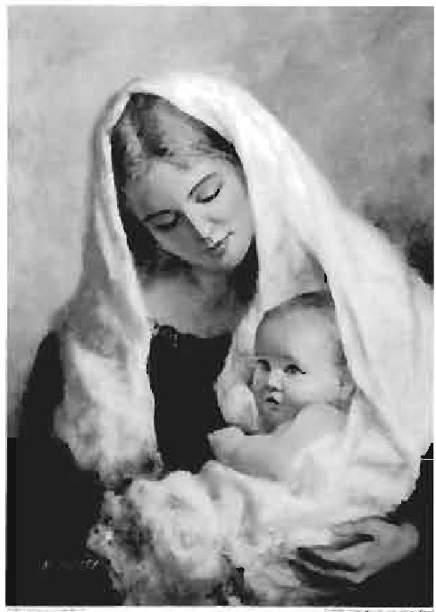Two different people, yet with the same name. Two separate women, diverse by design,

But I loved them both because they were mine. The first was the Mother who carried me here, Gave birth and nurtured and launched my career.

She was the one whose features I bear,

Complete with the facial expressions I wear. She gave me her love, which follows me yet, Along with the examples in life she set.

As I got older, she somehow younger grew,

And we'd laugh as just Mothers and daughters do. But then came the time that her mind clouded so, And I sensed that the Mother I knew would soon go. So quickly she changed and turned into the other,

A stranger who dressed in the clothes of my Mother. Oh, she looked the same, at least at arm's length, But now she was the child and I was her strength.

We'd come full circle, we women three,

My mother the :first. the second and me.

And if my own children should come to a day, When a new Mother comes and the old goes away, I'd ask of them nothing that I didn't do.

Love both of your Mothers as both have loved you.

**Joann Snow Duncan10n**

**Questions**

**Ask and answer the questions** in **pairs.**

1. How are the two mothers different from each other?
2. How are they the same?
3. What did the first mother do to the speaker?
4. Who was the speaker's second mother? Describe her briefly.

*S* What would be the speaker's advice to her own children?

1. Who are the three women referred to in the poem? Briefly descnl>e them.
2. What should children do to their mother and why?
3. Do you like this poem? Why?

**Lesson 3: The Sands of Dee**

1. **Listen to the poem. Read it aloud** In **groups.**

**The Sands of Dee**

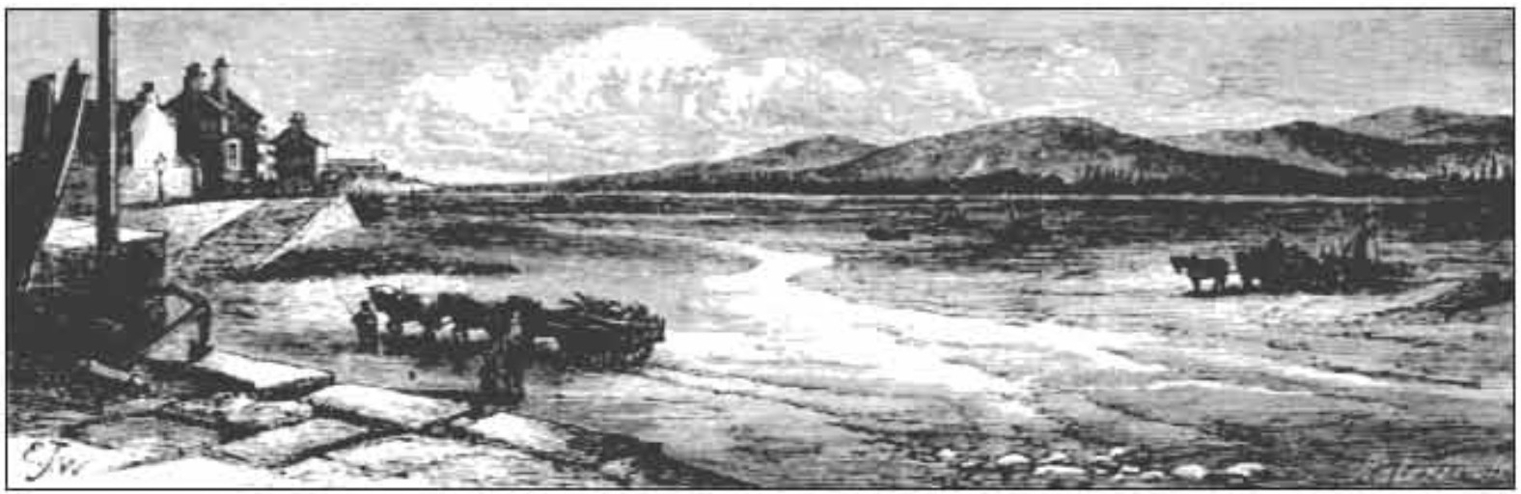

Fonna-23) English For Today-9-10

"O Mary, go and call the cattle home, And call the cattle home,

And call the cattle home

Across the sands of Dee!"

The western wind was wild and dank with foam, And all alone went she.

The western tide crept up along the sand, And o'er and o'er the sand,

And round and round the sand,

As far as eye could see.

The rolling mist came down and hid the land And never home came she.

"Oh! Is it weed, or fish, or floating hair, A tress of golden hair,

A drowned maiden's hair Above the nets at sea?

Was never salmon yet that shone so fair Among the stakes of Dee?'

They rowed her in across the rolling foam, The cruel crawling foam,

The cruel hungry foam,

To her grave beside the sea:

But still the boatman hear her call the cattle home Across the sands of Dee.

**Charles Kingsley**

1. **Answer these questions.**
   1. What was the weather like when Mary went to bring the cattle home?
   2. Look at some words, phrases and sentences that have been repeated several times. Explain why the poet has done that.
   3. How has the poet described the sea?
   4. Narrate the story of Mary in your own words.
   5. Suppose you were walking on the shore with a couple of your

friends while Mary was drowning. Describe what you would have done.

###### Lesson 4: Time, You Old Gipsy Man

1. **Read and answer the following questions.**
   1. Have you ever seen a gipsy? If yes, where?
   2. Do gipsies live in our country?
   3. In what ways are they different from the general people?
2. **Now read the poem and answer the questions that follow.**

**Time, You Old Gipsy Man**

Time, you old gipsy man, Will you not stay,

Put up your caravan

Just for a day?

All things I'll give you, Will you be my guest? Bells for your jennet Of silver the best,

Goldsmiths shall beat you A great golden ring,

Peacocks shall bow to you, Little boys sing,

Oh, and sweet girls will Festoon you with may. Time, you old gipsy, Why hasten away?

Last week in Babylon, Last night in Rome, Morning, and in the crush Under Paul's dome; Under Paul's dial

You tighten your rein­ Only a moment

And off once again; Off to some city

Now blind in the womb, Off to another

Ere that's in the tomb.

Time, you old gipsy man, Will you not stay,

Put up your caravan Just for a day?

**Ralph Hodgson**

**Questions**

* 1. Why does the poet call time an 'old gipsy man'?
  2. Make a list of things the poet will offer time if it stays just for a day.
  3. What else can you offer time if it stays for a day?

**Lesson 5: Stopping by Woods on a Snowy Evening**

1. **Ask and answer these questions.**
   1. Do you enjoy natural beauty like flowers, trees, woods, hills, etc.?
   2. Have you ever been to a place where you enjoyed such beauty? If yes, briefly describe it.
2. **Read the poem and say how the words** in **each stanza rhyme. For example,**

in stanza 1 *know* (line 1) *though* (line 2) and *snow* (line 4) rhyme with each other.

**Stopping by Woods on a Snowy Evening**

Whose woods these are I think I know. His house is in the village though;

He will not see me stopping here

To watch his woods fill up with snow.

My little horse must think it queer To stop without a farmhouse near Between the woods and frozen lake The darkest evening of the year.

He gives his harness bells a shake To ask if there is some mistake.

The only other sound's the sweep Of easy wind and downy flake.

The woods are lovely, dark and deep. But I have promises to keep,

And miles to go before I sleep, And miles to go before I sleep.

**Robert Frost**

1. **Answer the following questions.**
   1. Where do you think the poet is going? Why is he going there?
   2. Why did the poet stop by the woods though it was dark and he was alone?
   3. Guess what promise the poet had to keep before he would sleep.
   4. Write an imaginary dialogue between the poet and his horse.

###### Lesson 6: The Purple Jar (Part-1)

1. **Think about the following situation.**

Suppose your mother / father has given you some money to spend on anything you like in a fair. Going round the fair, you have shortlisted the following items:

* 1. a beautiful decorative wooden horse
  2. a colourful shirt / *kamiz* of latest fashion
  3. a box of delicious chocolates for your family
  4. a golden pen---a gift for your best friend

But you have money enough to buy only one thing. Write a paragraph about what you will buy and why.

1. **Read the story and answer the following questions.**

Rosamond, a little girl about seven years old, was walking with her mother in the streets of London. As she passed along she looked in at the windows of several shops, and saw a great variety of things. She wanted to stop to look at them and buy them all, without knowing their uses or even without knowing their names.

At first they stopped at a milliner's shop. The windows of the shop were decorated with ribbons, lace and festoons of artificial flowers.

"Oh, Mamma, what beautiful roses! Won't you buy some of them?" "No, my dear."

"Why?"

"Because I don't want them. They are not real flowers."

They went a little further and came to a jeweller's shop. In it were a great many pretty, bright ornaments of little value, set beautifully behind the "'"l glass.

Plemuxe11:Ddl'wpoae

"Mmnma, willyou buy some ofthecoT'

"Whichoflhem, R01a111cmd'l"'

"Wbi¢h?l don't know whicli.LQok at di earrinp, 1hatneclc:J....,,1hoaopondmtal Anyof themwilldo, they8l'O IO pretty!"

"Yea, they areenpretty,but of what ue would

they be:to *m,/f''*

"I amm. Lfamtna,youcouJd:findsome1JSO

if you only boughtthem fir&L"

"ButI would ratherfindout the usefint."

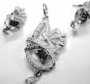

*(")..._*

'

i *r* J

Th.OQgh**a** liUl.e Rosam,;mdkt:ptonlookingat theshope a"ridtried10

persuacJo her moCh«to buy1hisor tbaL

"Mamma, 'bucklea an: useful thins&-Pleasebuy some."

"Ill.ave a pairof buckle&. I don't needanynow."Soaayinghermotherwalktd

on.

QantiODII

* 1. Maba listof tbiDgs R.oc•JlYJlldwanll,cito b'Jl}'.
  2. How did1h11 Dl'ltiner'• shoplooklih?
  3. WhatC1IIIyou aooill a je'Weller'sshop ina town/cityin Bengl•de41,

whidiyou know wdl?

Lesson 7: ThePurple Jar (Part-2)

1. **Rud more** of Che atwy,

This nmo Ro11111ond Wl8 mi1ly dibijptw **at 1-** mother wamd nothing. Ho-wevtt, while they werepesring hy **a** d!emillt'a shop, shesaw somejam--blile,gr-.red,yellow mr,dpurplo and w seemed to have

a fascillatio!I.fur a puiple jar. But her mother aniWtl:ed aa befure, •or

:;: whit UJO would111.iybo1ome.lloaamoad?"

"Oh, Mamma, I would use it for a flower pot."

"But you have a flower pot and the jar you are dying for buying· 1s not a flower pot."

"Yiet, Mamma, I l1"k.e 1t so much I"

Then suddenly she cried, "Ouch! A stone, mamma, a stone has got in my shoe. It hurts!"

"Oh! How did it get there?"

"See, there's a hole in my shoe, Mamma. In fact, my shoes are quite worn out. Would you be so good as to buy me another pair?"

"But, Rosamond, I haven't got money enough to buy shoes, jars, jewellary, buckles and all that you wish to buy."

Rosamond became sad again. Her mind flashed back to all those beautiful things she had seen that morning.

"But, Mamma, I like the purple jar very much. And now my foot hurts. Could you buy me only these two things --- the jar and a pair of shoes, please?"

"No, Rosamond, you can buy only one thing. However, you may buy the other thing next month. And you have to decide which one you would like to buy now.'

"I need the shoes badly," Rosamond began to argue with herself, but my heart is in that beautiful jar."

Then looking at her shoes, she told her mother, "These shoes are not so bad, except for the hole in one. I think I can make them last till the end of the month, can't I? Don't you think so, Mamma?"

"I want you to think for yourself, dear."

"Okay, if you please, I would like to have the purple jar.' "Very well, you will have it."

1. **Tick the best answer.**
   1. Which is the correct statement?
      1. Rosamond saw the chemist's shop from a distance.
      2. She liked the jars of all the colours equally.
      3. She had a special liking for a jar of a particular colour.
      4. Her mother found some use of the purple jar.
   2. Rosamond wanted to buy
      1. all the jars. b

c a flower pot. d

the purple jar. a useful pot.

* 1. The money Rosamond's mother has can buy only a one thing. b two things.

c three things. d four things.

* 1. Why did Rosamond persuade her mother to buy her a pair of shoes?

Because

* + 1. her shoes had become old and ugly.
    2. she had no money to buy the purple jar.
    3. the shoes in the shop were very beautiful.
    4. a stone got in her shoe and was hurting her.
  1. What made Rosamond finally decide to buy the purple jar?
     1. the beautiful size of the jar
     2. her mother's inability to buy the shoes
     3. her shoes being not so bad
     4. the beautiful colour of the jar

###### Lesson 8: The Purple Jar (Part-3)

1. **Read the last part of the story to see what happened to Rosamond's beautiful purple jar.**

Rosamond and her mother were going back to the chemist's shop. As they were walking, Rosamond had to stop once again to take another stone out of the broken shoe, and she often limped with pain.

Forma-24, English For Today-9-10

When they got back to the shop, Rosamond's mother asked her to carefully examine the jar before she bought it. But Rosamond was so excited that she bought it even without looking at what was inside the jar.

Happily she came back home with her mother. Then Rosamond quickly brought some flowers from the garden and was going to put them into the jar. But as soon as she took the top off, she saw something dark inside, which gave off an unpleasant smell.

"What is it, Mamma? I didn't want this black thing and the terrible smell."

"Nor did I, my dear."

"But what shall I do with it?" "That I can't tell."

"Okay, Mamma, I must pour it out and fill the jar with fresh water."

Then she made the jar empty. But to her great disappointment, she found that it was no longer a purple jar --- it was a plain white glass jar. With its coloured water gone, the jar did no longer look beautiful.

Rosamond cried with tears of disappointment in her eyes. She also cried for her folly. Every day her shoes grew worse and worse, and she could neither run, dance, jump, nor go shopping with her mother.

Thus Rosamond suffered for a whole month and learned a lesson the hard way. She hoped that she would be wiser in future.

**Adapted from The Purple Jar by Maria Edgeworth**

1. **Answer these questions.**
   1. Why didn't Rosamond examine the jar before buying it?
   2. What did she take the jar for?
   3. How did she come to know that the purple jar was in fact a plain white glass jar?
   4. Describe her sufferings and disappointments for buying the purple Jar.
2. **Read all the three parts of the story again and answer these questions.**
   1. How did Rosamond try to persuade her mother to buy all the pretty things she saw in the shops?
   2. How did her mother try to stop Rosamond from buying all the things she wanted to buy?
   3. Write two paragraphs-one about Rosamond and the other about her mother. Use words and phrases from the box below, which are appropriate for each character. You can also use your own words and phrases.

a seven year old girl, use, disappointed, purple, worse, lesson, sufferings, artificial, ornaments, pretty, liking, worn out, persuade, beautiful roses, disheartened, enough, badly, examine, unpleasant

smell, stupidity, emotional, practical, decide, limped

###### Lesson 9: A Pound of Flesh

1. 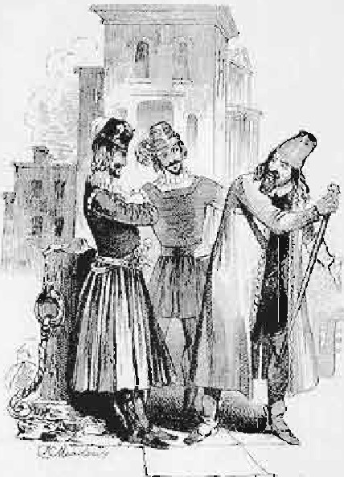**Look at the picture and ask and answer the questions.**
   1. What do you see?
   2. What are the three persons doing?
   3. What type of clothes are they wearing?
   4. Are you familiar with such clothes?
   5. Who wears such clothes?
   6. Mention which clothes of our country are close to the ones the men are wearing in the picture?
2. **Read the text.**

*":i*

Once upon a time in Venice, Italy, there was a very rich merchant named Antonio. He had many ships that sailed in the sea. His ships carried different types of merchandise to other countries. He sold those goods there. He bought spices and other valuables from foreign countries and sold them in Venice.

Antonio was a good and kindman. He always helped the poor. The people of Venice lovedhim very much for his honesty and kindness.

Antoniohad a close friendnamed Bassanio. He wu a handsome young manand was bom ina noble family. Bassanio likedtolive a very luxurious life. He loved grandeur and style. He spent more money than he earned. As a result, he was very often short of money. In such situations, Bassanio would go to his best friend Antonio for help. Antonio would helphim with cash.

It sohappened that Bassanio fellinlove witha wealthyladynamed Portia. Portia was known not only for her beauty but also for her wisdom. She was soft towards Bassanio too.Hewanted to visit Portia ina grandmannerbut hedid not have any money. So he went to Antonio.

Bassanio said, "Dear friend Antonio. I am in great need of some money. I would like to visit Portia at Belmont, grandly dressed and with many servants. But I don't have any money right now. Please help me to fulfill myintention.11

Antonio said, "This isnota problem, my friend. How much doyou need?"

"Three thousand ducats [Venetian CUITeD.cy] will do.'• "I don't have 1hat much money with

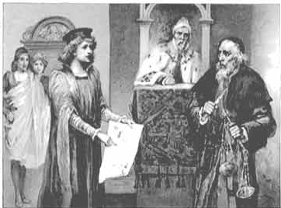me now as all my ships have gone out in 1he sea withmerchandise. But don't worry, my friend, rn arrange three thousand ducats for you."

So he decided to bom>w the sum

from a moneylender named Shylock. " Shylock was a very crooked man. l Antonio and Shylock hated each

other. Shylock used to lend money with high interest. He would even send the debtor to prison if the latter failed to pay his debt. On the

contrary, Antonio used to lend money to help those who needed it and would not charge any interest.

Shylockagreedto lendhimmoney butononecondition. Ifhe failed torepay the money in three month1s time, he would pay a penalty. Shylock would cut a pound of flesh from any part ofAntonio's body.

Pl andPurpose 189

Antonio willingly agreed, thinking that his ships would soonreturnwith all the rich merchandise and he could easily return the money to Shylock by selling them. Shylock made.Antonio signa bondbefore givinghimthe money.Antonio took the moneyand gave it to Bassanio.

1. True or False? If false, givethe correct information.
   1. Bassanio was a veryrichman.
   2. Bassanio and.Antonio hatedeachother.
   3. Antonio went to Shylock to borrow some money.
   4. Shylock happily gave Antonio the money he askedfor.

*S* Antonioneeded the money tobringhismerchandise.

1. Read the text in **B again and**amwer the following **question,.**

l Why was Bassanio short of money all the time?

1. Whydid he go to Antonio?
2. Whydid Antonio go to Shylock?
3. Whydid Shylock get a bond signed byAntonio?
4. What was written in the bond?

Lesson 10:The Three Caskets

1. Look at the picture and discuss It In pairs.

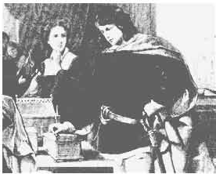

1. **Read** the text ancl answer the questions that follow.

Bassanio went to Belmont to visit Portia grandly dressed, with many *servants.* Portia's fatherhaddiedlately. Before his death hehad1hought of an1lllllSUal plan to find a good husband for his daughter. He wanted a man tomarry Portia for herself and not for her wealth. He had three caskets made, one of gold, one of silver and one of lead. One of the caskets had Portia's portrait in it. The suitor whowould first choose the casket with the portrait would marry her.

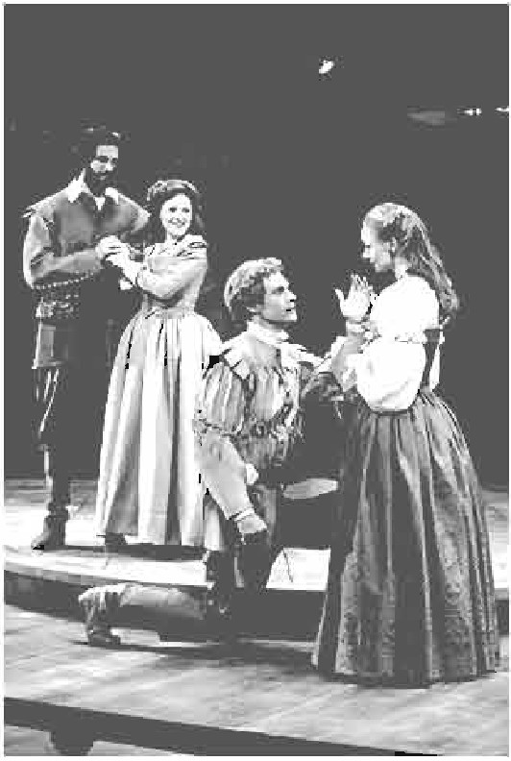The first one to try was the prince of Morocco. He thought that silver and lead are poor metals. It is the casket made of precious metal that can hold the precious picture. So he chose the gold casket. But all he found was a picture of a skull with a message that said, "All that glitters is not gold." The prince was very sad and went back home. Then came the prince of Spain. He looked at the silver casket for a long time. On it was written, "He who chooses me will get what he deserves." The prince had a very high opinion about himself. He thought that he deserved the best. He therefore chose the silver casket and opened it. Inside the casket he found the picture of a blinking fool. He was very disappointed and offended. He immediately rode away.

Then it was Bassanio's tum. He looked at the caskets for a long time. He thought, " Appearances are often misleading. Bad men appear good and they hide their inner ugliness under fine clothes." So he chose the plain looking lead casket. On opening the casket, he found the portrait of Portia inside.

Bassanio and Portia got married. There was great joy at Belmont and the newly married couple were spending their time happily.

But soon their happiness turned into sorrow by a piece of news. A messenger came with a letter from Antonio. The letter said, "Dear friend Bassanio, all my ships have been lost at sea. I cannot pay the money I owe to Shylock. So I have to pay the penalty. Dear friend, come and see me if possible. I would like to see you once before I die." Bassanio quickly left for Venice.

**Questions**

* 1. Why did Portia's father make such a strange plan?
  2. Write what you know of the three caskets.
  3. How many people attempted to choose the right cask.et? What was the result?
  4. Who succeeded to marry Portia? Why/How?
  5. Why did the joyous mood at Belmont tum sad?

Pleasure and Pwpose 191

**Lesson 11: The Trial**

**A Read the text and answer the questions that follow.**

When Bassanio reached Venice, Antonio was already in the court of justice. They were waiting for the trial to begin. The Duke entered the courtroom, took his seat and the trial began. The Duke requested Shylock to be merciful and not to claim his pound of flesh. But Shylock would not listen to him. Bassanio offered him twice the amount of money that Shylock lent Antonio but Shylock did not accept it. He said, "I claim my pound of flesh. The law is on my side. Antonio must pay the penalty written in the bond."

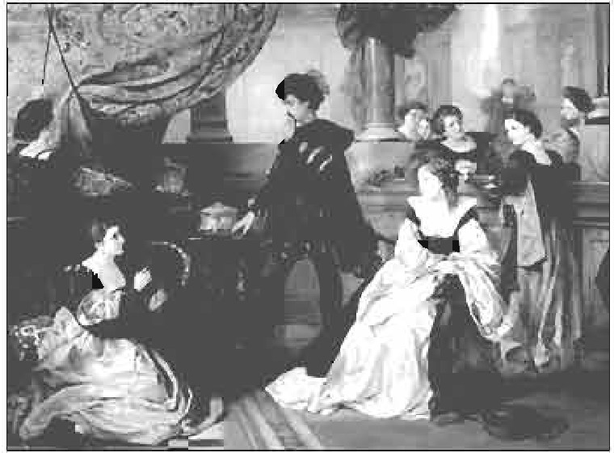The Duke was extremely sorry that he could do nothing to help Antonio. The law was on Shylock's side and the law must be abided. The Duke feared that ahhough the wisest lawyer in Venice was coming to speak in defense of Antonio, he would not be able to save the merchant Soon a young clerk entered the courtroom with a

letter from that lawyer. The lawyer was ill and would not be able to come to the

court.

He requested the Duke to let his young friend, Doctor Balthazar, defend Antonio. The Duke gave his permission, and Doctor Balthazar entered the courtroom. He looked very young, and the Duke doubted if the wisdom of the young lawyer could save Antonio. This young lawyer was no other than Portia in disguise and the young clerk was her friend, who was also in disguise.

Portia begged Shylock to be merciful and told him how God bestows mercy to those who are merciful themselves.

" Mercy" Portia said, " brings a blessing to him who shows it and to him who receives it. All of us pray to God for mercy. But God will only have mercy on us if we have mercy on others."

Shylock paid no heed to Portia. All he wanted was his pound of flesh.

*""* Portia asked, "Can't Antonio pay the debt?"

t'-1 Bassanio cried," Yes, he can pay it, and even more.... Even I can pay ten

times the sum my friend borrowed from Shylock." "Won't you take the money, Shylock?" Portia asked.

"No, I demand the lawful penalty. Give me my pound of flesh." "Let me see the bond Shylock", said Portia.

Shylock handed the bond to her. She read it with great attention and then said,

"You are right Shylock. The law is on your side. You can claim the flesh. But I would request you one more time to accept the sum Bassanio is offering you, and let me tear up the bond." But Shylock would not give up his claim. Portia then turned towards Antonio and said, "Get ready Antonio for Shylock to cut his pound of flesh. The law gives it to him."

Shylock was filled with joy on hearing what Portia said. He began to praise Portia in disguise, for her wisdom and righteousness. He cried out, "Oh noble judge! Oh excellent young man, you are a second Daniel, who has come to this earth."

Portia urged Shylock to cut the pound of flesh he demanded. Delighted, Shylock walked towards Antonio with a knife in hand. He told Antonio to uncover his chest. But as he was about to cut Antonio's flesh, Portia stopped him. She cried out, "Wait a second, Shylock! Never forget - there is no mention of blood in the bond. Therefore, you cannot shed a single drop of blood while you cut your pound of flesh; or else you pay the penalty. And the penalty is, the state will take your property from you. You lose everything that you have now, Shylock."

Shylock understood it was not possible for him to cut a pound of flesh without shedding blood. He was defeated by the wise lawyer. He hung his head and without another word left the courtroom. Thus Antonio's life was saved.

**Lessons 9, 10** & **11 are adapted from *The Merchant of Venice* by William Shakespeare.**

**Questions**

1. Who was Portia? What do you know about her?
2. What did Portia say regarding mercy?
3. How did Portia save Antonio's life?
4. Sketch the character of Antonio.
5. How do you evaluate the character of Shylock?

193

**Sample Questions From SSC Examination 2018**

**English Paper One Full Marks: 100**

**Time: 3 hours**

(Answer all the questions. Figures in the margin indicate full marks.)

**Read the passage. Then answer the questions below.**

21 February is a memorable day in our national history. We observe the day every year as International Mother Language Day. The day is a national holiday.

On this day, we pay tribute to the martyrs who laid down their lives to establish Bangla as a state language in undivided Pakistan in 1952. The struggle to secure the rights of our mother language is known as the Language Movement.

The seeds of the Language Movement were sown on 21 March 1948 when Mohammad Ali Jinnah, the Governor General of Pakistan, declared in a public meeting in Dhaka that Urdu would be the only state language of Pakistan. The declaration raised a storm of protest in the eastern part of the country. The protest continued non-stop, gathering momentum day by day. It turned into a movement and reached its climax in 1952. The government outlawed all sorts of public meetings and rallies to stop it.

The students of Dhaka University defied the law and brought out a peaceful protest procession on 21 February 1952. When the procession reached near Dhaka Medical College, the police opened fire on the students, killing Salam, Rafiq, Barkat, Safiur and Jabbar. As a result, there were mass protests all over the country and the government had to declare Bangla as a state language. This kindled the sparks of independence movement of Bangladesh.

1. **Choose the correct answer from the following alternatives.** 1x7=7
   1. 21 February is a memorable day for all the Bangladeshis because on this day in 1952:
      1. Urdu was declared as the only state language of Pakistan.
      2. Bangla was declared a state language of Pakistan.
      3. some great people laid down their lives to establish Bangla as a state language.
      4. students protested against Mohammad Ali Jinnah's declaration of Urdu as the only state language of the country.

Forma-25, English For Today-9-10

* 1. The seeds of the Language Movement were sown by:
     1. Salam
     2. the martyrs
     3. Jinnah
     4. the students
  2. The phrase "storm of protest" means:
     1. mild protest
     2. strong protest
     3. moderate protest
     4. symbolic protest
  3. The gap between the beginning and the climax of Language Movement was
     1. 2 years
     2. 3 years
     3. 4 years
     4. 5 years
  4. The greatest outcome of the Language Movement is:
     1. the status of Bangla as a state language
     2. the independence of Bangladesh
     3. the International Mother Language Day
     4. mass protests all over the country
  5. Salam and Barkat were the citizens of
     1. Bangladesh
     2. Nepal
     3. India
     4. Pakistan
  6. The Pakistani government declared Bangla as a state language because it was
     1. compelled to do so
     2. requested to do so
     3. urged to do so
     4. advised to do so

**Answers:** i) c; ii) c; iii) b; iv) c; v) b; vi) d; vii) a

1. **Answer the following questions.**
2. Why is 21 February a national holiday?
3. What was "undivided Pakistan"?

**2x5=10**

1. Why did Pakistani government outlaw meetings and rallies in 1952?
2. Why did the police kill Salam, Rafiq, Barkat, Safiur and Jabbar?
3. How is Language Movement related to the independence of Bangladesh?

**Suggested Answers:**

1. 21 February is a national holiday because on that day in 1952 Rafiq, Salam, Barkat, Safiur and Jabbar laid down their lives to establish Bangla as a state language of Pakistan. The day is observed as a national holiday as a mark of our tribute to the martyrs.
2. "Undivided Pakistan" was the Pakistan before 1971. In 1971 East Pakistan became independent and emerged as a new country-Bangladesh.
3. Pakistani government outlawed meetings and rallies in 1952 in order to stifle the people's voice raised against the declaration of Urdu as the only state language of Pakistan.
4. The moral strength of the students' peaceful procession on 21 February 1952 in support of Bangla as a state language frightened the Pakistani government. Therefore, their police opened fire and killed the processionists-Salam, Rafiq, Barkat, Safiur, and Jabbar.
5. The success of Language Movement succeeded in kindling the sparks of independence movement. The independence movement eventually turned into the liberation war and the Bangalees got a new country­ Bangladesh.
6. **Read the following text and fill in each gap with a suitable word based on the information of the text. lx5=5**

Eveyone wants to share this happiness with near and dear ones. That's why people rush for their homes in spite of serious hazards? This is nothing but people's desire to return to the roots. Do human beings have roots like the trees? The answer is 'yes' but unlike the roots of the trees they are invisible, they lie in our minds. It's these roots that make a bond between us and family members,

in-laws, friends, neighbours or even between us and the land where we were born and grew up. In that sense our families, our land of birth, relatives, our culture, traditions, or surroundings are our roots. And wherever we stay, we feel the power of our roots. It's our roots that develop our identity making us what we are. When we lose that bond, we become rootless. Human beings who do not have any roots are a non-entity. In other words, they do not have an identity. They don't know where they are from, and/or where they are heading to. This often makes them feel empty and lost.

By nature, human beings love a)_ to share their feelings with near and dear ones. This invisible b) _ for each other lies in our hearts. It always pulls us to c) _ back to our roots. It develops our identity and d) _ us to know who we are. Ifwe deny our roots, we will deny our existence. So, we can't but e) _ our roots.

**Suggested Answers:**

1. companions/friends
2. feelings
3. go/come
4. helps/assists
5. nourish/ strengthen
6. **Read the passage from the membership of a reading club. Complete the following table with information from the passage. lx5=5**

Pathok Club aims at developing reading habit among community people irrespective of age. It is open 12 hours a day starting from 8:00 am. The subscription fee varies for the different age groups. If you are between 5 to 17, you will have the junior membership. It requires Tk. 200 for a 3 month and Tk. 300 for a 6 month memberships. Annual membership, which will allow one additional facility like free entry to the movie show every week, can be obtained forTk. 600. The membership charges for adult age group (18 to 50) are quarterly Tk. 300 and half yearly TK. 500. Annual membership charge is Tk. 300 more than the 6 month membership fee and it comes with the facility to access the movie library. Senior membership is for people above 50 who have to pay Tk. 100 quarterly and Tk. 200 half yearly. Yearly membership for them is Tk 300, which also allow them free access to the movie library along with home delivery and pick up facilities.

|  |  |  |  |  |  |
| --- | --- | --- | --- | --- | --- |
| Pathok Club details | | | | | |
| Obiective | Cultivating reading habit | | | | |
| Opening hours | From 8:00 am to (1) pm | | | | |
| Membership type | Age group (in years | Subscription charge and facilities | | | |
| Quarterly | Half yearly | Annually | Additional Facilities for annual  members |
| (2) ................ | 5-17 | Tk.  200 | Tk. 300 | Tk. 600 | Access to movie show |
| Adult | 18-50 | Tk.  300 | Tk.  500 | (3) Tk...... | (4) ............. |
| Senior | (5) ................ | Tk. 100 | Tk. 200 | Tk. 300 | Free access to movie library and home  serv1ce |

**Answers:**

1. 8:00 pm
2. Junior
3. Tk. 800
4. Access to the movie library
5. 50 and above
6. **Write a summary of the above passage in your own words. 10**

**Suggested Answer:**

To grow reading habit in its community, Pathok Club is offering some lucrative memberships where the fee is the lowest for elderly people and the highest for the middle group of 18 to 50. There are three types of membership for each of the junior, adult and senior member groups which are quarterly, half yearly and annual with some extra facilities for the annual membership.

1. **Match the parts of sentences given in column 'A' 'B' and 'C' to write five complete sentences. lx5=5**

|  |  |  |
| --- | --- | --- |
| **Column A** | **ColumnB** | **ColumnC** |
| 1. Mount Everest which is in 2. It was named after an Englishman 3. Climbing mountains like Everest 4. In spite of all the difficulties and dangers the daring 5. After two months of difficult and dangerous climbing | 1. George Everest who surveyed 2. Edmund Hillary and Tenzing Norgay reached the top on May 10 and 3. mountaineers are not daunted because 4. is difficult and dangerous because 5. the Himalayan Mountains to the North of India between Tibet and Nepal | 1. the Himalayas m 1841. 2. mountains always look exciting and challenging to them. 3. is the highest mountain in the world. 4. have gone into history as the first to conquer the highest mountain in the world. 5. there is snow all over and there might be snow slides and cracks under the ice and snow. |

**Answer:**

1. Mount Everest which is in the Himalayan Mountains to the North of India between Tibet and Nepal is the highest mountain in the world.
2. It was named after an Englishman George Everest who surveyed the Himalayas in 1841.
3. Climbing mountains like Everest is difficult and dangerous because there is snow all over and there might be snow slides and cracks under the ice and snow.
4. In spite of all the difficulties and dangers the daring mountaineers are not daunted because mountains always look exciting and challenging to them.
5. After two months of difficult and dangerous climbing Edmund Hillary and Tenzing Norgay reached the top on May 10 and have gone into history as the first to conquer the highest mountain in the world.
6. **Put the following parts of the story in correct order to make the whole story. Only the corresponding numbers of the sentences need to be written. lx8 = 8**
   1. The fox said,"What a noble advice it is!" Then he carried the turtle to the river and let it go.
   2. The fox began to shout, "You are ok, come now, dear. But the turtle raised his neck and said, "Here there are more cunning animals than you."
   3. The turtle began to make more distance and by noticing it tears came to the fox's eyes.
   4. The shouting of the fox got gradually softer.
   5. Once a hungry fox captured a turtle to eat and said, "How hard your body is!"
   6. The fox said, "I am here, don't waste my time. Come quick while you are soft enough".
   7. The turtle began to dive and make a great distance between them.
   8. The cunning turtle said, "Let me go to the river to soften my body".

**Answer:**

The parts of stories can appear in the following order: e), h), a), f), g), b), d), c).

1. **Answer the following questions to write a paragraph on Global Warming. 10**
   1. What is global warming?
   2. What are the causes of global warming?
   3. What are the effects of global warming?
   4. What should we do to stop it?
   5. Why do we need a green environment?

**Suggested Answer:**

**Global Warming**

Global warming is now a major worldwide concern. It is the gradual warming of the air surrounding the earth as a result of heat being trapped by environmental pollution. There are many factors responsible for it. Firstly, the destruction and burning down of tropical rain forests; secondly, traffic that clogs up city streets; thirdly, the rapid growth of industries and the use of CFC; fourthly, the use of detergents. As a result, the world is heating up. However the main culprit

is the carbon dioxide gas produced by the burning of fossil fuels and forests. All these are responsible for global warming as well as climatic change. The effects of global warming are very alarming for our life and existence. Because of global warming the temperatures may have risen by as much as 4° C. It could severely reduce mankind's ability to grow food; destroy wildlife and damage wilderness, raise sea levels and flood coastal areas and farmland. It is a severe threat to our life and existence. So to save the globe and to live a healthy life we should come forward to stop environmental pollution and the emission of green house gases. To ensure a green environment we should plant trees and stop destruction of forests. A green environment can ensure healthy and danger free life. We all should work hand in hand to save the globe from the harmful effects of climate change .

1. **Read the beginning of a story below. Add at least ten sentences to complete the story.** 10

It was on the first day of Boishakh. Dulal came out of his house in the morning with all his family members. Their first destination was the Ramna Park. In the park, there were people of all ages. Dulal could see a group of foreigners too. One of them had a camera and he was clicking all the way. All of a sudden, he came near Dulal.....................

**Suggested answer:**

................................................and in a sweet yet strange voice said, 'Shubho Nababorsho'.

Dulal felt excited. 'who taught you to say that'? asked Dulal. 'I have heard people saying it everywhere in the garden'.

The camera-happy man was from Norway. He said, 'Look, we are friends now. I will give you a small book that contains general info about my country. But please tell me about this day. I have visited many places of the world but I have never seen such a festive rally of people'.

'Do you like it'? Dulal asked. 'It's fantastic and exciting'.

Dulal guided the foreigner to the Institute of Fine Arts. The huge new year procession was about to start with all kinds of colorful masks. Dulal started telling the man about the motifs of the masks. All on a sudden, he remembered that his parents must be frantically looking for him. In a nervous tone Dulal said, 'Sorry, I have to go'. Without waiting for the foreigner's response, he started r-ri running to Ramna Park to meet his parents.

Sample QueetiODB 201

1. The graph below shows the number of computer ownen by gender In a clty named 'X f.rom the year 2012 to 2016. Describe the chart ln 150 words. You should hfgbHght and 1ammame the tnformatlon given in tile ehart. 10

Computer ownership by gender in city 'X': 2012-2016

.:; 25000

:I

20000

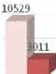tA ISOOO

13001

17020

! 10000

li

5 5000

a.

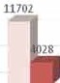0

e

!OU 2011 20l4

.; Y ars

*.a*

E

:,

z

2015 *201(,*

Sample amwer:

The graph presents the number of computer users both male and fE!malo in the city 'X' *ave:r* five yeani from 2012 to 2016. It shows th.at the popularity of computer among users ofboththe sexes steadily increased over the span of time.

At the bP.ginning of thetime period we see **a** big difference betweenthenumber of male and female computer users of where the male users out number the female users thiee to one.There isa gradual growth in the numbersofboth types ofusersover theyears, butthegrowth ismore rapidin thecase offemale users. The number of male usershas doubled over five years, wheRas them:unber of female usersis four times moreat the end thanin the beginning year.

Theuseofcomputers *is*gradually becoming moreandmo.repopular among both

thesexes, while women aregradually achievingparitywith men.

Forma.-26, Bv,glisb ForToda.y-9-10

1. **Suppose, you are Rayan/Afsana. Yesterday something amazing happened to you which you can't but share with your friend, Abrar/Pranto. Now, write an e-mail to Abrar/ Pranto about the incident.**

**10**

**Suggested answer:**

To: [zahiddrmc@gmai1.com](mailto:zahiddrmc@gmai1.com) Subject: Sharing patriotism

Dear Pranto,

I know it may not have time to read my mail as you are extremely busy with your study tour. But I believe the story will move you greatly.

Yesterday morning, I was heading towards my school to take an exam in a rickshaw. Everything around was so quiet that I felt a little scared. On my way, I saw some paper flags lying on the roadside. I remembered that yesterday was 16th December. Suddenly, the grey bearded puller stopped the rickshaw, got down and sprinted down the road. I was so terrified that I couldn't utter a single word. But I noticed that in a minute he returned with those flags. Composing myself, I told him that I was quite moved by his action. Taking a deep breath, he said, "Look, these are the flags for which I fought risking my life. So, I can't allow anyone to step on them." I realized that this patriotic zeal made the victory possible in 1971. My eyes became wet with tears. I believe it's time for all ofus to play our part in realising the dreams of our indomitable freedom fighters for which they sacrificed their lives and limbs. Hope to hear from you.

With love Afsana

Sample Questions 203

1. **Farheen is a 15 year old girl. She wants to go to Cox's Bazar with her parents after her final exam. Her father tells her to book rooms in Sea Star Hotel over telephone. Write a short dialogue that Farheen might have with the hotel receptionist. 10**

**Suggested answer:**

Hotel Receptionist (HR): Good afternoon. This is Hotel Sea Star. How can I help you?

Farheen HR

Farheen HR

Farheen HR

Farheen

HR

Farheen

HR

Farheen HR

Farheen HR

Farheen HR

I would like to make a hotel reservation. What day are you going to arrive here? We will be there on the 25th of December. How many rooms do you need?

We need two rooms.

Would you like to have double rooms?

We need only one double room. The other one should be single.

Sea-side or hill-side?

Please make sure that the double room will be a sea­ side room. The other one may be hill-side.

How long will you be staying? We need the rooms for 3 nights.

Would you like any smoking room? No, thank you.

Alright. We have booked the rooms for you. Please be sure to arrive before 4:00 pm on your check-in date.

Thank you.

You're most welcome.

**THE END**

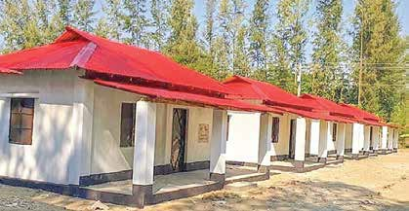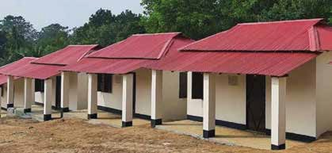



**e** IS t-l , , 91mm 'f-i l>IC-1-!1

?;,?;,q Cf Cf I

**e** IS

"11 "W I

**e** CflS .i1 , , 6MC (>5Mf

I>l-!1<1\IC-!1-!1 <1l®:1lrn m ,

IS '1B1<1l-!1C<P "<Pm 1





vnf¾aJ '& <p c

- (:Cf

**A thing of beauty is a joy for ever**



ol;,-ffif-l!l (c.'wf fir, 8 )

c. "11 "1

{3

{3 P\41'-!lCi-1



**Ministry of Education**